
BOWSMAN SCHOOL
OCTOBER 2026 NEWSLETTER
Important Dates to Remember:
Oct 7th – FREE Hot Lunch
Oct. 12th – No School – Thanksgiving
Oct.27th – Qwik Stop Lunch
Oct. 23rd – No School – SAGE -Professional Development
Oct 26th – No School – Professional Development

PRINCIPAL MESSAGE
I would like to take an opportunity to thank our entire school community of students, parents, and staff, for a great start to our school year!
Mrs. Sutherland
It’s that time of year! Check your child weekly for Head Lice!!


If head lice are found, please ensure hair has been treated and that ALL nits are removed. Please contact the school if you need guidance.
A reminder to parents that we require your current address and valid phone number for our records, along with any other changes to your child’s file. This is especially important for emergencies, medical alerts, and permission consent for activities. Please ensure your registration form is up to date, filled out completely, and handed in as soon as possible.

THINGS TO REMEMBER:
**The weather is beginning to get colder so students should be dressing warmly. All students are expected to go outdoors for recesses and lunch hours, Grade 6/7/8 have the option of staying in.
**Please phone the school to let us know when your child/ren will be absent from school, even when their bus is cancelled.
**All doors will be locked during the day. Parents/Visitors are asked to ring the doorbell to enter the school.
**Parents are encouraged to park away from the school bus route when dropping off and picking up their children. If you are meeting your child, please have a designated pickup spot outside.
**Parents are asked to ensure their children are in good health. If your child is ill, please do not send him/her to school.
**Please label all outdoor clothing items, as there is a large lost and found collection accumulating without names. **Mabel’s Labels are great for all belongings! **

BISON NEWS
Terry Fox Walk
The annual Terry Fox walk was held September 22nd. Students and staff were asked to bring a Toonie for Terry. Thank you to everyone who brought their change to be donated to this important cause. Donations are still being accepted until October 9th for anyone that still wants to contribute.
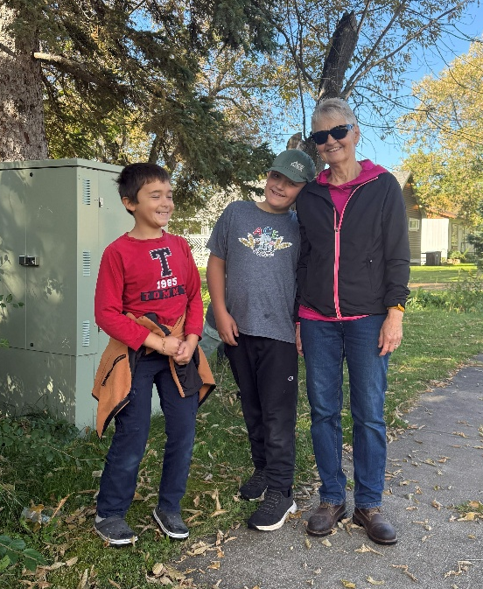
Grandmothers Walk

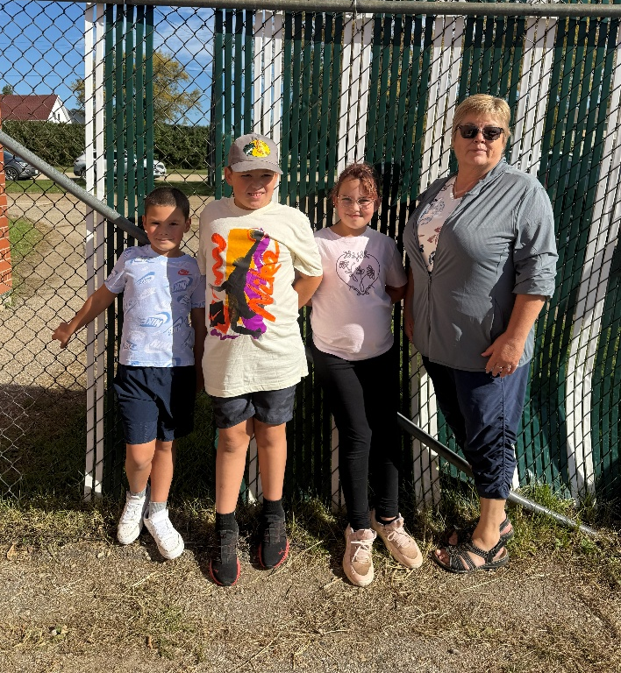
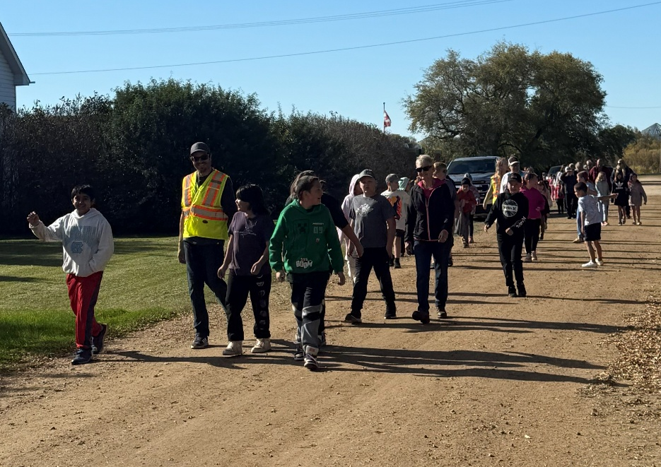
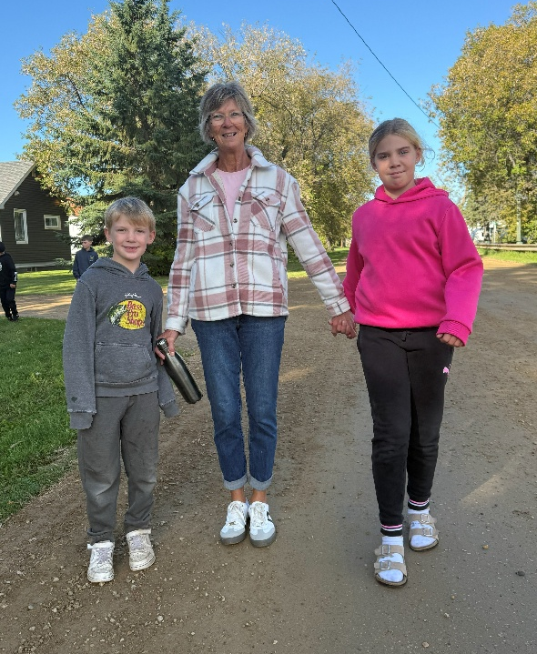
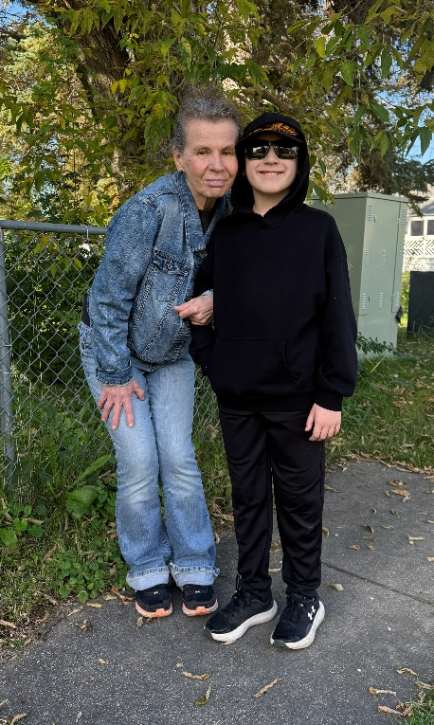
The Grandmothers Walk was held September 21st, thank you to all the grandmas, kookums, babas, moms and grandpas who joined us!

Cross Country Run
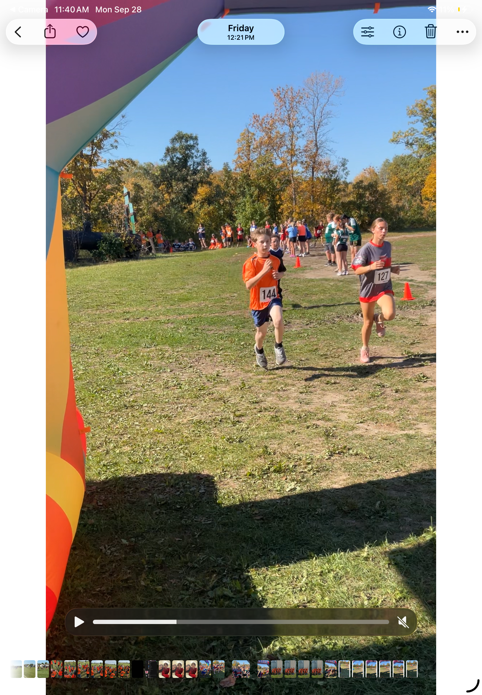
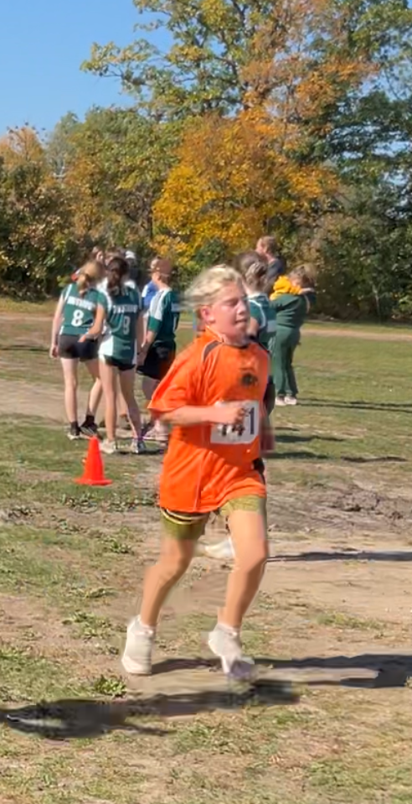
Some Bowsman students showed great effort and determination at the recent cross-country run. Nine students proudly represented our school in the two-kilometre race, while one relay team of four completed the four-kilometre event. It was a great day to run, and our students gave it their all from start to finish. We are proud of all our runners for their hard work, sportsmanship, and dedication.
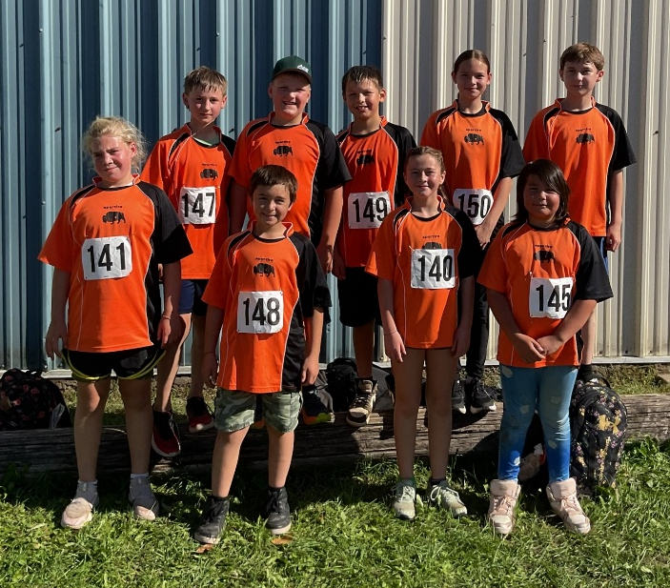
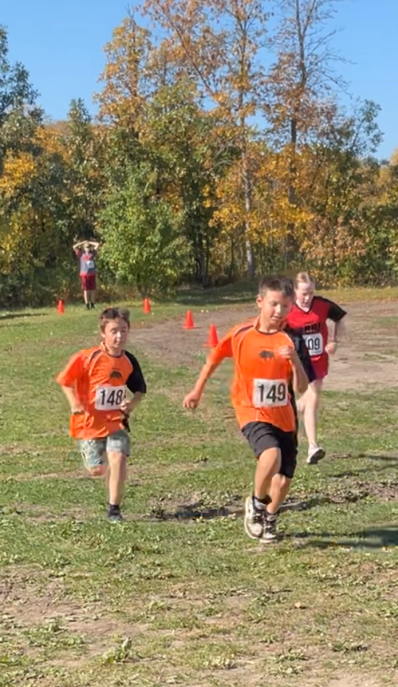
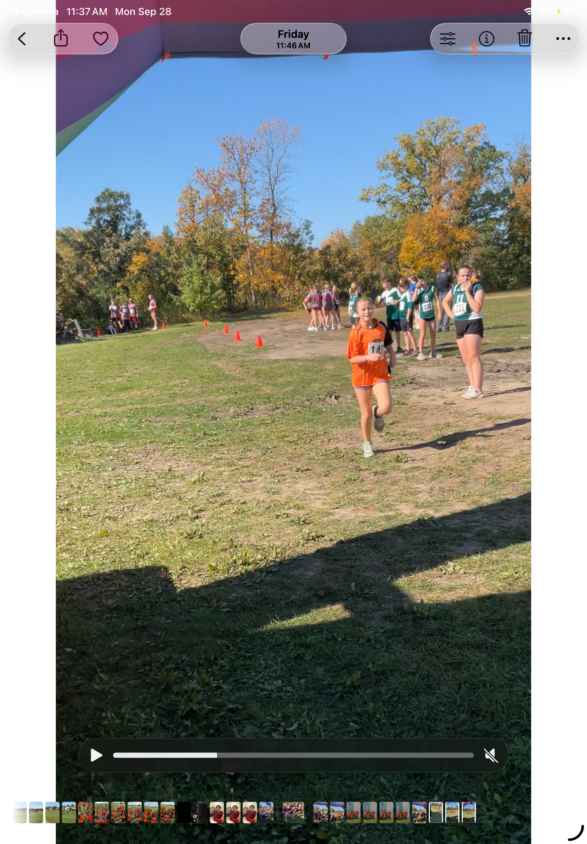
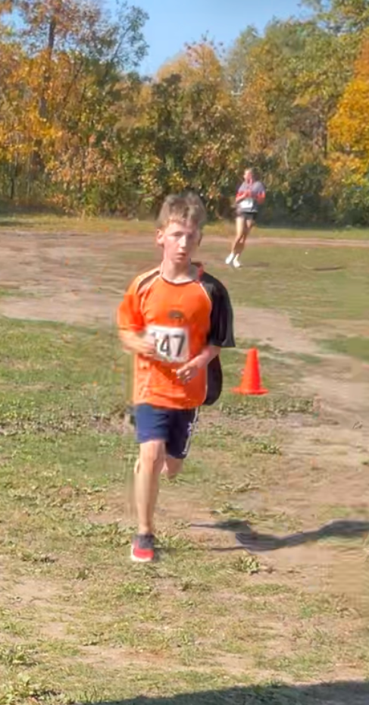
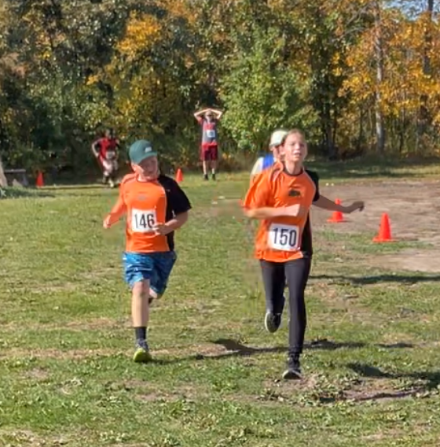
ATTENTION PARENTS:
Are you interested in helping the Bowsman School Parent Group? If you or a family member/ friend is at all interested in volunteering at the school throughout the year (in the classroom, during field trips, swimming lessons, big school events, etc.) you must complete a Child Abuse Registry Check as well as a Criminal Record Check. Please see the office to get a form along with 2 pieces of ID needed. Hope to see you help our school!
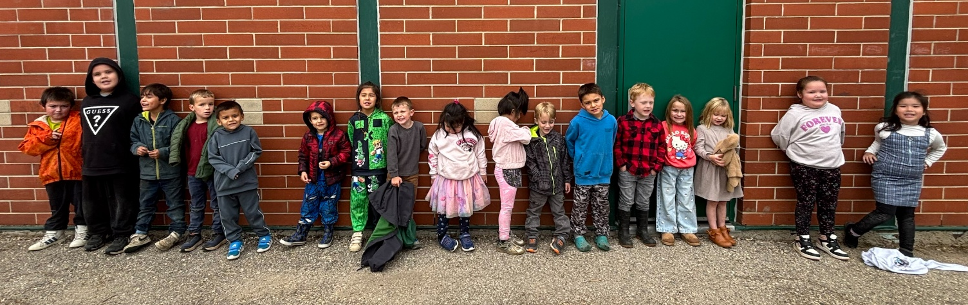

SOCCER DATES
Figure 1 K/1 class lining up after their playground time
The Grade 5 students will be competing in the Valley-wide Soccer Jamboree held at the Rotary Sports Fields in Swan River on Thursday, October 1st. Swan Valley Soccer Championships will be held the next day, Friday, October 2nd where the Bison soccer team will represent or school. Good luck team!

Hot Stew and Bannock Lunch
for students and staff
Wednesday, October 7 at 12pm
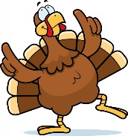
NO SCHOOL – MONDAY, OCTOBER 12TH
HAPPY THANKSGIVING TO ALL


VOLLEYBALL
Volleyball Development Days are planned at the SVRSS/ESRSS for October 15th and 28th from 10:00am- 3:00pm for grade 6-8 students who are interested.

QWIK STOP LUNCH – TUESDAY, OCTOBER 27th

Orders forms will be sent out Wednesday, October 14th and need to be returned by Tuesday, October 20th.
No late orders will be accepted.



NO SCHOOL
FRIDAY, OCTOBER 23rd
&
MONDAY, OCTOBER 26TH

PROFESSIONAL DEVELOPMENT
FOR ALL TEACHERS

BOWSMAN SCHOOL HALLOWEEN PARTIES
Watch for more information on the celebration of this event.

HARVEST LUNCH

Plans are underway for a Harvest Lunch to be held in November. Please stay tuned for details


Photovision Picture Re-Takes
Bowsman School picture retakes will be held at Taylor School on Tuesday, October 20th from 10:15-10:45 am. Should you wish for your child to have re-takes, or if your child needs to have their 2026-2027 picture taken, parents are responsible in getting their child to Taylor School for this time. Please let us know if you will be going for re-takes, so photographer can expect you.

This newsletter is available in alternate formats upon request.

