
**WELCOME BACK TO SCHOOL!!
September 2026

Please read through this letter carefully and be sure that all forms sent home are completed fully and returned to the school by Tuesday, September 15th.

Principal’s Message

Welcome back! Our staff is very excited to have all students back and starting a new school year. We are looking forward to the many activities and learning opportunities for students this year at Bowsman School.

This Photo by Unknown Author is licensed under CC BY-NC
Mrs. Sutherland
Principal

2026– 2027 Bowsman School Staff

Mrs. C. Sutherland Principal/Resource/6-8 RTI
Miss L. Klatt Kindergarten/Grade 1 Homeroom
Miss C. Cook Grade 1/2 Homeroom
Ms. K. Hollier Grade 3/4 Homeroom, 8 Science
Mr. M. Rusk Grade 5 Homeroom, 6 Science
Miss B. Sauve Grade 6/7 Homeroom, 8 ELA
Mr. K. Bender Grade 8 Homeroom, K-8 Physical Education, 6-8 Math
Miss A. Zagrodney Grade K – 8 Music – Days 2,4,6
Mrs. C. Pierrepont Resource Teacher/Literacy Intervention
Mrs. E. Abrahamson Educational Assistant
Miss D. Deeks Educational Assistant
Mrs. J. Broda Educational Assistant
Mrs. V. Honke Educational Assistant, Librarian
Mrs. A. Jacobs Educational Assistant
Miss P. Chatrand Educational Assistant
Mrs. D. Unrau Educational Assistant
Mr. M. Bighetty Custodian
Mrs. C. Werbicki Administrative Secretary

BUS DRIVERS Thank you to all our bus drivers for getting our students to and from school safely, each day.
Donna Farand #11 Richard Farand #24
Ferlin Abrahamson #15 Carolin Foster #25
Lori Watts #20 Brian Burick #26
Matt Black #23

Healthy Snack

Morning Healthy Snack program will begin September 15th. Please send a healthy snack in your child’s lunch kit for the first week!

REMINDER: All students should stay home if not feeling well.
Please call the school if your child will be absent from school.

Please remember that now that we are back at school and your child is in contact with many other students, please check your child’s head weekly for head lice.

REGISTRATION FORMS


All students will have a registration and permission form package. Please make sure you have completed all the forms fully (both pages need parent signatures). It is extremely important that all students have a primary and emergency contact with working phones. Bus students need to have a storm billet who lives near the school. Should your phone information change, please update the school as soon as possible.

SCHOOL PICTURES

On Friday, September 18th, Lifetouch, will be here to take our school photos. Please be sure that your child comes to school dressed for pictures at 9:00 a.m. Reminder: If you send a brush or comb along with your child, please emphasize the importance of NOT lending them to anyone else.

****** EMAIL ADDRESS *****

Our correspondence with parents/guardians will be primarily delivered via email. Please make sure that you have a valid email address listed on the registration form. Report Cards and future newsletter and calendars will be emailed!

STUDENT ACCIDENT INSURANCE


The Swan Valley School Division has supplied us with forms for student accident insurance, again this year. The insurance is voluntary.

If you are interested, send the completed form and cheque directly to the company or you can apply online via our school division website.

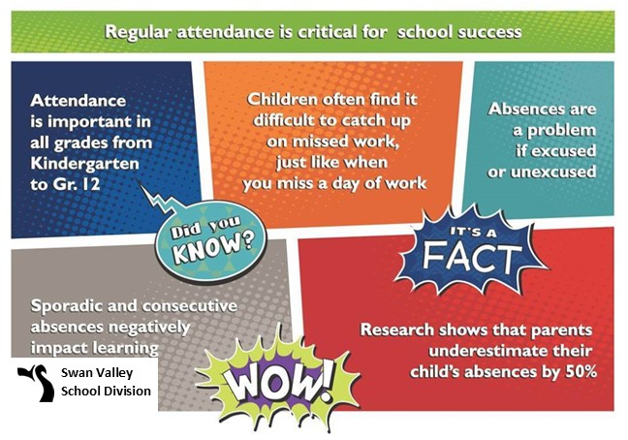
Bowsman School Guidelines
Cell Phone Use Kindergarten to Grade 8 students are banned from using cell phones during school hours, including breaks and lunch as per Manitoba Education


Students are encouraged to leave their cell phones at home. If students need to bring their cell phone to the school, they are to remain in their lockers for the entire day inside their backpack/jacket. Phones are not to be seen throughout the day. Should students not abide by the new Provincial Rule regarding cell phones, the following three strikes will be enforced:

1st cell phone sighting: REMINDER
– students will be reminded to put their cell phone away and out of sight for the day
2nd cell phone sighting: WARNING
– students will be warned that their cell phone will be put in the office for the remainder of the day if it is not put away properly for the day
3rd cell phone sighting: OFFICE STORAGE
- Students will have their cell phone placed in the office for the remainder of the day

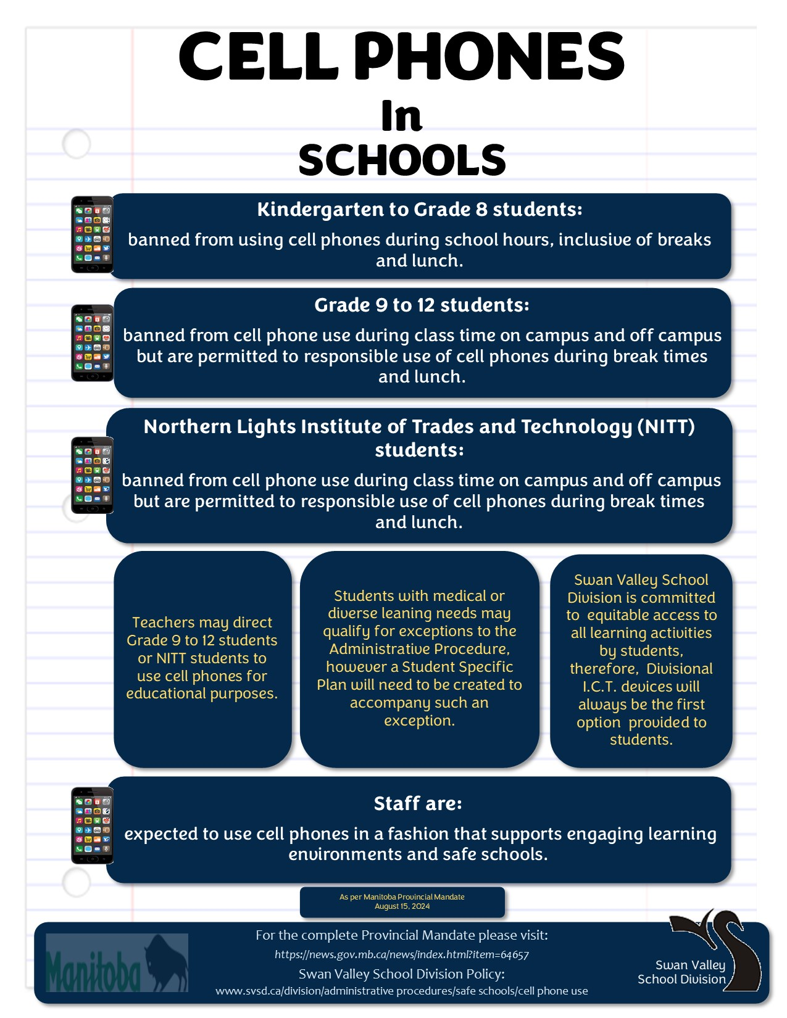

“This newsletter is available in alternate formats on request.”

