
BOWSMAN SCHOOL
DATES TO REMEMBER
March 6 – Grade 8 Transitioning
March 8 – Time change
March 10 – Opt. Ski Day Gr 4-8
March 12/13 – P/T Interviews
March 13 – No School
March 16 – Gr. 8 SVRSS Tour
March 17 – Pizza Lunch
March 25 – Gr. 4-8 Ice Fishing
March 23-27 – SPIRIT WEEK
March 30-April 3 – Spring Break
MARCH NEWSLETTER 2026


FOR SEPTEMBER 2026
If you have a child who will be 5 years old by December 31st, 2026, it is time to register for the 2026-2027 school year. Please come to the school to fill out a registration form. You will need to bring a proof of age (government issue ID or MB Health Card). If you have any questions, please call: 204-734-4506.
WE LOVE TO READ!
Thank you to all our guest readers who came to read to the various classes!
It was great to see all the staff and students take part in the February I Love to Read Month activities!
Book showdown, class favorites = K/1/2/3: Hockey Superstars, 4: I Survived (chapter book over graphic novel) , 5/6: Bad Kitty & 7/8: Dr.Seuss
Students also participated in identifying silhouettes of book characters.

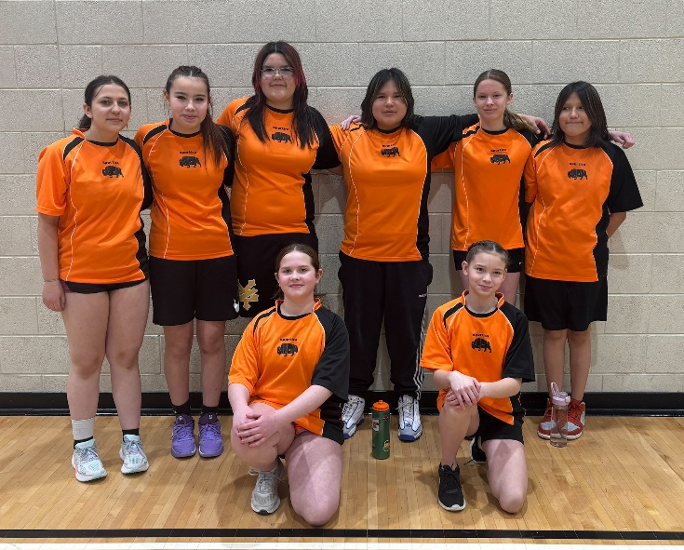
CONGRATULATIONS BISON GIRLS BASKETBALL TEAM They are ‘A’ Champions !
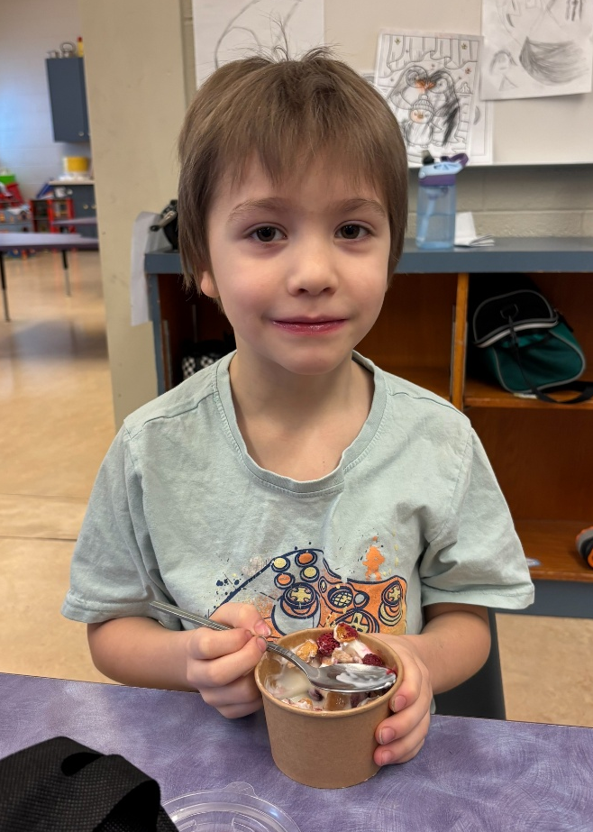
Thank You SVRSS for the Delicious Weekly Snacks!

Yummy yogurt, berries & cereal;
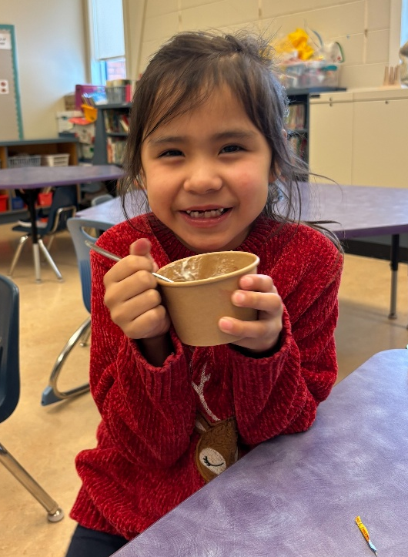

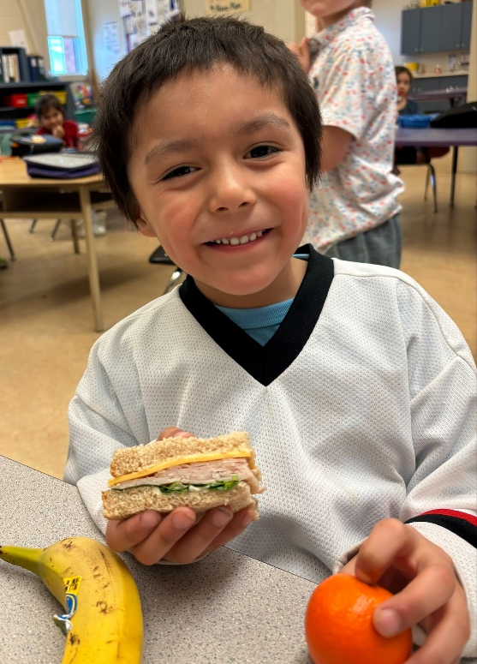
Sandwiches

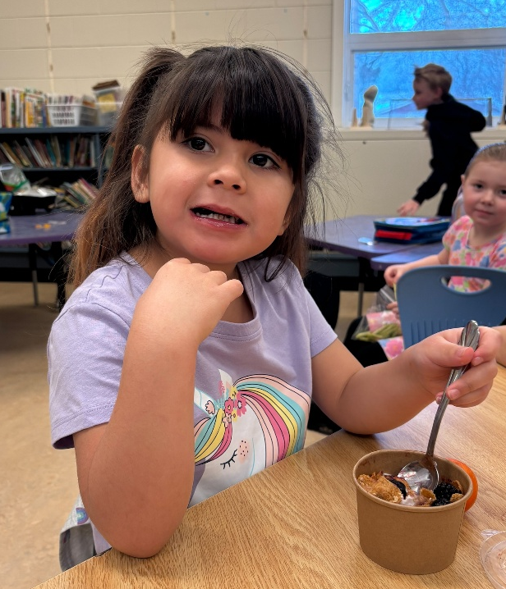
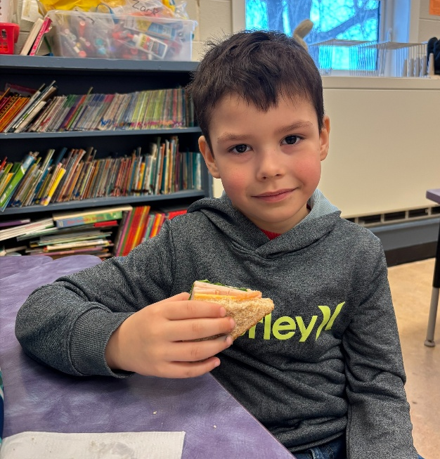
Muffins; Delicious Sandwiches;

&
Breakfast Oats
Bowsman School Athletics
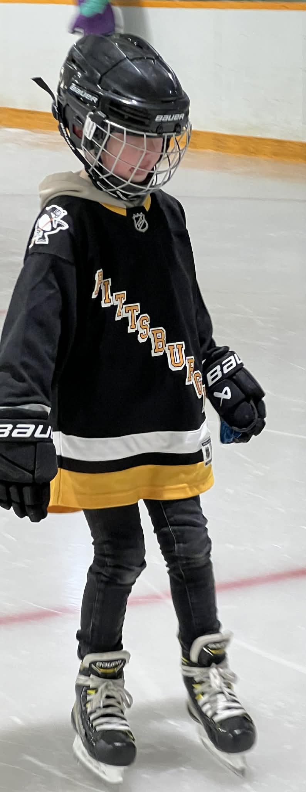
February skating fun at the Bowsman Rink!

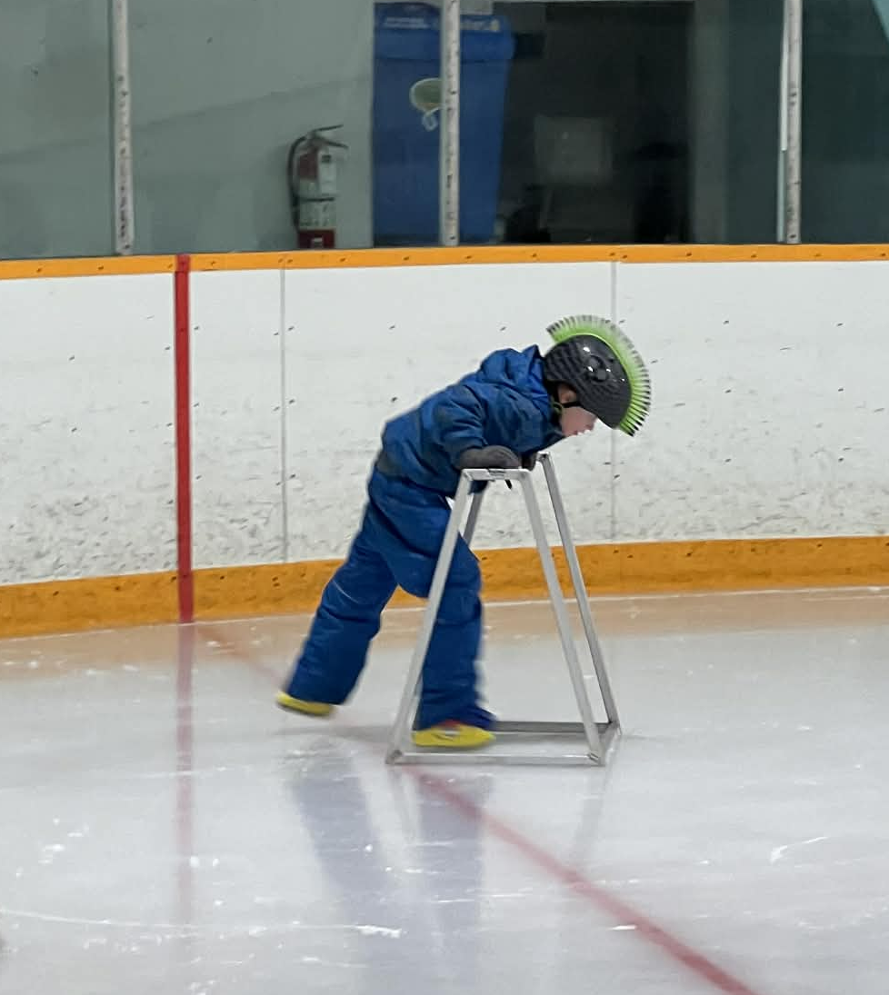
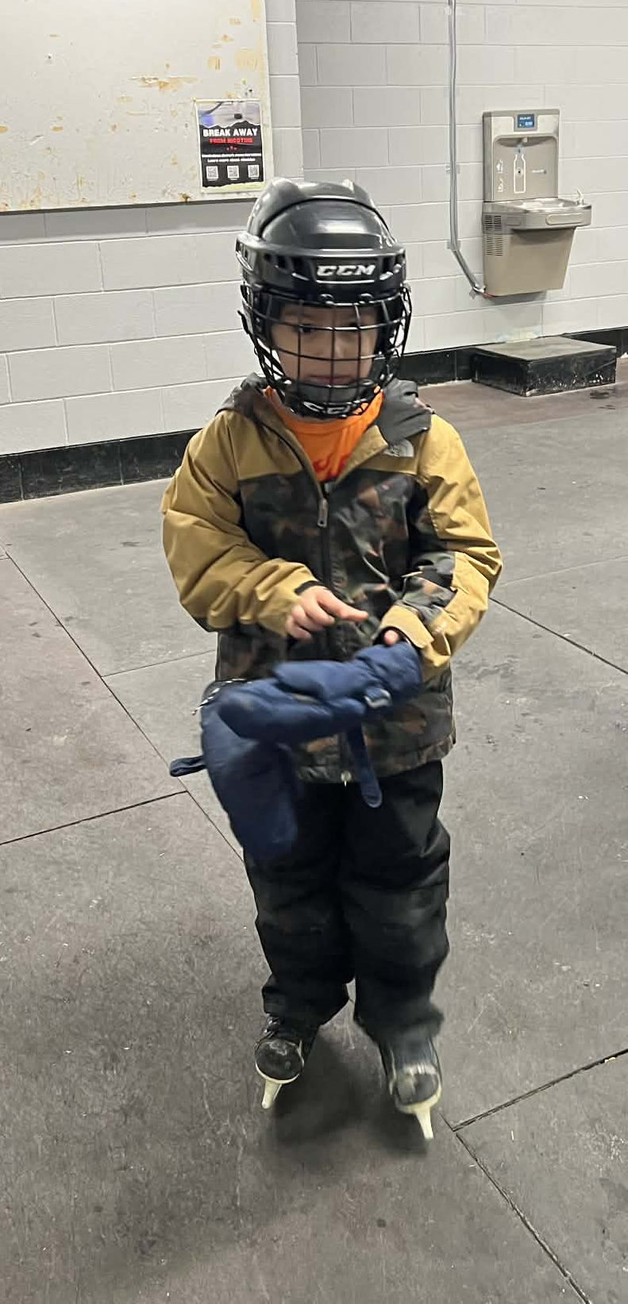


ATTENTION GRADE 8 PARENTS

Mrs.Badowski and Ms.Barabash from the SVRSS will be meeting with the Grade 8 class March 6th to discuss the high school registration process and course options available to them in grade 9. Grade 8 students will tour the high school Monday PM, March 16th. The SVRSS will then hold an Open House for current Grade 8 parents March 18th at 7pm. Teachers will provide a brief explanation of their introductory courses to students and their parents at this time.

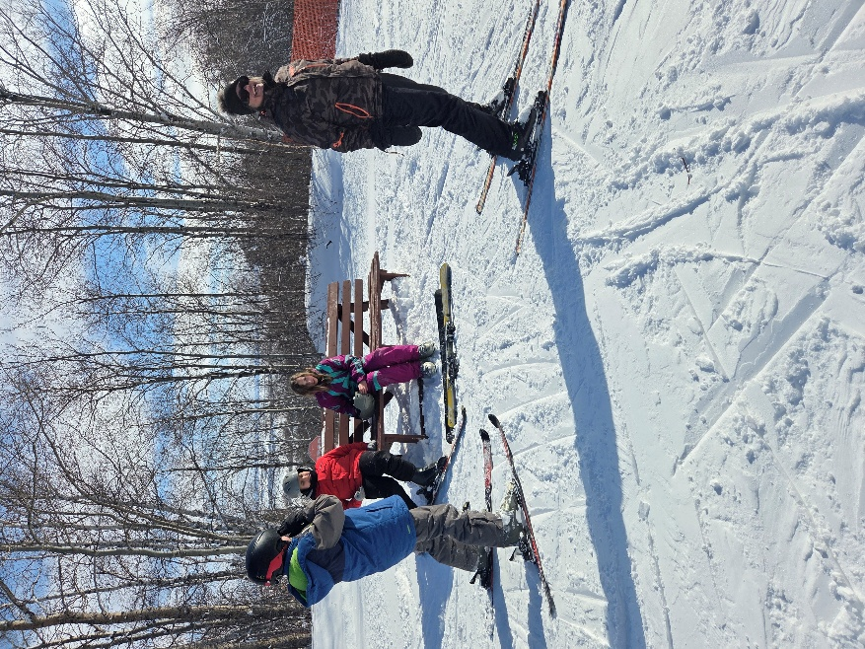
THUNDERHILL Grade 4-8 SKI TRIP – March 10

Please ensure permission forms and equipment forms are completed to participate. There will be a cost of $25 this trip. Students that opt out will have class at school, as usual.



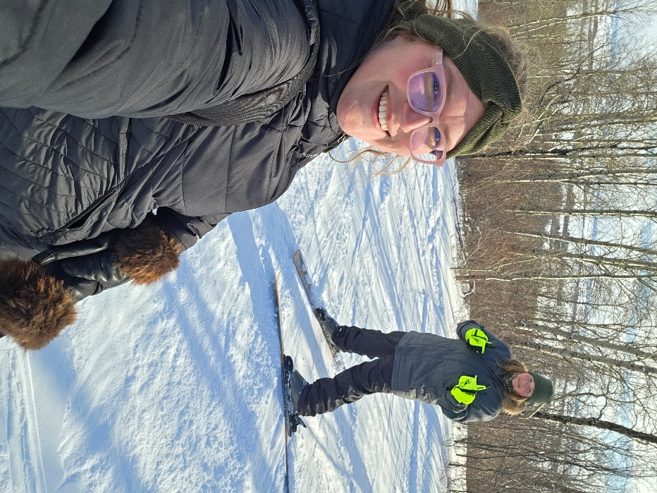

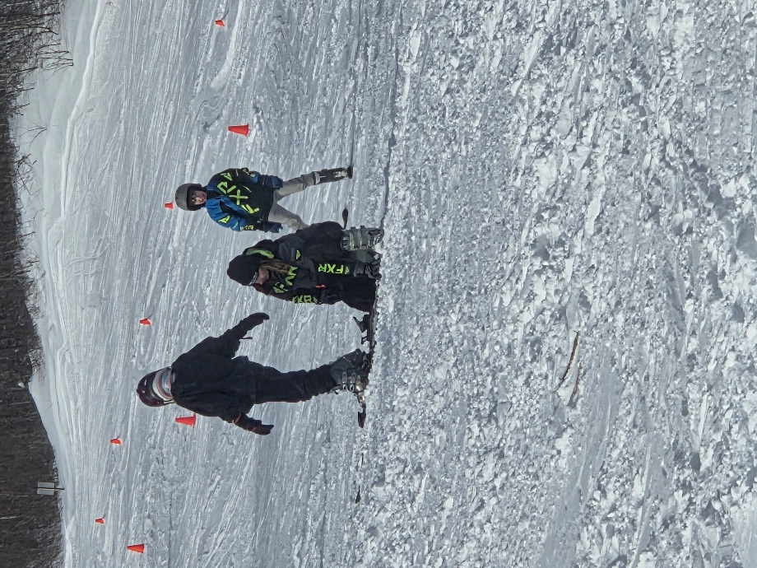

A great day at Thunderhill February 24th!

SPRING AHEAD!

On Sunday, March 8th, we all need to turn our clocks forward 1 hour to begin Daylight Savings Time.


PARENT TEACHER INTERVIEWS

Parent/Teacher interviews will be held on Thursday, March 12th from 4-6 pm, and Friday, March 13th from 9:30-11:30am.
Please make an appointment by calling the school at 204-734-4506. Alternate arrangements can be made with your child’s teacher if these dates and times do not work for parents.

NO SCHOOL FRIDAY MARCH 13TH – PARENT TEACHER DAY


FREE PIZZA LUNCH

On Tuesday, March 17th, Bowsman School will provide a pizza lunch to all the students and staff. K-Grade 1 will receive 1 large pie piece, while Grades 2-8 will receive 2 large pie pieces.
Pepperoni or Cheese will be the student choices per slice, along with a juice box.
Please bring own lunch if this is not of interest.

ICE FISHING

Wednesday, March 25th, Grades 4 – 8 will be going ice fishing to Whitefish Lake. Parents/Guardians are welcome to join their child(ren) on these days, meeting the students at the lake. A hot dog lunch will be provided, therefore, please let us know if family member(s) will attend so enough food will be prepared. Details and permission forms will follow shortly.

SPIRIT WEEK MARCH 24 – 28

MONDAY, 23RD: PJ/Crazy Hair Day – wear your pajamas and bedhead to school!
TUESDAY, 24TH: Class Color Day – wear your class color of the day!
K/1: Red, 2/3: Orange, 4: Yellow, 5/6: Green, 7/8: Blue & Staff: Indigo/Violet
WEDNESDAY, 25TH: Wacky Wednesday - Backward/Inside-Out/Mix ‘N’ Don’t Match Day – wear your clothes all mixed up!
THURSDAY, 26TH: Farm Day – dress as a farmer or a farm animal!
FRIDAY, 27TH: 101 Dalmatian Day – dress in black & white!

SPRING BREAK – MARCH 30th – April 3rd
School will resume on April 6th. School Day 3.


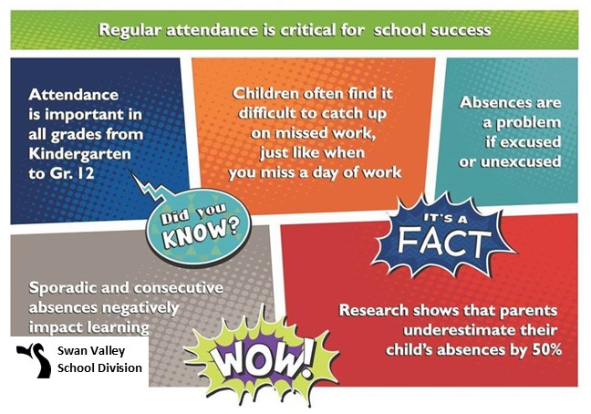
This newsletter is available in alternate formats upon request.

