

BOWSMAN SCHOOL


NEWSLETTER 2026

KINDERGARTEN 2026-2027

Do you have a child who will be 5 years old on or before
December 31, 2026
who would be attending Bowsman School in the fall? Then it is time to register!
Stop in to fill out a registration form or download it from the division website.
Proof of age (Government issued ID), and/or a Manitoba Health
Number MUST BE PRESENTED.
Please contact the school at 204-734-4506 with any questions!



February Dates to Remember: SCHOOL BUS CANCELLATIONS
4: Community Consultation Meeting Due to severe weather conditions,
6: Wear a colourful or Hawaiian shirt school buses may be cancelled for
12: Free Taco in a Bag Hot Lunch the day. Bus cancellations will be
13: Wear colour red announced on the radio and displayed
16: NO SCHOOL Louis Riel Day on the SVSD website and FaceBook
17: Hot Dog Sale forms go home page. Parents still need to
20: Wear a sports T-shirt or jersey phone in their child who cannot
24: Hot Dog Sale forms DUE get to school so all children are
24: Gr 4-8 Ski Day accounted for.
25: Pink Shirt Day for Anti-Bullying
25: Free Qwik Stop Sandwich Lunch
26: Alt. Ski Day Gr 4-8
27: Hats off to Reading - Wear a Hat
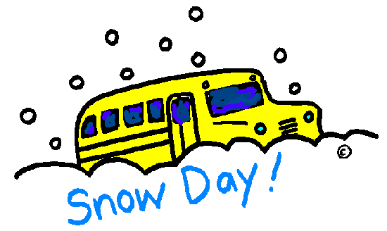
27: Hot Dog Day



FEBRUARY IS “I LOVE TO READ MONTH”

We will again be doing various activities within the school, during class time, but there are a few activities that parents can help with at home.
Each week, on Friday, will have an I Love to Read Month Dress Up Day.
If the clothing the students wear have words on them, all the better!
February 6: Surfs Up for Reading … Wear a colorful or Hawaiian shirt
February 13: How Many Books Have You ‘Read”? … Wear the colour red
February 20: Team Up for Reading … Wear a sports T-shirt or jersey
February 27: Hats off to Reading … Wear a hat
Happy Reading, everyone!


TACO IN A BAG LUNCH – THURSDAY, FEB 12th

Bowsman School will be providing a free Taco in a Bag lunch to all staff and students on Thursday, February 12th.

VALENTINE’S ACTIVITIES

All Valentine’s activities will be done in individual classrooms. Please do not send candy or food for exchanging at school. Teachers will send out a notice for cards.


NO SCHOOL – MONDAY, FEBRUARY 16th

There will be no school on February 16th, as this is a statutory holiday. (Louis Riel Day)

FEBRUARY SKATING SCHEDULE

Grades K-8 are going to be starting skating this month. Students are to supply their own skates and helmets, if able. Reminder to dress for the rink temperature!
Remember: CSA approved helmets are required for skating; bike helmets will not be allowed. Students (Grade 5-8) can bring along hockey sticks, but only if their helmets have cages on them and they have hockey gloves.
**Should your child need equipment, FaceBook Marketplace may have, Saskam in Kamsack has a great selection of used skates and helmets or Play It Again Sports has an online website**
Please let your teacher know if you will need equipment, as there is access to a limited supply of skates and helmets to borrow.
*Permission forms with skating dates have been sent out and are required for students to participate*
Wednesday February 4, 11, 18 & 25 - Grades 2/3, 4/5 & 6
Friday February 6, 13, 20 & 27 - Grades K/1 & 7/8
CROSS COUNTRY SKIING and SNOWSHOEING

Bowsman School grades 4-8 will be cross-country skiing and snowshoeing in gym, weather and snow dependant. Please dress appropriately for outside gym classes. Jackets, ski pants, toque, mitts, neck warmer, etc.


DOWNHILL SKIING AT THUNDERHILL

Our grades 4 – 8 students will be going downhill skiing at Thunderhill in February & March, weather permitting. Forms will be going home soon and must be returned by the due date in order to go. ALL SECTIONS OF THE FORM MUST BE FILLED OUT. There cannot be any sections left out on the form as it is very important for the staff at the ski hill to have all the information to ensure that your child is properly equipped and safe while at their facility.

February ski date is set for the 24th, with an alternate date of February 26th
QWIK STOP SANDWICH LUNCH –WEDNESDAY, FEB25th

Bowsman School will be providing a free Sandwich lunch, from Qwik Stop, for all students and staff on Wednesday, February 25th.

PINK SHIRT DAY FEBRUARY 25 ANTI-BULLYING DAY – WEAR PINK!

Hot Dog Lunch Fundraiser, Friday, February 27th

Forms will be sent out February 17th and DUE back on Tuesday, February 24th..
NO LATE ORDERS PLEASE! Thank you to our Parent Group volunteers who make and serve this lunch! The December hot dog sales and generous donation from McFayden Truck & Trailer went towards art supplies and Christmas concert decorations. January and February’s sales and two generous donations from the Graham Family will go towards field trips for the school.



“This newsletter is available in alternate formats on request.”

