

BOWSMAN SCHOOL
DECEMBER NEWSLETTER 2025

IMPORTANT DATES:
Dec 10th – Turkey Soup Lunch for all students & teachers
Dec 10th – Quarter Sale
Dec 15th -19th – 5 Days of Christmas
Dec. 17th –Christmas Concert 1:30PM
Dec 19th – Last day of classes before Christmas Break
Jan. 5th – First day of classes after Christmas Break (Day 5)
WINTER CLOTHING

Just a reminder to dress for the weather! All students spend time outdoors throughout the day for recesses, lunch & occasionally for Phys Ed. Please label all clothing/footwear with your child’s name, as there are a number of things in the lost & found box.
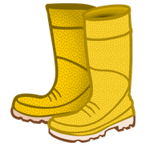
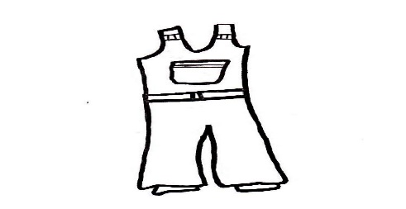
This Photo by Unknown Author is licensed under CC BY-NC
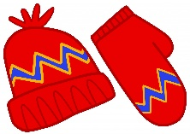

HARVEST LUNCH

A delicious harvest lunch was enjoyed by all at Bowsman School on November 13th. Thank you to the SVRSS for preparing our turkey meal with all the fixings!

LOST & FOUND

Our lost and found rack is now overflowing! Students are asked to check there weekly. Parents, please remind your children to check there if they are missing any items of clothing! Having their names inside all their items will help with safe returns!


LION’S VISION SCREENING
The Lion’s Club will be conducting eye screening on December 2nd. They will screen, with parental permission, Grades Kindergarten, One, Three, Five and Seven.
A report will be sent home with findings. If it is recommended that your child follow up with an optometrist appointment, please do so as soon as possible.
It is important that your child wears their glasses consistently and sees an optometrist yearly.

Volleyball
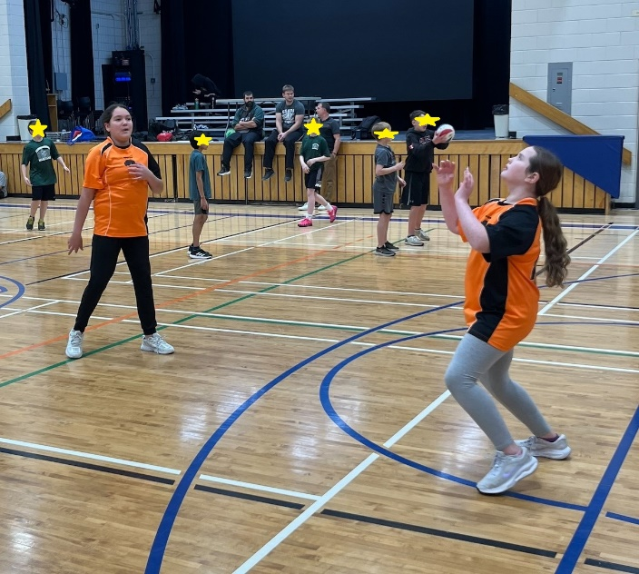
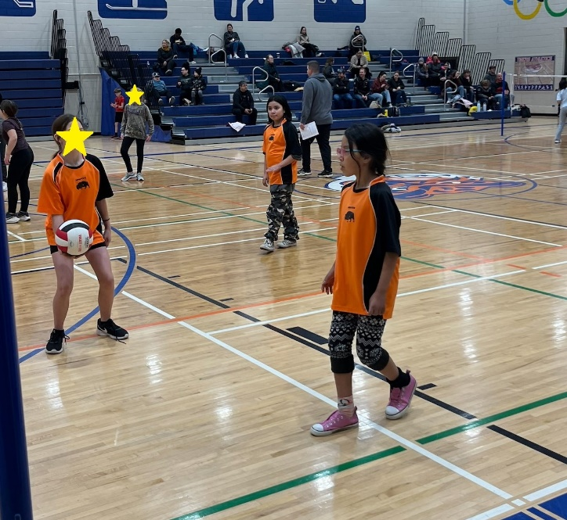

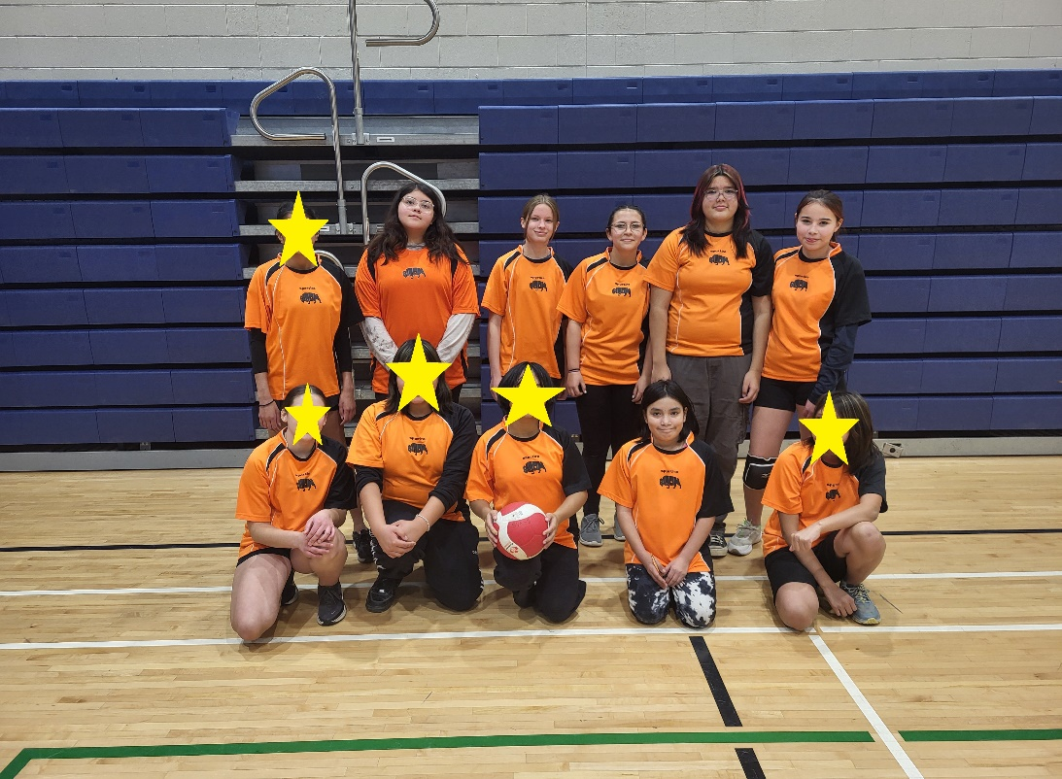

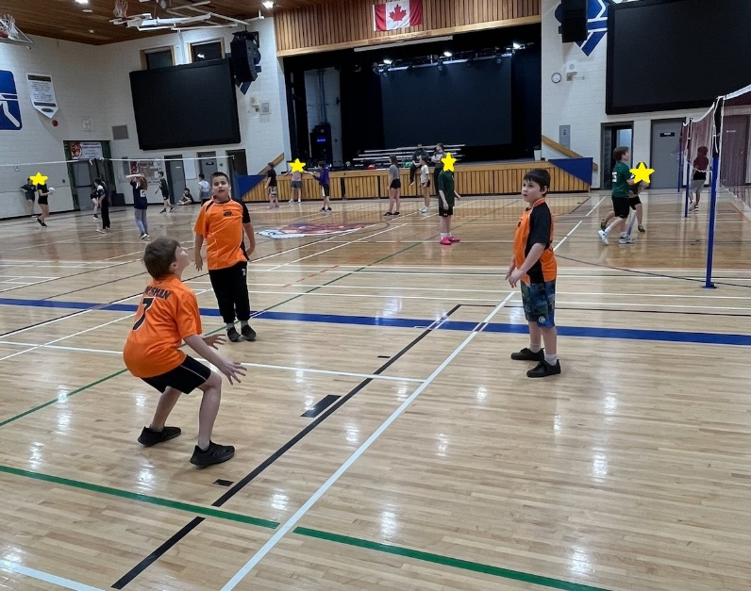
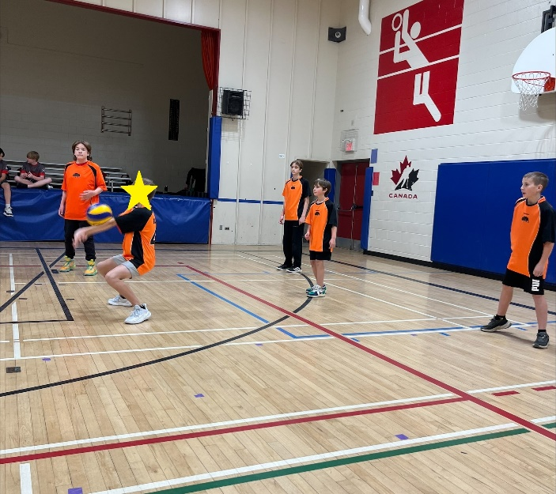

The Valley Champs, and Mini Volleyball tournaments were a lot of fun in November.

HOT LUNCH – WEDNESDAY, DECEMBER 10th

The school will provide a free hot lunch for all students and staff.
Menu will be Turkey Rice Soup with a bun along with a juice box.



STUDENT COUNCIL ACTIVITIES

The Bowsman School Student Council have planned some winter holiday spirit activities to take place before Christmas Break! Check out below: 5 Days of Christmas!


December 15 | December 16 | December 17 | December 18 | December 19
Pajama Day | Coloring Contest | Concert Wear | Hot Chocolate Candy Guesses | Formal Wear Dance Day

BOWSMAN SCHOOL CHRISTMAS CONCERT

What to wear for Christmas Concert 🍭 Costume Requirements by Class

Daycare (Candy Cane Forest)
• Red & white clothing (sweater, t-shirt, dress, leggings)
Kindergarten / Grade 1 (Gumdrop Grove)
• Bright pastel colors (pink, blue, yellow, purple)
Grade 2/3 (Marshmallow Meadow)
• White or light pastel shirt
Grade 4 (Lollipop Lagoon)
• Bright rainbow colors
Grade 5/6 (Gingerbread Castle)
• Brown/tan shirt (Gingerbread color)
Elves
• Green/red outfits

Everyone is invited to attend the Bowsman School Christmas Concert Wednesday, December 17th at 1:30pm. The students and daycare children will be working hard to prepare over the next few weeks. Please join us for music and singing to celebrate the Christmas Season.

Parents are welcome to take their children home following the concert. Please ensure the classroom teacher is notified they are going home with their family.

WHAT IS BETTER BEGINNINGS?
Better Beginnings is a parent/child program that supports the health and learning development of young children (from birth to age five) and their families.

It is a FREE program and is open to all children from birth to 5 years who are accompanied by a parent or a childcare provider.

The program offers a 1.5 hour session in community classrooms in: Benito, Bowsman, Minitonas, and Swan River. Sessions are on a drop-in basis, no registration required.


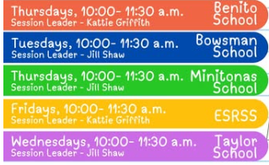
This Photo by Unknown Author is licensed under CC BY-NC

Sessions offer playtime, crafts, stories, songs, rhymes, healthy snacks, gym time and family resources.

Your role as a parent at Better Beginnings:

Parents/ childcare providers are in charge of each child that they bring to Better Beginnings. However, if there is conflict between children and the parent is unaware, the leader or another parent may intervene on your behalf until it comes to your attention. It is important that Better Beginnings is a safe place for all children.

Parents should encourage their children to participate in age-appropriate activities. Parents are encouraged to participate alongside their children during all activities in the session.

Examples of parent participation are:
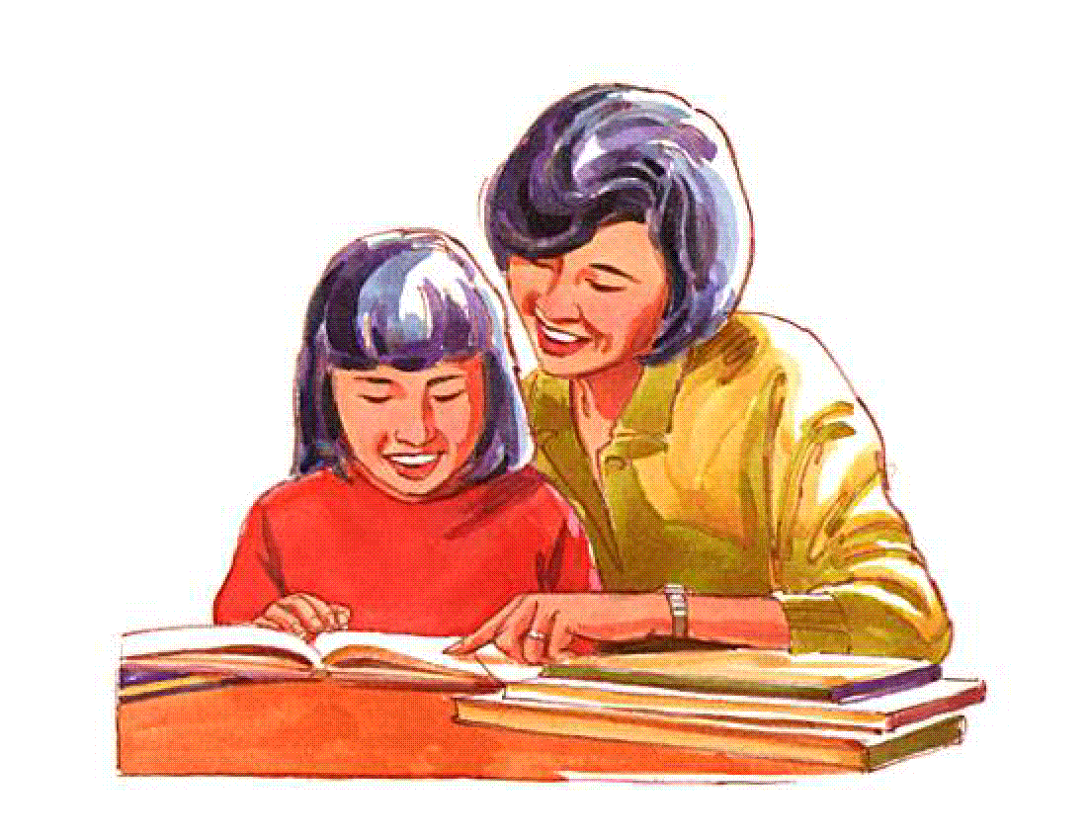
1) Joining your child on the floor to build a tower or do a puzzle together.

2) Joining in the circle during songs, rhymes, or other activities. Please sing along!

3) Directing your child to the floor for story time. Sit down with them to help them get involved with the story and stay interested.

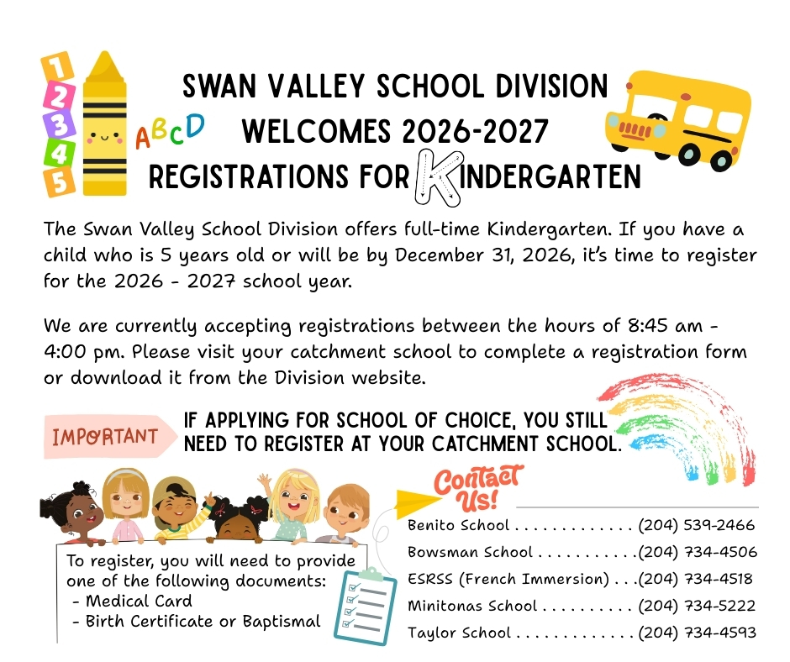

LICE CONTINUES TO BE AN ONGOING ISSUE THIS FALL.

Please continue to check your child’s hair daily for lice. For treatment, Resultz has been known to work better than Nix and can be purchased at the pharmacy or picked up free with a treaty number. Once treatment has been done, the nits need to be removed. This may need to be done daily to find the nits that may have been missed. A second treatment is recommended a week later. It is important to complete household cleaning as well. For information on how to deal with lice, please refer to the MB public health website and follow the Head Lice Control Check List factsheet. Thank you for helping us to get this issue under control!
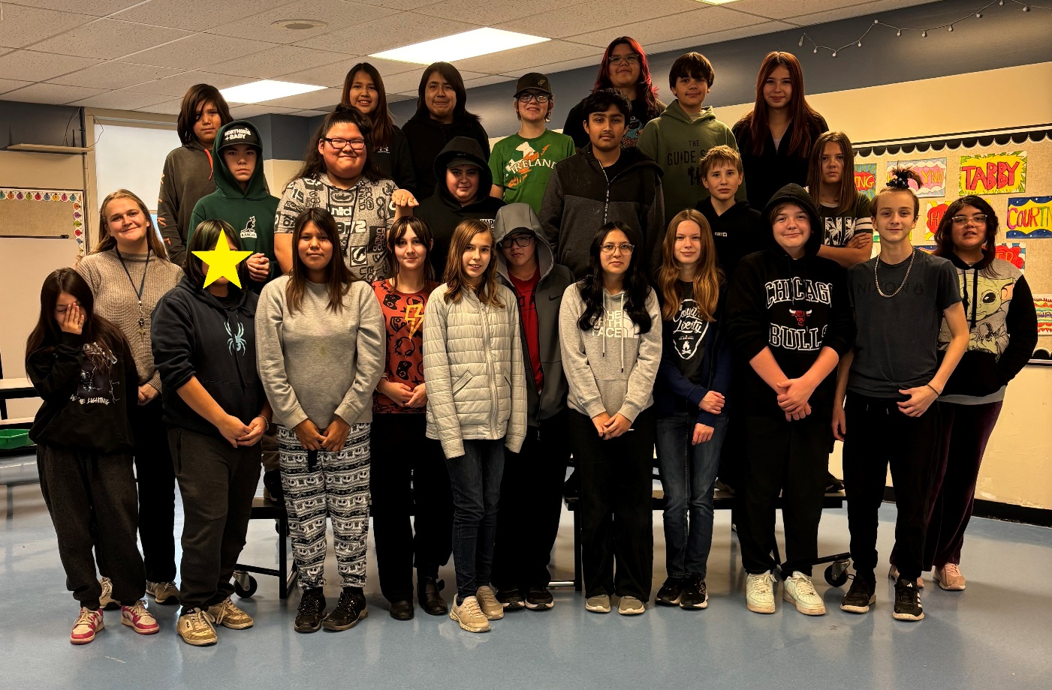

Mrs. Barker’s class had perfect attendance November 18th!

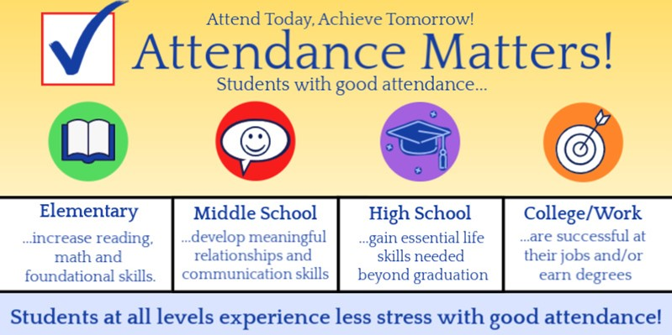

We wish you all a safe and happy holiday and all the best in the 2026 New Year!

