
BOWSMAN SCHOOL

NOVEMBER NEWS 2026

THINGS TO REMEMBER:
Important
Dates to Remember:
Nov 2nd – NO Time Change
Nov 10th – Remembrance Day Service 10:30am
Nov 10th – FREE Sloppy Joes Hot Lunch
Nov 11th – No School – Remembrance Day
Nov 19th – Parent Teacher interviews 4-6pm
Nov 20th – No School – Parent Teacher Day interviews 9:30-11:45am
Nov 23rd - Little Caesars forms DUE by NOON
Nov 23rd – Vision Screening
Nov 25th –$5 Harvest Lunch

** All students in grades K-5 are expected to go outdoors for recesses and lunch hours. Please dress for the weather!

**Please label all belongings, there are many students who have the same or similar items of clothing or footwear.

**Please bring a change of clothes for school, including extra mitts.

**Please phone the school to let us know when your child/ren will be absent from school, even when their bus is cancelled.

**All doors will be locked during the day. Parents/Visitors are asked to ring the doorbell to enter the school.

**Parents are encouraged to park away from the school bus route when dropping off and picking up their children. If you are meeting your child, please have a designated pickup spot outside the front of the school.

**Town students, who do not bring a lunch, must go home for lunch.
**Please check weekly for head lice**


THERE WILL BE NO TIME CHANGE
AS PER MB GOVERNMENT

FREE HOT LUNCH – TUESDAY, NOVEMBER 10TH

The school will provide a free hot lunch for all students and staff.
Menu will be Sloppy Joes with a juice box.
Students will need to bring their own lunch if they do not want to participate

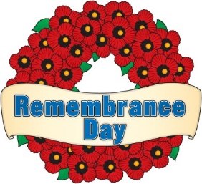
REMEMBRANCE DAY SERVICE

Bowsman School will hold its school service on Tuesday, November 10^{th,} at 10:30am. Parents are welcome to join us in the gym at this time.

NO SCHOOL Wednesday, November 11th


PARENT/TEACHER DAY

This year we will be having Parent/Teacher interviews on
Thursday, November 19th 4:00-6:00pm & Friday, November 20th 9:30-11:45am
Parents can choose between in-person or phone interviews on these two days.

Report cards will be sent out electronically, along with a paper copy; please ensure your email address is up to date. Your child’s MET number is needed as a password (it can be found on past report cards, the online portal, or by calling the office.)

For any questions, to update your email address, or to book an appointment, call 734-4506. Appointment times will be given to those parents who do not book ahead, teachers will phone during that time.

There is NO SCHOOL for students on FRIDAY, NOVEMBER 20th


Lion’s Vision Screening will be held the morning of November 23rd
for students in Grades K, 1,3,5 & 7

$5 HARVEST LUNCH

Bowsman School will be enjoying a delicious
Harvest Lunch
Wednesday, November 25th
The school will be served a full turkey dinner prepared by the SVRSS.
The meal will include turkey, potatoes, stuffing, gravy, kernel corn, and a juice box.

This lunch will be $5 each (to cover part of the cost).
Order forms and money will be due Monday, November 23rd

BISON NEWS
Volleyball development days, October 15th and 28^{th,} were great learning experiences for the Grade 6,7 & 8s. Their final volleyball day will be on November 25^{th,} at the SVRSS, from 10am-3pm. There will be mini volleyball for the Grade 5s on November 26th and the Grade 6s on November 27th, both at the SVRSS from 5-8pm.
**Students who do no participate in extra-curriular sports, are expected to attend school on Sports Days, as classes carry on as usual**
FUNDRAISER FUN

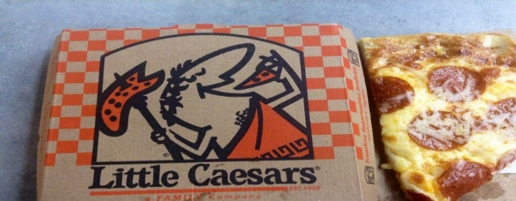
The Bowsman School Parent Volunteer Group is hoping to raise funds towards playground equipment and student outings by selling Little Caesars pizza/products. Forms will be sent home Thursday, November 12th. Online orders will be accepted as of today .

NO LATE ORDERS WILL BE ACCEPTED

ONLINE ORDERS ARE DUE Sunday, November 22ND
Group ID # 150322 Fundraiser ID #479878
FUNRAISING FORMS ARE DUE back Monday, November 23rd
DELIVERY DATE IS MONDAY, DECEMBER 7TH

Better Beginnings in Bowsman
Who: Jill Shaw Email: jshaw@svsd.ca
When: Tuesdays 9:45-11:15am (start date: Oct 27)
What: program for children and families (pre school age)
Where: Co-Regulation Room and Gym

Better Beginnings is a Swan Valley program that supports the health and learning development of prenatal to age 5 children and their families. Recent studies have shown that the years from birth to five years old are the most important in a child’s growth.
A child's activities during this crucial period can determine how the child's brain is wired. This wiring lays the groundwork for how the child will get along and learn later in life.
Better Beginnings is a partnership of community service organizations whose goal is to create a positive and nurturing environment that allows a child to develop to their fullest potential by providing an effective networking and referral system. The program is funded through the Province of Manitoba - Healthy Child in conjunction with the Swan Valley School Division.
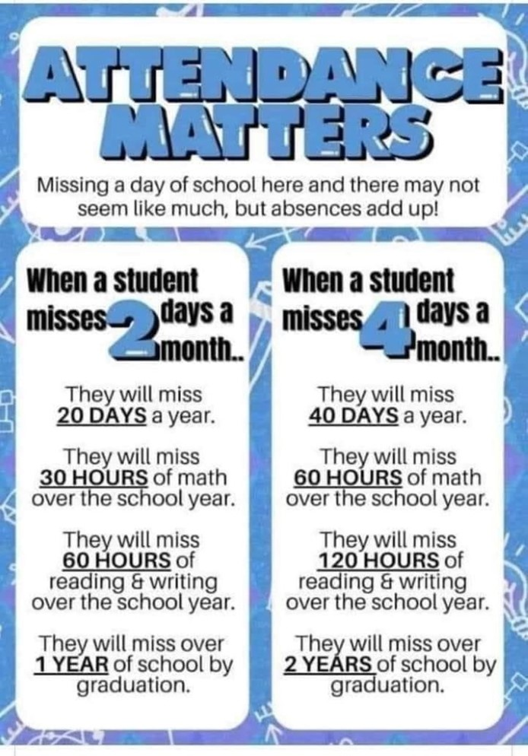

This newsletter (or… document) is available in alternate formats upon request.

A Contest for Bowsman School students only!
1st prizes are $20, 2nd prizes are $15, contest closes Nov.9th!


