BOWSMAN SCHOOL
NOVEMBER NEWS 2025

THINGS TO REMEMBER:
Important
Dates to Remember:
Nov 2nd – Time Change
Nov 10th – Remembrance Day Service 10:45am
Nov 11th – No School – Remembrance Day
Nov 13th – FREE Harvest Lunch
Nov 20th - Little Caesars forms DUE
Nov 20th – Parent Teacher interviews 4-6pm
Nov 21st – No School – Parent Teacher Day interviews 9:30-11:45am
Nov 26th – FREE Sloppy Joe Lunch

** All students in grade K-6 are expected to go outdoors for recesses and lunch hours. Please dress for the weather

**Please phone the school to let us know when your child/ren will be absent from school, even when their bus is cancelled

**All doors will be locked during the day. Parents/Visitors are asked to ring the doorbell to enter the school

**Parents are encouraged to park away from the school bus route when dropping off and picking up their children. If you are meeting your child, please have a designated pickup spot outside

**Town students who do not bring a lunch must go home for lunch

**Please check weekly for head lice**

DON’T FORGET TO CHANGE YOUR CLOCKS
NOVEMBER 2nd FALL BACK

REMEMBRANCE DAY SERVICE

Bowsman School will hold our school service on Monday, November 10th at 10:45am. Parents are welcome to join us in the gym at this time. NO SCHOOL November 11

HARVEST LUNCH

Bowsman School will be enjoying a delicious Harvest Lunch
Thursday, November 13
The school will be served a full turkey dinner prepared by the SVRSS.
The meal will include turkey, potatoes, stuffing, gravy, kernel corn, and a juice box.

This lunch will be free of charge to all students and staff.

For those students who go home for lunch, please plan to stay this day.
For those students who do not want turkey dinner, bring your own lunch as usual.

FUNDRAISER FUN

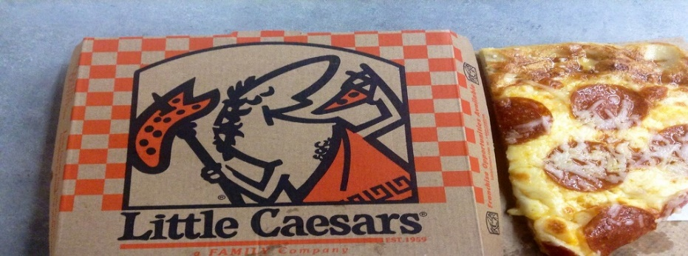
The Bowsman School Parent Volunteer Group is hoping to raise funds towards playground equipment and student outings by selling Little Caesars. Fundraising forms will be due back Group ID # 150322 Fundraiser ID #461358 November 20th

PARENT/TEACHER DAY

This year we will be having Parent/Teacher interviews on
Thursday, November 20th 4:00-6:00pm & Friday, November 21st 9:30-11:45am
Parents can choose between in-person or phone interviews on these two days.

Report cards will be sent out electronically this year, please ensure your email address is up to date. Your child’s MET number is needed as a password which can be found on past report cards, the online portal, or by calling the office.

For any questions, to update your email address, or to book an appointment, call 734-4506. Appointment times will be given to those parents who do not book ahead, teachers will phone during that time.

There is NO SCHOOL for students on FRIDAY, NOVEMBER 21st
HOT LUNCH – WEDNESDAY, NOVEMBER 26TH

The school will provide a free hot lunch for all students and staff.
Menu will be Sloppy Joes with Carrot sticks and juice box.

BISON NEWS
Volleyball development days October 16th and 29th were great learning experiences for the Grade 7 & 8s. *Revised* Their final volleyball day will be on November 25th at the SVRSS from 10am-3pm. There will be mini volleyball for the Grade 5s on November 26th and the Grade 6s on November 27th, both at the SVRSS from 5-8pm.
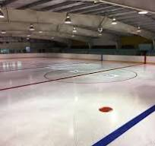
Bowsman Community Skating Arena Club
Annual General Meeting
Thursday, November 6th, 7pm at the Rink
Everyone welcome - Anyone interested in volunteering is encouraged to come!


Better Beginnings in Bowsman
Who: Jill Shaw
When: Tuesdays 10:00-11:30am (start date: Oct 20)
What: program for children and families (pre school age)
Where: Co-Regulation Room and Gym

Better Beginnings is a Swan Valley program that supports the health and learning development of prenatal to age 5 children and their families. Recent studies have shown that the years from birth to five years old are the most important in a child’s growth.
A child's activities during this crucial period can determine how the child's brain is wired. This wiring lays the groundwork for how the child will get along and learn later in life.
Better Beginnings is a partnership of community service organizations whose goal is to create a positive and nurturing environment that allows a child to develop to their fullest potential by providing an effective networking and referral system. The program is funded through the Province of Manitoba - Healthy Child in conjunction with the Swan Valley School Division.

Fall skills/Player ID camp
Sunday, November 9
Hudson Bay Community School Gym
Girls(gr 6-12)/Jr. boys(gr 6-8): 9-11am, 2-4pm
Sr boys(gr 9-12): 11am-1pm, 4-6pm
Cost: 60.00 per athlete due before they hit the court, payable by cash or E transfer to coachsalmond@gmail.com
Registration forms can be filled out the morning of the camp or are available from Coach Salmond or Coach Morin via email. Please inform either Coach Salmond or Coach Morin by November 1st of your attendance so sessions can be planned accordingly. They can be reached at coachsalmond@gmail.com (3068657729) or hbmorin@gmail.com (3062601594)
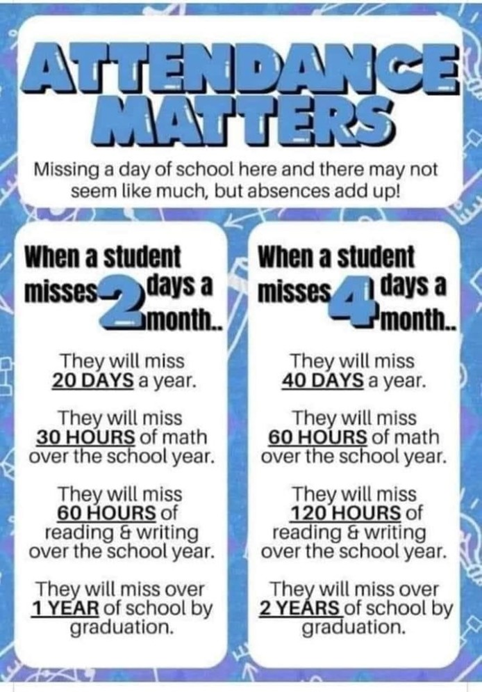
This newsletter (or… document) is available in alternate formats upon request.

