
BOWSMAN SCHOOL NEWSLETTER

Dates to Remember:


May 8th – Pancake Breakfast Fundraiser
May 14th – Meatball Hot Lunch
May 18th – Victoria Day - No School
May 22nd – Sunburn Classic (grades 5-8)
May 27th – Chicken Fingers & Fries Lunch

Spring Time Outdoors

Please dress appropriately for the weather! Warm outdoor clothing for the mornings is encouraged, along with rubber boots for the water and mud.
All students need to make sure they have a change of clothes or two.

KINDERGARTEN REGISTRATION
It’s that time of year again – it is time for you to register your child for kindergarten.

If you have a child, or know of someone in our area who has a child who will be 5 on or before December 31st of this year, please encourage them to contact the school to arrange to register their child for kindergarten as soon as possible.

Parents:

Is your contact information up to date in your child’s records? Please ensure the school has your current phone number and email address so that you can be reached or important information can be sent to you in a timely manner.
Did you know that Bowsman School has a parent fundraising volunteer group?
Just some of the things parents have done for our students over the years:
- Held hot dog and hamburger lunch sales
- Helped set up, serve and clean up annual pancake breakfast
- Purchased Kinder Grad T-shirts and Grade 8 Grad hoodies
- Sponsored ski days to Thunderhill for grades 4-8, as well as many other initiatives
Please consider helping all our Bowsman School students and staff with your time. If you have any questions, please contact Mrs. Sutherland.
GRADE 8 TRIP

The grade 8 class had their annual trip March 27th, before their teacher, Mrs. Barker, went on her maternity leave. The whole day was packed full of fun activities close to home. The van full of students began their trip by stopping in at Giant Tiger to pick up snacks for their movie planned for later that night. A Fox and Feather Pottery class was the next stop. Students were able to work on a project, many of which may be a gift for a special lady on May 10th. The Dairy Queen was the class choice for lunch, as everyone wanted ice cream! Up Your Alley Bowling was up next where everyone randomly played 5 rounds against each other. Glow bowl with crazy moves was a favorite! Swimming at the Westwood Inn pool followed to cool off after their bowling workout. Supper at Northern Lites eatery was enjoyed by all, where everyone got a chance to talk about their favorite parts of the day so far. The final stop of the day was back to school for a movie night with popcorn and snacks. The movie soon turned into a game of hide and go seek in the darkness of the school. This was probably the highlight of the day! Best wishes go out to Mrs. Barker and her soon to be little bundle of joy!!

BADMINTON

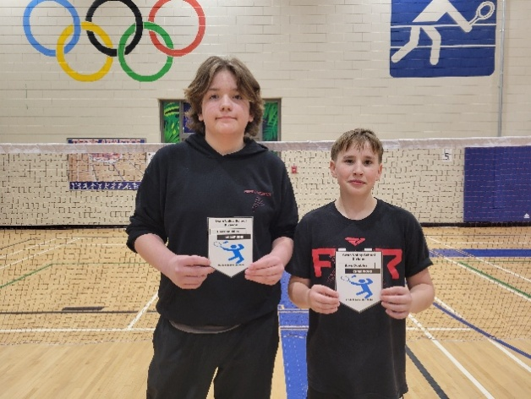
Congratulations to all badminton players who competed in the grade tournaments. Extra congrats to Tori for girls doubles runner-up, to Peyton and Alex for their first-place championship in boys doubles, to Hayden for his runner-up place in boys singles, to Kae-lynn and Aubree for placing second in girls doubles, and to Kae-lynn for her girls singles championship. Valley Championships were equally successful! Hayden and Ryder were boys doubles champs, while Kae-lynn was the girls singles champ. Way to represent our Bisons!
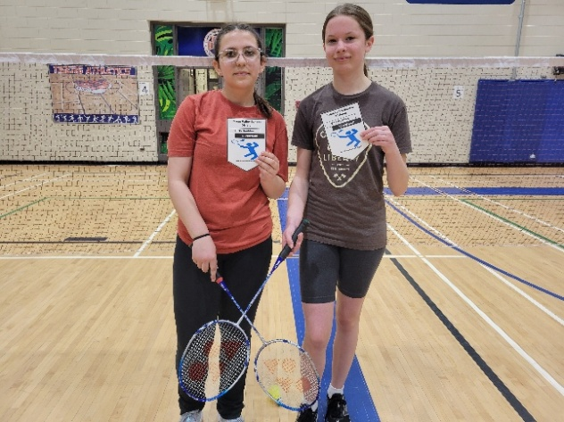

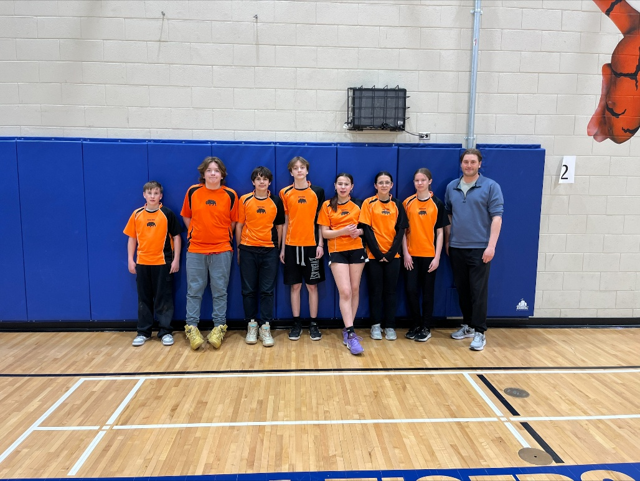

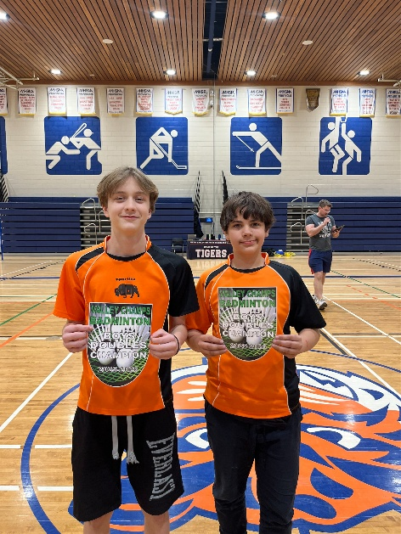
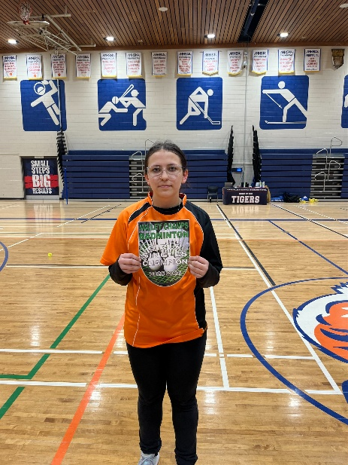

Annual Mother’s Day Pancake Breakfast
All students and community members are welcome to take part in our Pancake Breakfast Fundraiser on Friday, May 10th, from 8:00am – 10:00am. This will include pancakes, sausages, and a drink. Students will be preselling tickets, as well as tickets will be available at the door. Pre-order forms, to skip the line, are due by May 7th! Bowsman School students’ tickets have been sponsored by Swan Valley Funeral Services. Thank you to them for their generosity! Students will attend the breakfast with their class at 9am, unless they have eaten with their families earlier. This fundraiser is to help support the Grade 8 year end trips, along with our school year-end endeavours.
Skip the line! Get your pre-order ticket form in today!
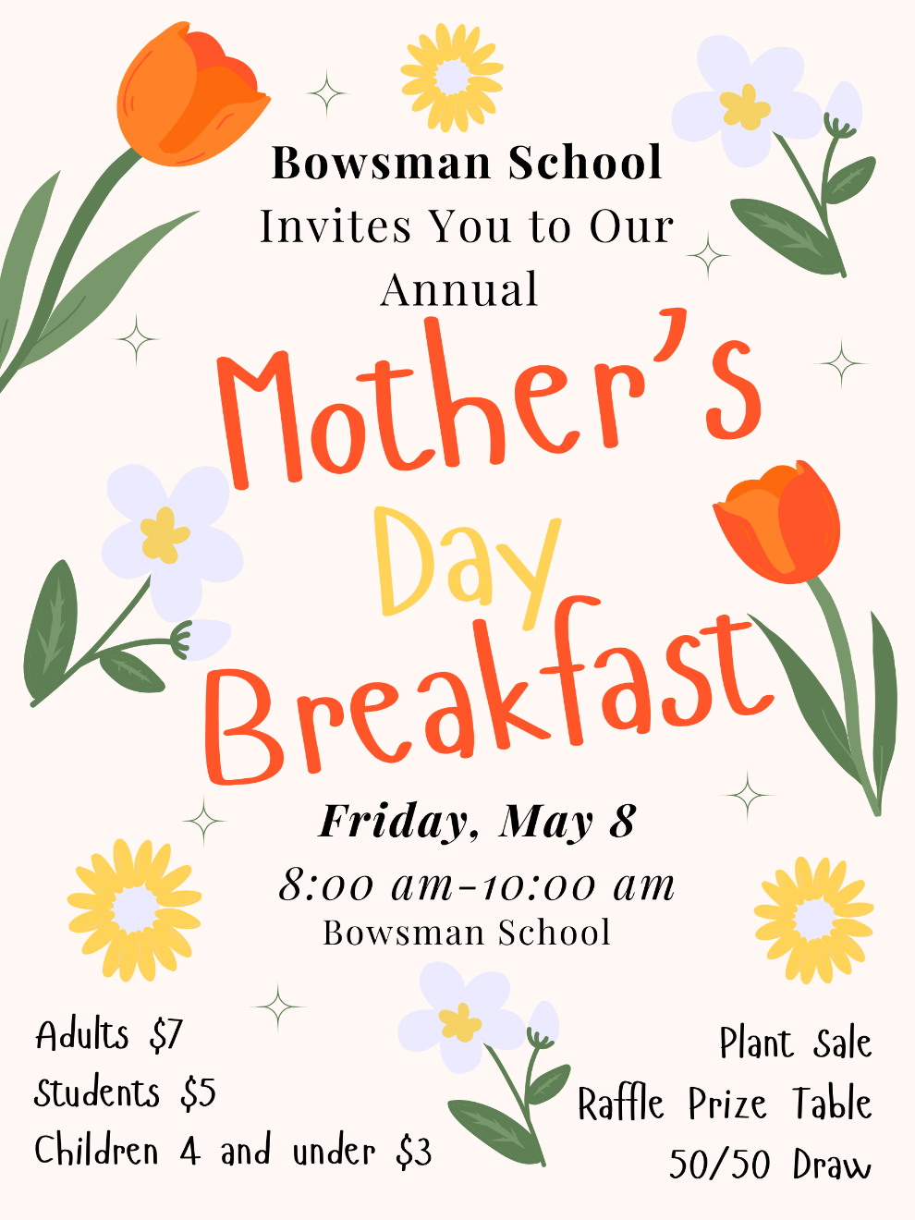



Community Plant Swap

A community plant swap will be held Friday, May 8th during our Mother’s Day Breakfast. We invite everyone that can, to bring flowers or plants that could benefit others – like shoots ready for replanting or homegrown plants. Please bring these to the school, where they will be sold as part of our fundraiser. This is a great way to share the joy of gardening while supporting our event!
If you have any questions, please email: csutherland@svsd.ca

FREE HOT LUNCH

Sweet and sour meatballs, hash brown casserole & corn hot lunch will be held Thursday, May 14th for all students and staff. Please bring your own lunch if you don’t want to participate.


NO SCHOOL REMINDER

No school on May 18th – Victoria Day

SUNBURN CLASSIC


On Friday, May 22nd, our Grade 5 – 8 students will be participating in the annual Sunburn Classic Track & Field Meet. SVRSS 10AM-3PM
Student transportation is provided by the division.
Come out to cheer on your child!

FREE HOT LUNCH
A hot lunch for chicken fingers and fries will be held on Wednesday, May 27th for all students and staff. Please bring your own lunch if you do not want to participate.

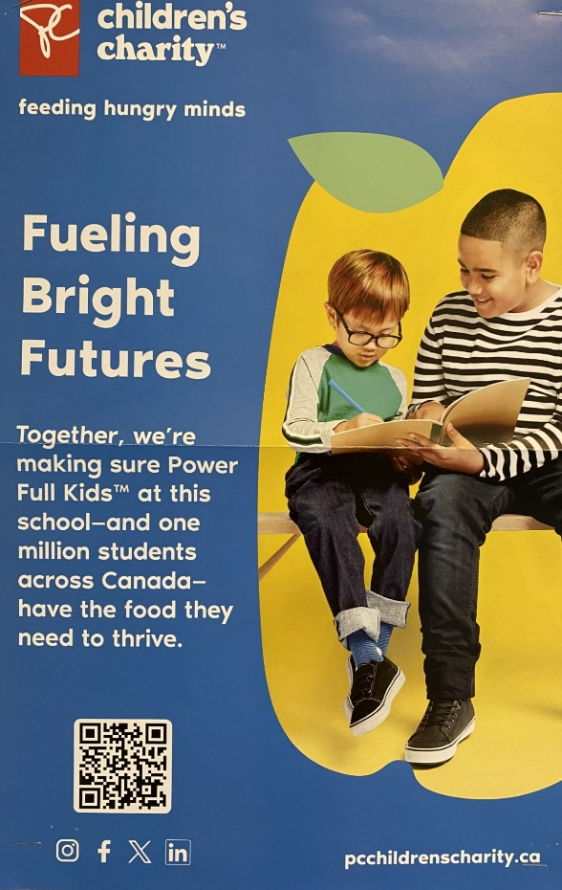
SNACK PROGRAM RECOGNITION
Thank you to PC Children’s Charity for their generous grant towards our snack program!
Thank you to the NELLO grant named for Nello Altomare the MB education and childhood learning minister. He oversaw the development and execution of Canada’s first universal school food program, which delivers food to every child in Manitoba’s public schools. The vision for the program was to ensure no child in a Manitoba classroom went hungry and it was a key part of the Manitoba government’s mandate to build an education system where every child is set up for success.

And thank you to Child Nutrition Council of Manitoba Grant! The Child Nutrition Council of Manitoba is a charitable organization dedicated to helping Manitoba school children learn, grow, and succeed by supporting our breakfast, snack and lunch programs.

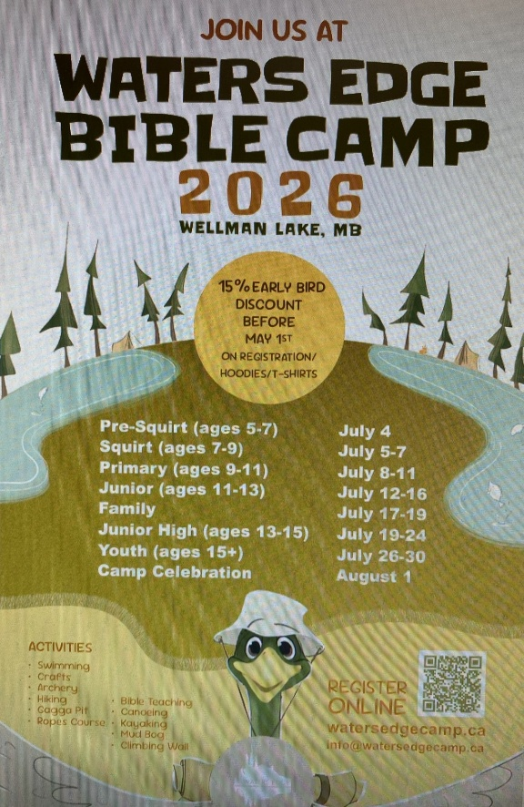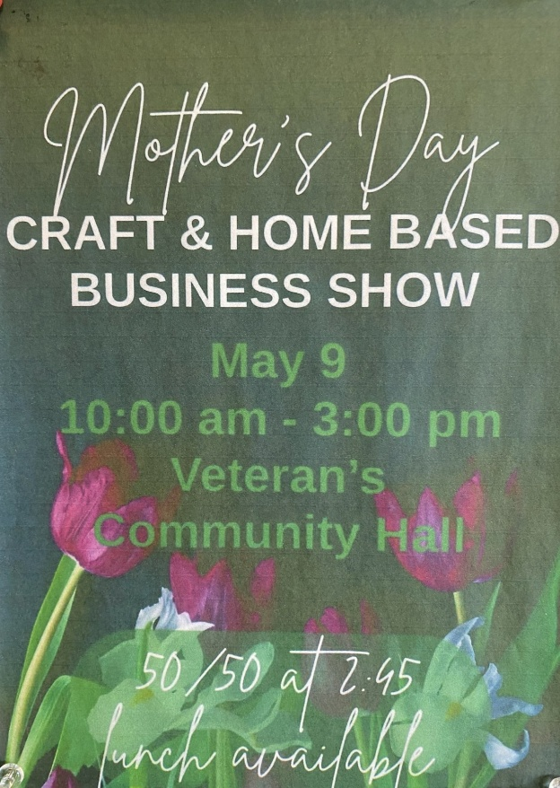

“This newsletter is available in alternate formats on request.”

