
BOWSMAN SCHOOL JUNE NEWSLETTER 2026



KINDERGARTEN 2026-2027
Do you have a child that will be 5 years old on or before December 31, 2026
who would be attending Bowsman School in the fall? Then it is time to register!
Stop in to fill out a registration form or download it from the division website.
Proof of age (Government issued ID), and/or a Manitoba Health
Number MUST BE PRESENTED.
Please contact the school at 204-734-4506 with any questions!



MOTHER’S DAY LUNCH
Our Mother’s Day Breakfast in May was a huge success!
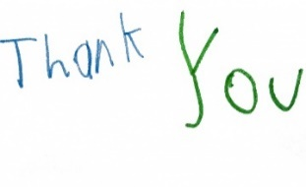
We would like to send a big THANK YOU to the following businesses for their breakfast donations: Swan Valley Funeral Services (Bowsman School meal tickets), Richardson Pioneer (sausages), P & H (pancake mix), and Swan Valley Co-op (supplies). We would like to also thank everyone for donating towards our raffle table and for bringing plants for the sale. And last but not least, to the Bowsman & District Lions Club for cooking the pancakes and sausages.
Approximately 350 people were served during this great school and community event!

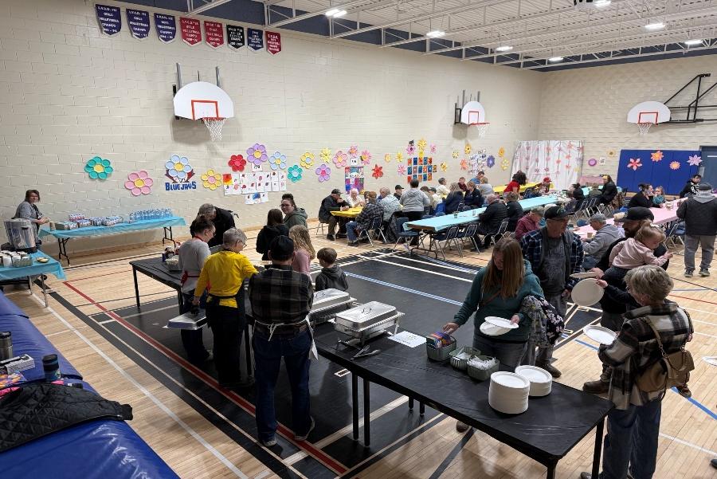
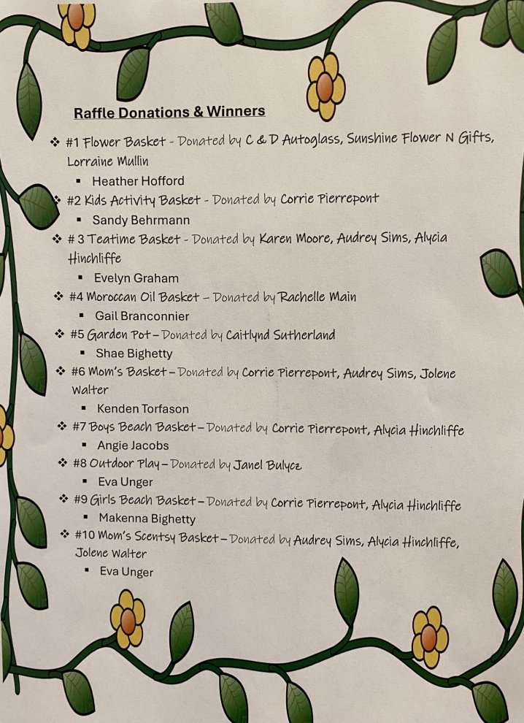
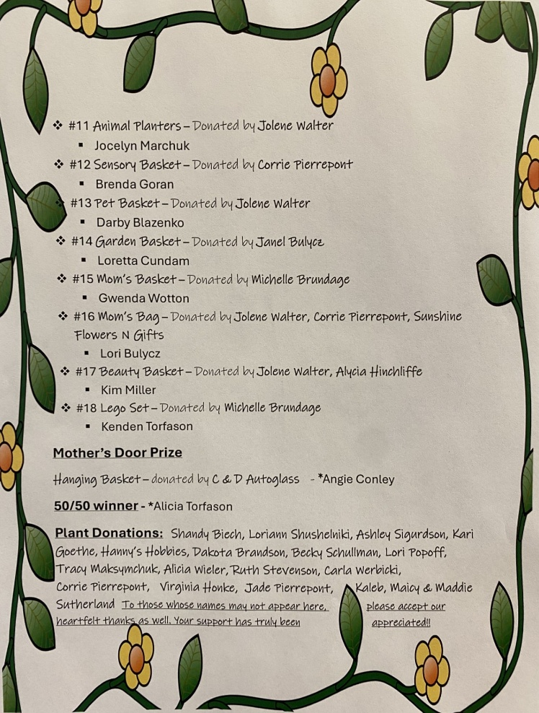
Sunburn Classic
Grade 5 to 8 students from across the Valley gathered at the SVRSS grounds to take part in the annual Sunburn Classic Monday, May 25th. A variety of running events, in addition to high jump, long jump/triple jump, discus throw and shot-put kept students moving from event to event throughout the day. Bowsman School students represented their school well, bringing back several ribbons from different age categories! Primary: Liana – 1st – 400m; Intermediate: Bennett – 2nd – 50m, 100m, 1st – 200m; Ashley – 2nd – shot put; Junior: Alex - 3rd - high jump; Tori – 2nd – Shot put; Senior: Aubree H. – 2nd – 100m, triple jump, 3rd – triple jump; Hayden - 1st - long jump, triple jump, 50m, 100m and 4x100m (with CBF team). Way to represent Bisons!


CLASSROOM FIELD TRIPS

Each classroom has different events planned, so please watch your child’s agenda and the school calendar for more information.

TRACK AND FIELD VALLEY CHAMPIONSHIPS

June 5 at SVRSS 10am-3pm for certain students

K-GRADE 3 EMERGENCY EMS DAY, JUNE 10th

Details and permission forms to follow

LIBRARY BOOKS DUE THURSDAY, JUNE 11TH


Please take the time to go through your homes to look for any Bowsman School property, such as missing textbooks, novels, etc. Lost books will be charged to the students.

GRADE 4/5/6/7/8 FISHING AT WHITEFISH LAKE, JUNE 12TH

Details and permission forms to follow

NATIONAL INDIGENOUS PEOPLES DAY

National Indigenous Peoples Day (June 21st) will be celebrated at the Legion Park on
Tuesday, June 16th from 10am-3pm. More information will follow once plans are confirmed.

THE LAST DAY FOR HEALTHY SNACK WILL BE ON JUNE 18TH

Parents are reminded to send extra snacks in your child’s lunch bag for the last days of school.

Thank you to President’s Choice, to the Child Nutrition Council of Manitoba, and to the Provincial Nutrition Grant NELLO for supporting our school.
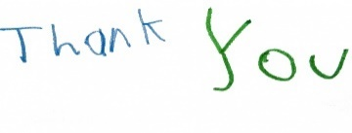
Thank you to the SVRSS cafeteria, Qwik Stop, Julie Nahnybida, and Bowsman Hotel for making some of our delicious snacks and lunches throughout the year!

Shout out to Chintan and Arpita Parmar from the Bowsman Hotel who provided and donated our last hot lunch of the year! chicken finger and french fries was a favourite for everyone!!


NO SCHOOL FRIDAY, JUNE 19TH

TABLOID DAY

All day school event being held Wednesday, June 24th
Families are welcome to watch the outdoor events
Stay tuned for more information
KINDERGARTEN RECOGNITION


The kindergarten class will be recognized for their achievements
Friday, June 26 at 11:00am before the family BBQ.
Miss Klatt would like to congratulate her Kindergarten students for a great year.
Good Luck and have fun in grade 1.


Beau, Theo, Larry, Violet, Bravery, Courage, Beau-Jack, Leroy, Maelynn, Maddison, Landen, Jaxson, & Max!

GOOD LUCK TO OUR GRADE 8 STUDENTS

We will be saying good-bye to our Grade 8 class.
Good luck in all your future plans.

Congratulations to the following students:

Soaring Eagle, Hayden, Kae-lynn, Dumas, Courtney, Rihanna, Peyton, Aubree, Aaron, Ryder, & Kenden!

The Grade 8 class will be recognized for their achievements
Friday, June 26 following the Kindergarten recognition

FAMILY BBQ

Please join us on Friday, June 26th at 11:45 for a Family BBQ lunch.
Bring your lawn chair or blanket and celebrate with us as we welcome summer break.

REPORT CARDS

Report cards will be sent out by email Monday, June 29, unless a paper copy is requested.


Office will be open August 26th & 27th, and September 3rd, 4th, 8th & 9th for any registration needs! Summer Hours 9am – 3pm

SCHOOL RESUMES ON THURSDAY, SEPTEMBER 10TH



^{k}

“This newsletter is available in alternate formats on request.”
