

BOWSMAN SCHOOL
APRIL NEWSLETTER
2026

IT’S REGISTRATION TIME!!

It’s Kindergarten registration time! If you have a child, or know someone with a child, who is turning 5 on or before December 31st, it’s time to sign up for school!

Registration forms can be filled out at school, can be found online, or we can also email the form to you.

Please bring a birth certificate or medical card for age verification.

Thunderhill Ski Trips
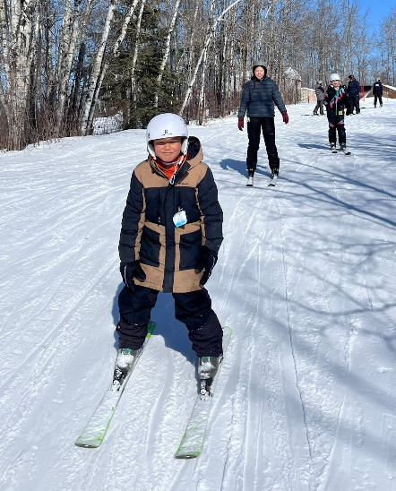
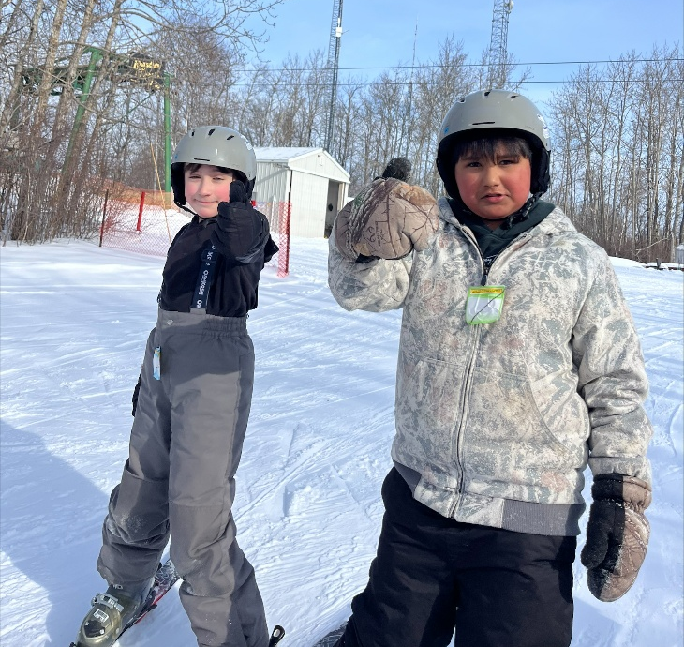
A group of Grade 4- 8 students had another great time on the hill!

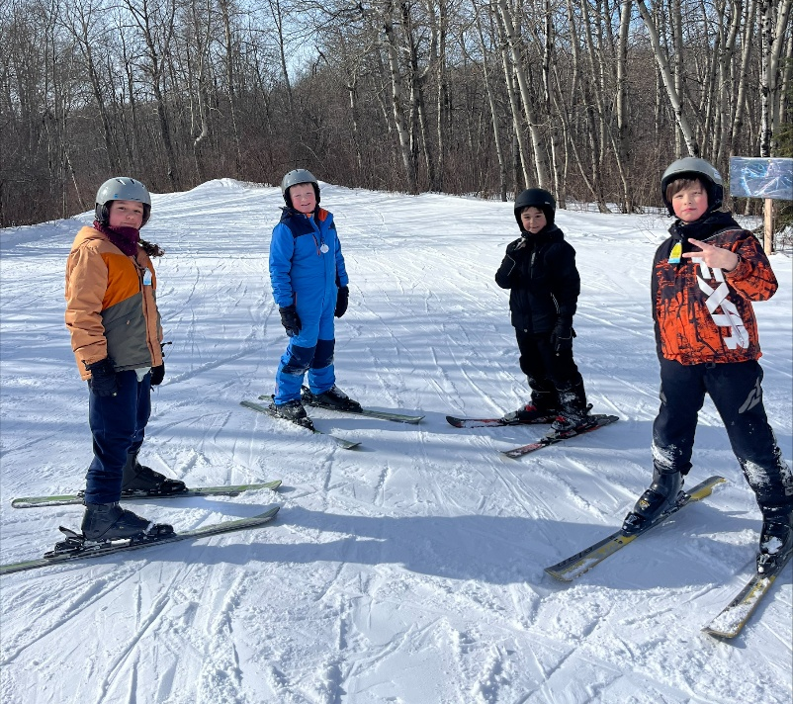

UNDERGROUND SPIRIT WEEK
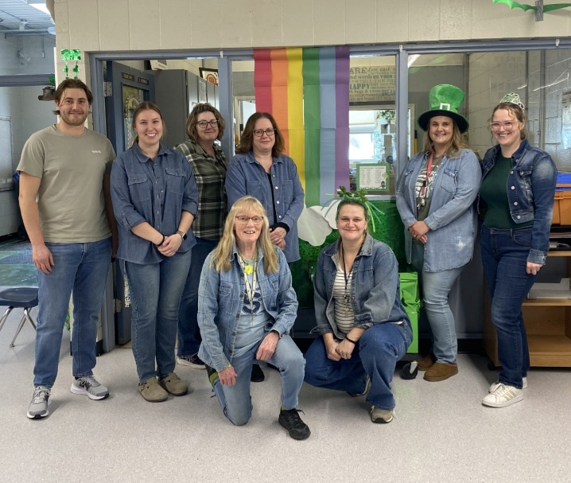
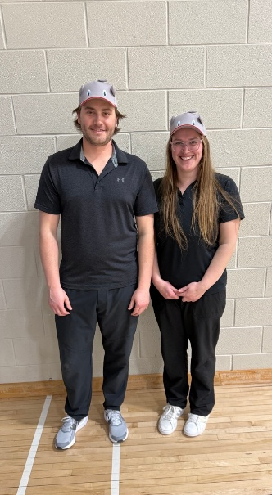
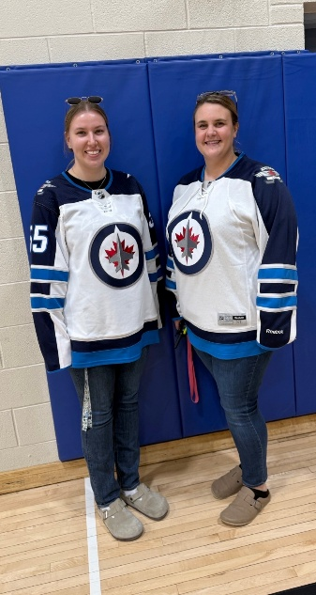
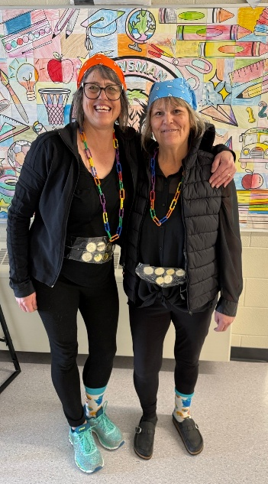
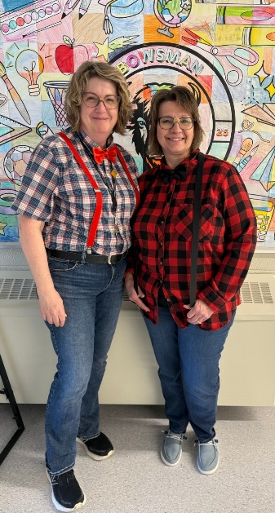
The Bowsman School Staff had a blast the week of March 16 for their Underground Spirit Week. Many students wondered why the teachers were going crazy! Crazy socks, denim, twins, tattoos, and fancy dress. Such fun!
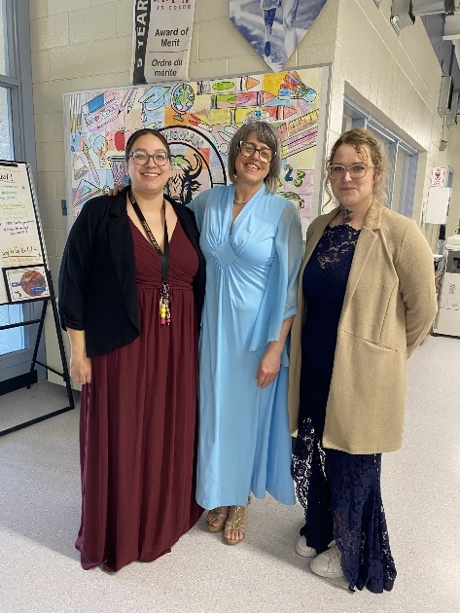

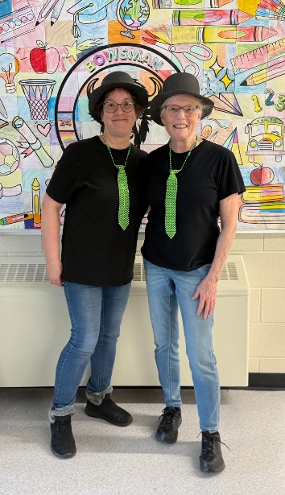
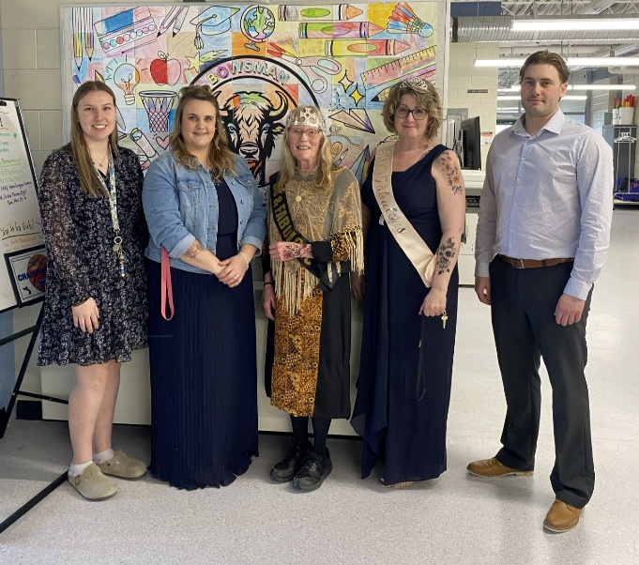




IMPORTANT APRIL DATES
April 9 – Free Ham & Perogy Lunch
April 14 – Gr 6 Public Health Immunizations
April 14– Gr 7 Badminton 5-8pm
April 15 – Gr 8 Badminton 5-8pm
April 17 – PD Day – No School
April 21 – Gr 5 Badminton 5-8pm
April 22 – Gr 6 Badminton 5-8pm
April 23 – Free Hamburger Soup Lunch
April 27 – Kindergarten Grad Photos
April 28 - Badminton Valley Champs

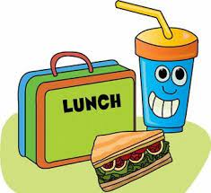
FREE Ham & Perogy Lunch APRIL 9th
Enjoy a FREE lunch of Ham, Perogies, SVRSS salad, and a bun catered by Julie Nahnybida
Bring your own lunch if this is not desired.
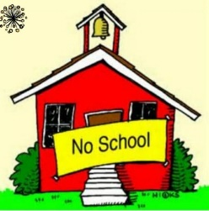

NO SCHOOL Thursday, April 17th ⁻ PD Day

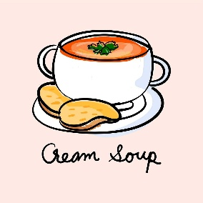
FREE Hot Hamburger Soup Lunch

Thursday, April 23rd there will be a free hot hamburger soup/bun lunch and drink provided to all students and staff of Bowsman School. Children can bring their own lunch if they do not want to participate.


KINDERGARTEN GRAD PHOTOS

On April 27th, PhotoVisions will be here to take our Kindergarten Grad Photos. Please ensure that your child has their own comb or brush for any “touch ups” that day.

LICE HEAD CHECKS

Please continue to carefully check your child’s head for lice or eggs. If they are found, you must treat your child with either a store-bought/Public Health remedy or home remedy. Resultz has been found to be the best treatment!!
Helpful Hint: use an LED light when checking for eggs/nits in your child’s hair. The LED light makes the eggs shine; therefore, they are easier to see and remove thoroughly.

If you find lice, your child should be treated today, again in one week and again the week following.

All eggs must be removed: please note: the nit comb that comes with the store-bought remedy does not remove all the nits. You must go through the hair strand by strand daily throughout the weeks after.

Please ensure that their bedding, etc. has been laundered in HOT water and any areas that your child has been near (mattress, couch, carpet, bed, toys, vehicle, etc.) is vacuumed thoroughly. Please be diligent in checking your child’s hair weekly, as we need to maintain a healthy environment for ALL our students.

Medication Administration

Swan Valley School Division acknowledges that certain students may require prescribed medication during the school day. If possible, the drug treatment regimen should be modified by the prescribing physician to eliminate the need for dispensing medications during school.
To request the administering of medication, the parent(s) must complete Part I of the Authorization and Administration Form and have their physician complete Part II. Part III will be completed by the school. The principal will designate a person to administer the medication. The original copy of the form shall be maintained in the school. Schools will refuse to administer prescribed medication to any child whose parents(s)/legal guardians(s) do not fully comply with this Administrative Procedure.
Medication must be delivered to the school by the parent/guardian or responsible adult in the original pharmacy container and in the proper dosage. If pills are to be taken in a dosage that is less than one pill, they must be cut to appropriate size before coming to school. Liquid medication must be accompanied by a measuring device which will provide the exact dosage.

Reminder to Parents: Bowsman School Guidelines
Cell Phone Use Kindergarten to Grade 8 students are banned from using cell phones during school hours, including breaks and lunch as per Manitoba Education

Students are encouraged to leave their cell phones at home. If students need to bring their cell phone to the school, they are to remain in their lockers for the entire day inside their backpack/jacket. Phones are not to be seen throughout the day. Should students not abide by the new Provincial Rule regarding cell phones, the following three strikes will be enforced:
1st cell phone sighting: REMINDER – students will be reminded to put their cell phone away and out of sight for the day
2nd cell phone sighting: WARNING – students will be warned that their cell phone will be put in the office for the remainder of the day if it is not put away properly for the day
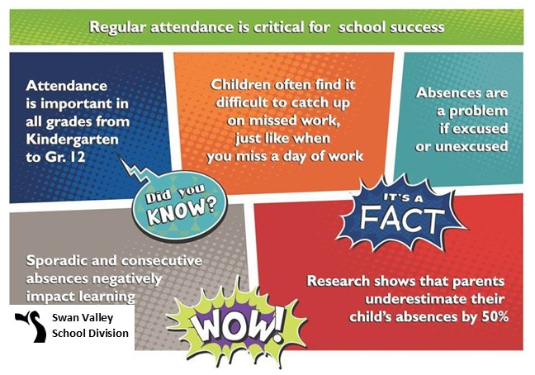
3rd cell phone sighting: OFFICE STORAGE - Students will have their cell phone placed in the office for the remainder of the day


Mother’s Day Breakfast 2026
Plans are underway for holding our annual Mother’s Day Breakfast Friday, May 8th, with sales going towards our class field trips and playground projects. Raffle prizes and plant slip donations are greatly appreciated! Parent volunteers are needed to help set up, serve, sell, and clean-up. Please contact the school if available to help in any way (record checks may have to be in place to do so).

HAVE A GREAT SPRING BREAK!
SEE YOU MONDAY, APRIL 6^{TH,} SCHOOL DAY 3

This newsletter is available in alternate formats on request.”

