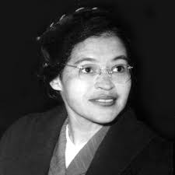
Rosa Parks
1913-2005
Rosa Parks was a civil rights activist who started the Montgomery Bus Boycott when she refused to give up her seat to a white passenger on a segregated bus.
“You must never be fearful about what you are doing when it is right.”

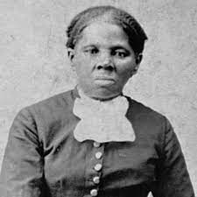

Harriet Tubman
1820-1913
Harriet Tubman was an escaped slave who led dozens of slaves along the Underground Railroad. She became known as the Moses of her People’ and it is believed she led approximately seventy slaves to freedom.
“There are two things I’ve got a right to, and these are, Death or Liberty.”
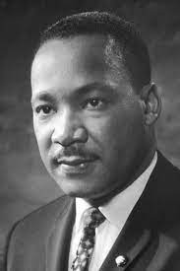
Martin Luther King Jr
1929-1968
Martin Luther King Jr. was a Baptist minister and activist who was a leader in the Civil Rights Movement. He won the Nobel Peace Prize in 1964 for combatting racial inequality through non-violent resistance.
“Faith is taking the first step even when you don’t see the whole staircase.”

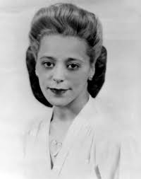
Viola Davis Desmond
1914-1965
Viola Desmond was a civil rights activist who refused to sit in the segregated area of the movie theatre and was put in jail for twelve hours and fined $26. She is the first Canadian woman to appear on a Canadian bank note.
“Do your little bit of good where you are. It’s those little bits of good put together that overwhelm the world.”
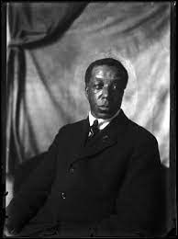
Billy Beal
1874-1968
Billy Beal was the first Black citizen in the Swan River Valley. He was believed to have medical training and helped local doctors administer vaccines.
“I’m not angry, I just want to start a riot in every street with my name on it, so I can say I’ve done something worth shouting about so I don’t have to face my untouched ceiling.”
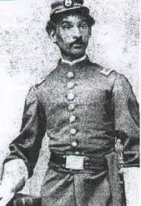
Anderson Ruffin Abbott
1837-1913
Anderson Ruffin Abbott was the first Canadian-born Black man to become a licenced physical. He was a writer and was committed to fighting against racially-segregated schools.
“It is just as natural for two races living together on the same soil to blend as it is for the waters of two tributaries to mingle.”
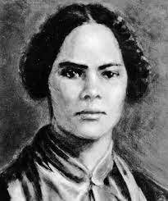
Mary Ann Shadd Cary
1823-1893
Mary Ann Shadd was the first Black woman to publish a newspaper, ‘The Provincial Freeman.” She was also an educator who established a racially integrated school.
“It is better to wear out than to rust out.”

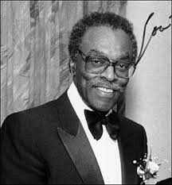
Lincoln Alexander
1922-2012
Lincoln Alexander was a lawyer who became the first Black member of Parliament and first Black federal Cabinet Minister.
“It is not your duty to be average. It is your duty to set a higher example for others to follow.”
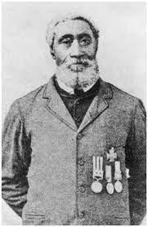
William Hall
1827-1904
William Hall was the first Black person to receive the Victoria Cross. As an officer in the Royal Navy, he secured a British garrison Lucknow, India.
“We go on and on about our differences. But, you know, our differences are less important than our similarities. People have a lot in common with one another, whether they see it or not.”

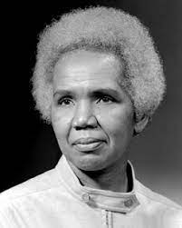
Rosemary Brown
1930-2003
Rosemary Brown was Canada’s first Black female member of a provincial legislature and the first woman to run for leadership of a federal political party.

“We must open the doors and we must see to it that they remain open, so that others can pass through.”
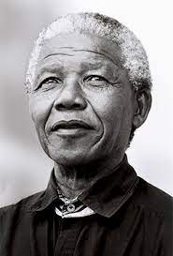
Nelson Mandela
1918-2013
Nelson Mandela was a political leader and philanthropist who served as the first president of South Africa from 1994 to 1999. He was the country's first black head of state
“Do not judge me by my successes, judge me by how many times I fell down and got back down again.”

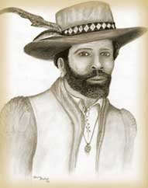
Mathieu de Coste
1589-1619
The first recorded Black person to arrive in Canada was an African named Mathieu de Coste who arrived in 1608 to serve as interpreter of the Mi'kmaq language to the governor of Acadia.
“People may hear your words, but they feel your attitude.” - Author: John C. Maxwell (about Mathieu de Coste)

