**BOWSMAN SCHOOL**

**OCTOBER 2025 NEWSLETTER**

**Important Dates to Remember:**

Oct 1st – FREE Hot Lunch

Oct 2nd – Parent volunteer meeting @ 5:30pm

Oct. 13th – No School – Thanksgiving

Oct.22nd – Qwik Stop Lunch

Oct. 24th – No School – SAGE -Professional Development

**PRINCIPAL MESSAGE**

I would like to take an opportunity to thank our entire school community of students, parents, and staff, for a great start to our school year!

****Welcome back and congratulations to Mrs.Broda (Miss Graham), and Mrs.Barker (Miss Vessey) who got married this summer.

Mrs. Sutherland

**A reminder to parents that we require your current address and valid phone number for our records, along with any other changes to your child’s file. This is especially important for emergencies, medical alerts, and permission consent for activities. Please ensure your registration form is up to date, filled out completely, and handed in as soon as possible.**

**THINGS TO REMEMBER:**

**The weather is beginning to get colder so students should be dressing warmly. All students are expected to go outdoors for recesses and lunch hours, Grade 7/8 have the option of staying in.

**Please phone the school to let us know when your child/ren will be absent from school, even when their bus is cancelled.

**All doors will be locked during the day. Parents/Visitors are asked to ring the doorbell to enter the school.

**Parents are encouraged to park away from the school bus route when dropping off and picking up their children. If you are meeting your child, please have a designated pickup spot outside.

**Parents are asked to ensure their children are in good health. If your child is ill, please do not send him/her to school.

**Please label all outdoor clothing items, as there is a large lost and found collection accumulating without names. **Mabel’s Labels are great for all belongings! **

**It’s that time of year – Check your child weekly for Head Lice!!**



**BISON NEWS**

***Terry Fox Walk***

The annual Terry Fox walk was held September 23rd. Students and staff were asked to bring a Toonie for Terry. Thank you to everyone who brought their change to be donated to this important cause.

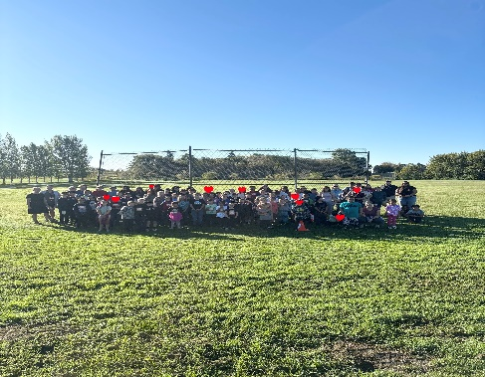

***Cross Country Run***

On a cool and mostly cloudy day of about 15 degrees, some Bowsman students showed great effort and determination at the recent cross-country run. Fourteen students proudly represented our school in the two-kilometre race, while one relay team of four completed the four-kilometre event.

It was a great day to run, and our students gave it their all from start to finish. A special congratulations goes out to **Hayden Church**, who placed **third** in the Grade 7/8 Boys category.

We are proud of all our runners for their hard work, sportsmanship, and dedication.

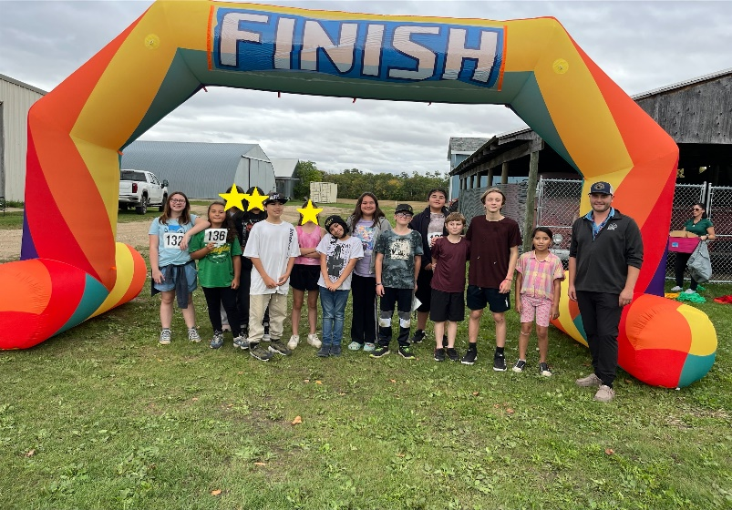 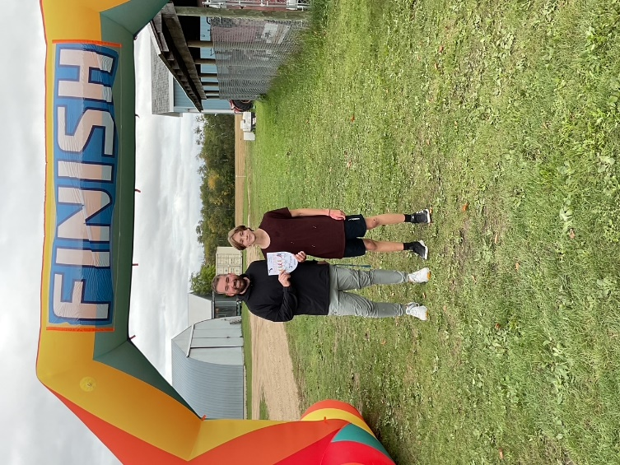

***Grandmother’s Walk***

The Grandmothers Walk was held September 25th, thank you to all the grandmas, kookums, babas and moms who joined us!

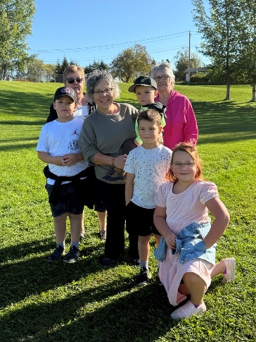 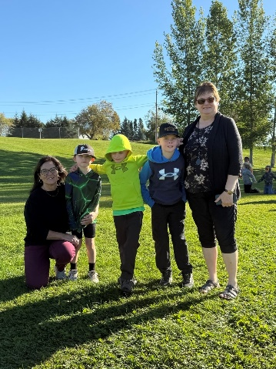 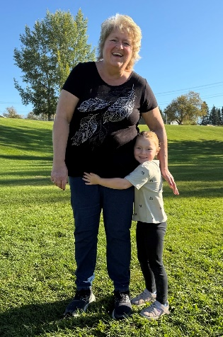 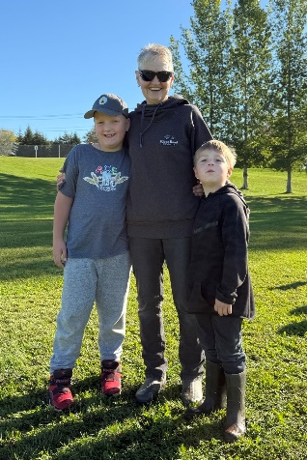

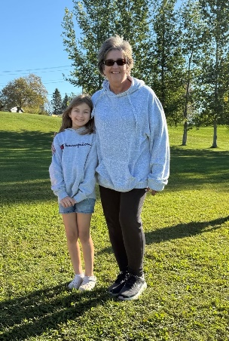 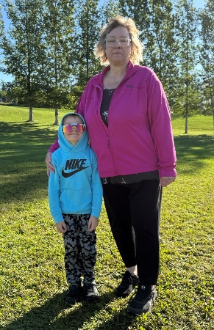 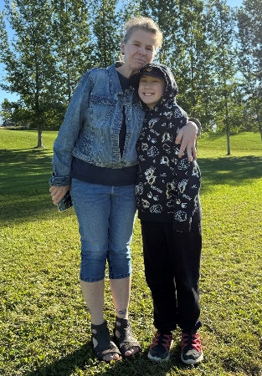 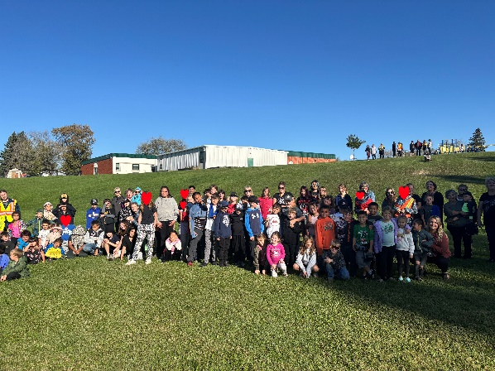



September 25th saw the Grade 5/6 students competing in the Valley-wide Soccer Jamboree held at the Rotary Sports Fields in Swan River. Swan Valley Soccer Championships were held all day September 26th. Good job, Bisons!

**ATTENTION PARENTS:**

There will be a **Bowsman School Parent Group** **Meeting** on **Thursday, October 2, 2025** **at 5:30pm** at the school for any parents interested in helping out at the school.

If you or a family member/ friend are at all interested in volunteering at the school throughout the year (in the classroom, during field trips, swimming lessons, big school events, etc.) you must complete a Child Abuse Registry Check as well as a Criminal Record Check. Mrs. Sutherland will have all forms ready to be filled out at the meeting, just need to bring 2 pieces of ID.

At the meeting we will also discuss upcoming projects and fundraising. Hope to see you there!

**NO SCHOOL – MONDAY, OCTOBER 13TH**

**HAPPY THANKSGIVING TO ALL**

**VOLLEYBALL**

Volleyball Development Days are planned at the SVRSS/ESRSS for October 16th and 29th from 10:00am- 3:00pm for those students who are interested.

**QWIK STOP LUNCH – WEDNESDAY, OCTOBER 22nd**

Orders forms will be sent out Wednesday, October 15th and need to be returned by Monday, October 20th.

**No late orders will be accepted.**



**NO SCHOOL**

**FRIDAY, OCTOBER 24th**

**PROVINCIAL WIDE PROFESSIONAL**

**DEVELOPMENT FOR ALL TEACHERS**

**BOWSMAN SCHOOL HALLOWEEN PARTIES**

We will keep you posted as more information becomes available on the celebration of this event.

**HARVEST LUNCH**

Plans are underway for a Harvest Lunch to be held in November

Please stay tuned for details

*This newsletter is available in alternate formats upon request.*