**BOWSMAN SCHOOL**

**OCTOBER 2023 NEWSLETTER**

**PRINCIPAL MESSAGE**

**Important**

**Dates to Remember:**

Oct. 9th – No School – Thanksgiving

Oct. 20th – No School – Professional Development

Oct. 25th – Qwik Stop Lunch

I would like to take an opportunity to thank our entire school community of students, parents and staff, for a great start to our school year!

Welcome to Ms. H. Vessey who is our new Grade 7/8 teacher, along with our new EAs, Ms. D. Deeks, Ms. C. Graham, Mrs. L. Mullin and Mrs. J.Rogers.

With Thanksgiving coming up, I hope that you are able to spend next weekend with those you are most thankful for and celebrate the things that you value most.

****Mrs. Shevernoha

**A reminder to parents that we require your current address and valid phone number for our records, along with any other changes to your child’s file.**

**This is especially important for emergencies, medical alerts and permission consent for activities. Please ensure your registration form is up to date, filled out completely, and handed in as soon as possible.**

**THINGS TO REMEMBER:**

**The weather is beginning to get colder so students should be dressing warmly. All students are expected to go outdoors for recesses and lunch hours.

**Please phone the school to let us know when your child/ren will be absent from school, even when their bus is cancelled

**All doors will be locked during the day. Parents/Visitors are asked to ring the door to enter the school.

**Parents are encouraged to park away from the school bus route when dropping off and picking up their children. If you are meeting your child, please have a designated pickup spot outside.

**Parents are asked to ensure their children are in good health. If your child is ill, please do not send him/her to school.



**NO SCHOOL – MONDAY, OCTOBER 9TH HAPPY THANKSGIVING TO ALL**

**SCHOOL PICTURE ORDER FORM**

Keep an eye out for School Picture proof packages that will be sent home once we receive them.

Please return order forms and money to school or order online by Due Date on packages.

**NO SCHOOL ON FRIDAY, OCTOBER 20th – PROVINCIAL WIDE PROFESSIONAL DEVELOPMENT FOR ALL TEACHERS**

**QWIK STOP LUNCH – WEDNESDAY, OCTOBER 25TH**

Orders forms will be sent out Wednesday, October 18th and need to be returned by Monday, October 23rd.

**BOWSMAN SCHOOL HALLOWEEN PARTIES**

We will keep you posted as more information becomes available on the celebration of this event.

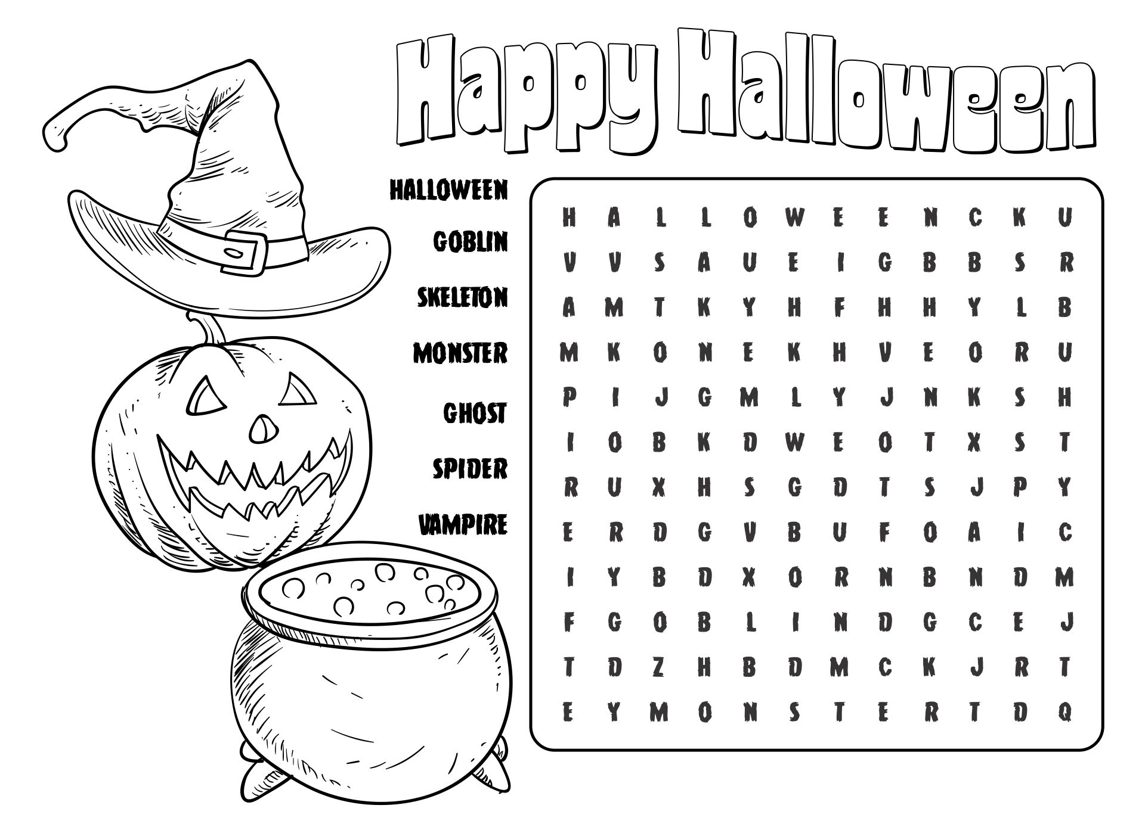

**ATTENTION PARENTS:**

Are you interested in spearheading school fundraisers or volunteering to help fundraise?

Would you be willing to help with some of the big school events?

If so, please attend a meeting, **Monday, October 30th at 5pm** at the school.

We will be looking to see who is interested and available, as well as to discuss potential fundraisers and events to benefit Bowsman School.

**REMEMBER – Check your child weekly for Head Lice!!**

**BISON NEWS**

Congratulations to our cross-country runners Alex, Marcel, Ethan and Aubree for completing the 2km run at the Swan Valley Museum September 22nd. Special mention to Ethan who came in 3rd for his age category!

 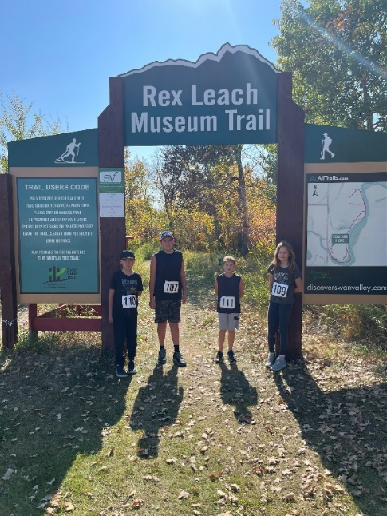 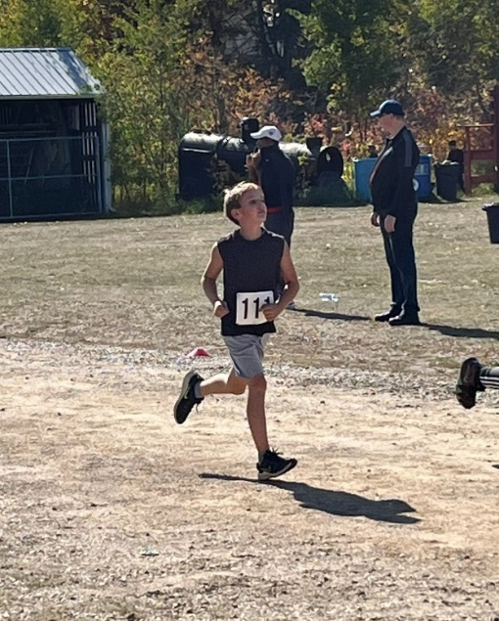

September 27TH saw the Grade 5/6 students competing in the Valley wide Soccer Jamboree held at the Rotary Sports Fields in Swan River. Good job Bisons! Swan Valley Soccer Championships have been rescheduled to Oct 6

Volleyball Development Days are planned at the SVRSS/ESRSS for October 4th from 1:30 – 6:00pm and 26th from 10:00- 3:00pm for those students who are interested

**BEGINNER BAND WORKSHOP (Grades 5/6/7/8)**

All Swan Valley band students are invited to participate in the Beginner Band Workshop October 13th and 14th at ESRSS. First year band students are asked to take part in this opportunity to get a strong start on their instrument and make their first year a success. Students will practice with instrument-specific clinicians and band instructors from the Swan Valley. ***There is no charge for this learning event.***At the end of the workshop, students perform a “mini concert” for family and friends. **In order to make this workshop run smoothly, a few parents are needed to help with chaperoning.** Please contact your child’s band instuctor if you can assist. Bowsman students, please return your blue Band form into Ms. Turton by Tuesday, October 3rd

**Friday, October 13th – 6:30 – 9:00pm**

**Saturday, October 14th – 9:00am – 12:00pm**

**Mini Concert at 11:30am**

**Location: ESRSS Swan River**

**INTRODUCING THE CO-REGULATION ROOM**

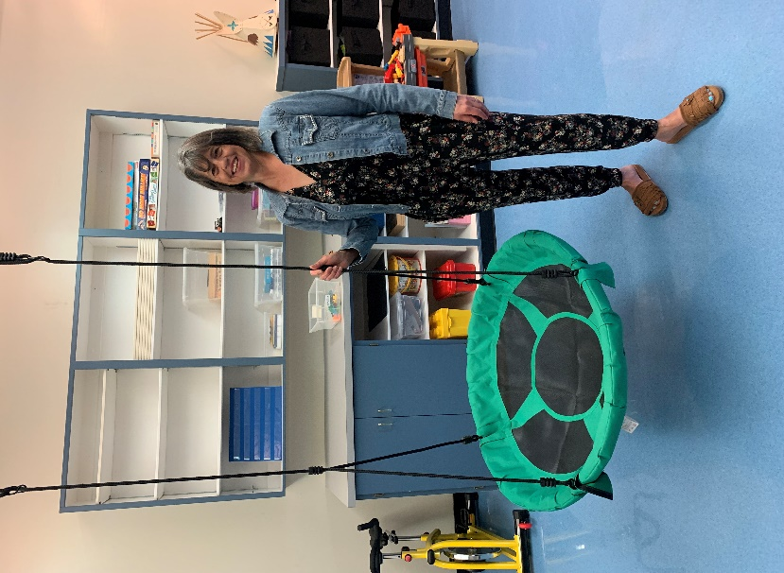Hi, my name is Mrs. Abrahamson and I was asked to manage the Co-Regulation Room in our school. This is a new program being used in all of the schools across the Swan Valley School Division. This room is for everyone, but some may need it more than others. It is not a form of punishment to come to this room, but is a safe place where students can come if they are having a rough day or need a brain break. They can choose a calm activity or something more active, depending what their body needs to help them regulate and get back to class ready to learn. It is our goal that this room will be a tool used to help them in their day and I feel privileged to be a part of that.

For more information, watch the following video on the SVSD website called “SVSD Therapeutic Schools” <http://www.svsd.ca/ci/p/4498>

~ Mrs. A ~

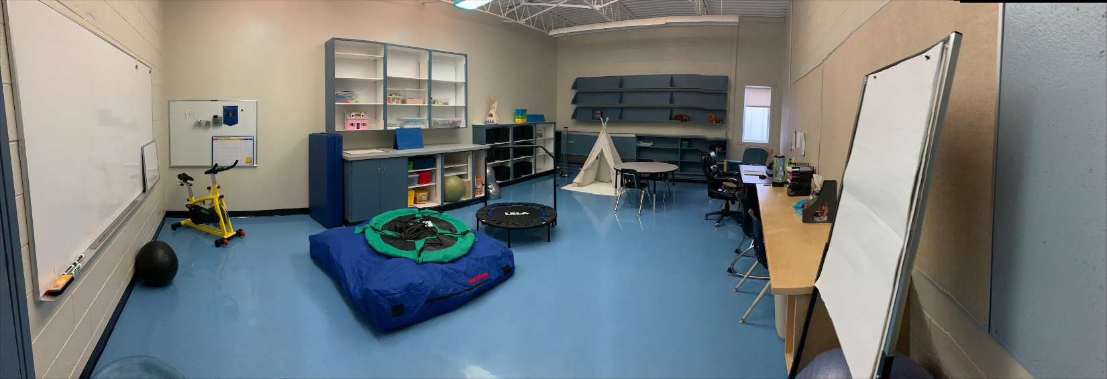

**HARVEST LUNCH**

Plans are underway for a Harvest Lunch to be held in November

Please stay tuned for details

