Sunday | Monday | Tuesday | Wednesday | Thursday | Friday | Saturday
 |  |  |  |  | 1  Day 3  Little Caesar’s Fundraising starts | 2
3  Time Changes  Move clocks back 1 hour   | 4  Day 4 | 5  Day 5  Swimming Gr 3,5,7  1-3:30 | 6  Day 6 | 7  Day 1  Swimming Gr 3,5,7  1-3:30 | 8  Day 2  Remembrance Day  Service @ 10:45
10 | 11  NO SCHOOL  Remembrance Day  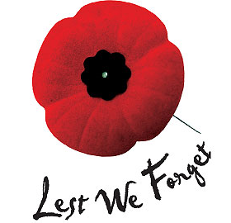 | 12  Day 3  Swimming Gr 3,5,7  1-3:30  Report Cards go home | 13  Day 4 | 14  Day 5  Vision Screening AM  HARVEST LUNCH  Swimming Gr 3,5,7  1-3:30  Little Caesar’s Fundraising DUE  Parent Teacher  Interviews 4-6pm | 15  NO SCHOOL  Parent Teacher  Interviews  9:30-11:45am | 16
17 | 18  Day 6 | 19  Day 1  Swimming Gr 3,5,7  1-3:30  Volleyball Final Day  SVRSS 10-3 | 20  Day 2  Mini-Volleyball Gr 5  SVRSS 5-8 | 21  Day 3  Mini-Volleyball Gr 6  SVRSS 5-8 | 22  Day 4 | 23
24 | 25  Day 5 | 26  Day 6 | 27  Day 1  Hot Lunch  Sloppy Joes | 28  Day 2 | 29  Day 3 | 30

