**WELCOME BACK TO SCHOOL!!**

**September 2025**

**Please read through this letter carefully and be sure that all forms are completed fully and returned to the school by Thursday, September 12th.**

**Principal’s Message**

Welcome back! Our staff are very excited to have all students back and starting a new school year. We are looking forward to the many activities and learning opportunities for students this year at Bowsman School.



[This Photo](https://freepngimg.com/png/61354-cute-kids-photography-61-playground-child-playing) by Unknown Author is licensed under [CC BY-NC](https://creativecommons.org/licenses/by-nc/3.0/)

Mrs. Sutherland

Principal

**2025 – 2026 Bowsman School Staff**

Mrs. C. Sutherland Principal

Miss. L. Klatt Kindergarten & Grade 1

Ms. C. Cook Grade 2 & 3

Ms. K. Hollier Grade 4

Mr. K. Bender Grade 5 & 6, K-8 Phys.Ed., 5-8 Math

Mrs. H. Barker Grade 7 & 8

Mrs. C. Pierrepont Resource Teacher, Grade 5/6 ELA & Social Studies

Mrs. E. Abrahamson Educational Assistant

Ms. C. Branconnier Educational Assistant

Mrs. J. Broda Educational Assistant

Mrs. V. Honke Educational Assistant, Librarian

Mrs. A. Jacobs Educational Assistant

Mrs. L. Mullin Educational Assistant

Custodian

Mrs. C. Werbicki Administrative Secretary

**BUS DRIVERS**



Thank you to all of our bus drivers for getting our students to and from school safely, each day.

Donna Farand #11 Richard Farand #24

Ferlin Abrahamson #15 Carolin Foster #25

Lori Watts #20 Brian Burick #26

Matt Black #23

**Morning Healthy Snack program will begin September 15th. Please send a healthy snack in your child’s lunch kit for the first week!**

**REMINDER: All students should stay home if not feeling well.**

**Please call the school if your child will be absent from school.**

***Please remember that now that we are back at school and your child is in contact with many other students, please check your child’s head weekly for head lice.***

# REGISTRATION FORMS

All students will have a registration and permission form package. Please make sure you have completed all the forms fully (both pages need parent signatures). **It is extremely important that all student have a primary and emergency contact with working phones. Bus students need to have a storm billet that lives near the school. Should your phone information change, please update the school as soon as possible.**

# SCHOOL PICTURES

On Friday, **September 19th**, Lifetouch, will be here to take our school photos. Please be sure that your child comes to school dressed for pictures at 9:00 a.m. Reminder: If you send a brush or comb along with your child, please emphasize the importance of NOT lending them to anyone else.

# EMAIL ADDRESS

# Our correspondence with parents/guardians will be primarily delivered via email. Please make sure that you have a valid email address listed on the registration form.

**Bowsman School Guidelines**

**Cell Phone Use *Kindergarten to Grade 8 students are banned from using cell phones during school hours, including breaks and lunch as per Manitoba Education***

 Students are encouraged to leave their cell phones at home. If students need to bring their cell phone to the school, they are to remain in their lockers for the entire day inside their backpack/jacket. Phones are not to be seen throughout the day. Should students not abide by the new Provincial Rule regarding cell phones, the following three strikes will be enforced:

**1st cell phone sighting:** **REMINDER**

**– students will be reminded to put their cell phone away and out of sight for the day**

**2nd cell phone sighting: WARNING**

**– students will be warned that their cell phone will be put in the office for the remainder of the day if it is not put away properly for the day**

**3rd cell phone sighting: OFFICE STORAGE**

**- Students will have their cell phone placed in the office for the remainder of the day**

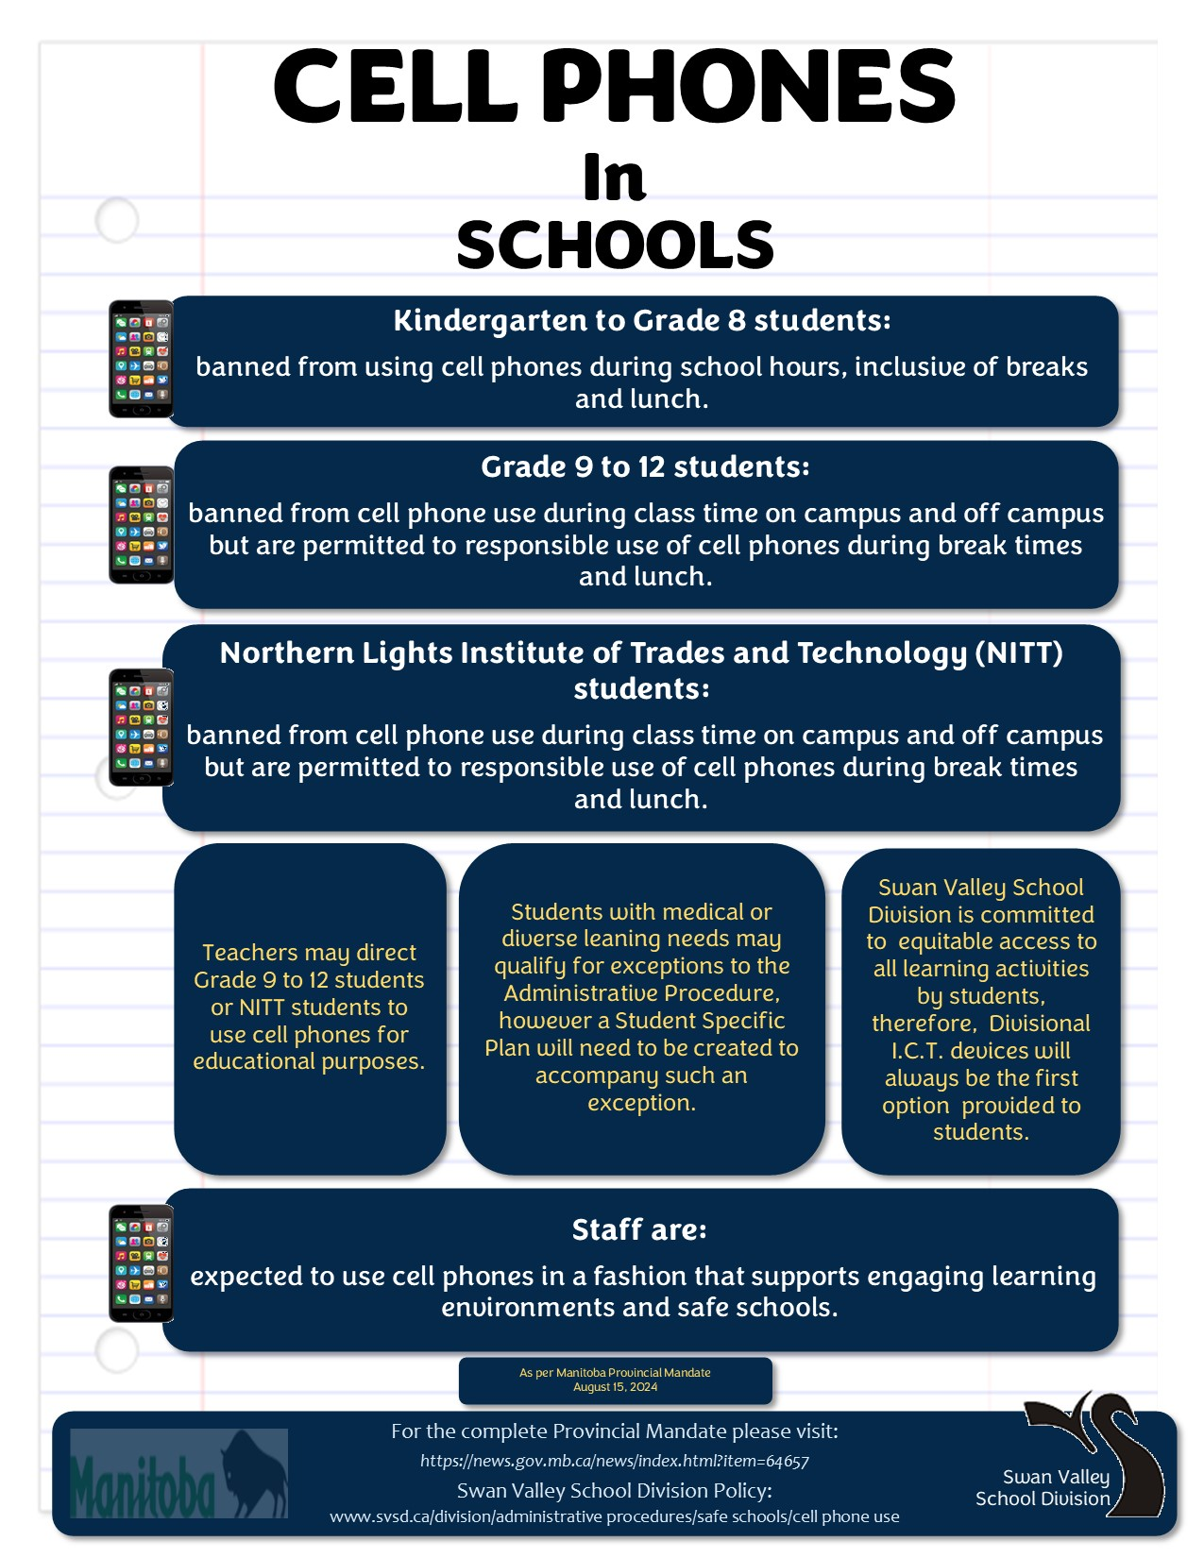

# STUDENT ACCIDENT INSURANCE

The Swan Valley School Division has supplied us with forms for student accident insurance, again this year. The insurance is voluntary.

If you are interested, send the completed form and cheque directly to the company or you can apply online via our school division website.

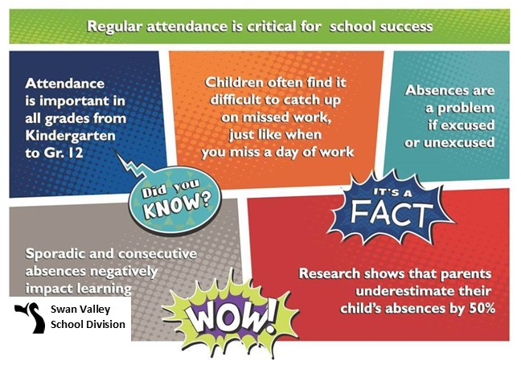

**2025 Mass Registration**  
**Children and Adult Groups represented together.  
  
DATE: Thursday, September 11, 6-8 pm  
LOCATION: Swan River Curling Rink  
  
To register for programs offered for all ages around the Valley!**

***Please note that The Town of Swan River Recreation Department   
has agreed to transfer this event to Communities That Care and CMHA.*For more Mass Registration details please access our**

**Facebook Page:   
Swan Valley Communities That Care**

**To Register please email to:** [d.potts@cmhaswanvalley.ca](mailto:d.potts@cmhaswanvalley.ca)  
or call 204-614-8892

**Deadline Friday, August 29, 2025**

