**BOWSMAN SCHOOL**

***DATES TO REMEMBER***

March 1 – Grade 8 Transitioning

March 6 – Alt Ski Day Gr 5-8 SVRSS Open House for Parents

March 8 – Gr 8 SVRSS Tour

March 8 & 22 – Hot dog sales

March 10 – Time change

March 13 – Gr 5/6 Ice Fishing

March 14 – Gr 7/8 Ice Fishing

March 14/15 – P/T Interviews

March 15 – No School

March 19 – Pizza Lunch

March 25 – 29 – Spring Break

**MARCH NEWSLETTER 2024**

 **FOR SEPTEMBER 2024**

If you have a child who will be 5 years old by December 31st, 2024, it is time to register for the 2024-2025 school year. Please come to the school to fill out a registration form. **You will need to bring a proof of age (government issue ID & MB Health Card).** If you have any questions, please call: 204-734-4506.

**Grade 7/8 Canteen**

Beginning in March, the Grade 7/8 class will be running a canteen during afternoon recesses. They will be selling a variety of healthy snacks.

**Price list:**

Veggie Straws $2

Protein Bar $3

Gatorade $3

Fig Bar $2

Juice Box $1.50

Muffin $2

Welche’s $1

Crackers $2

Pop Corners $2

**WE LOVE TO READ!**

It was great to see all of the staff and students partake in the February I Love to Read Month activities! Thank you to Lorna Munro who came out to read to the students!

**HOCKEY GAME**

On Wednesday, February 28th the Grades K-8 attended the afternoon Swan Valley Stampeder hockey game to cheer on our home MJHL team who played the Dauphin Kings. Thank you to all the organizers! Everyone had a great time!!

**100s DAY GRADE 2 PROJECTS**

 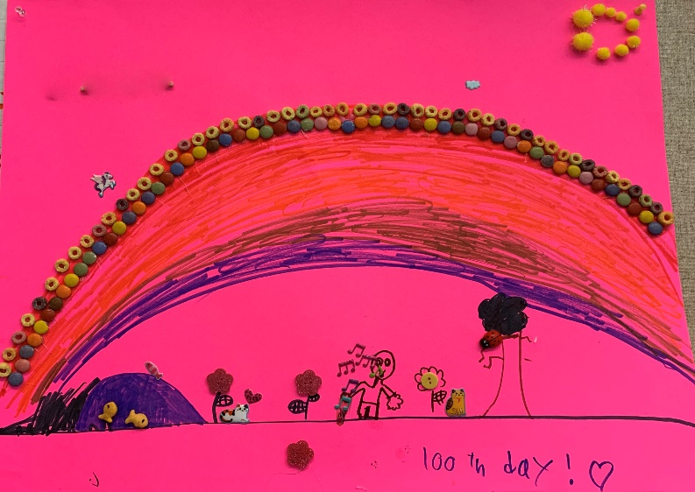

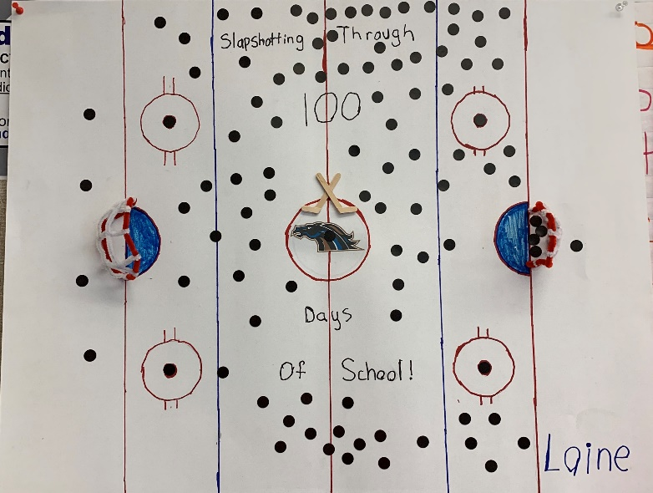 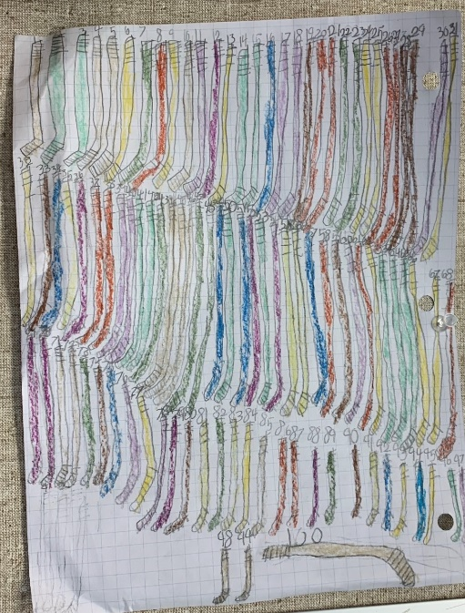

**100-YEAR-OLDS COME TO CLASS FOR 100th DAY OF SCHOOL**

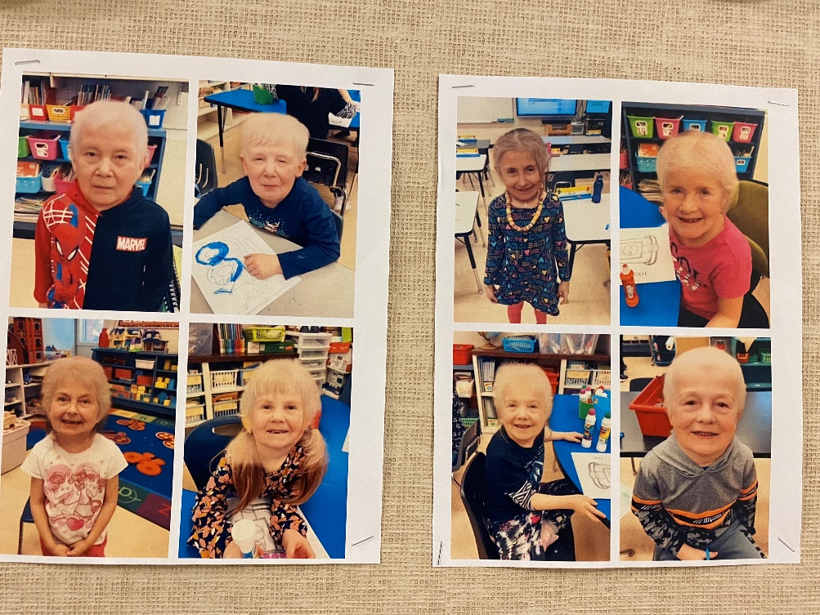

**BASKETBALL**

Bowsman School made one grade 5 and one grade 6 basketball team this year. The teams went to Ecole school in an evening and played in a round robin tournament against other teams from the valley. We also made a competitive team and practiced at noon to play in the valley champs which consist of grade 6-8 players. All students played competitively, fairly and proudly representing Bowsman athletics.

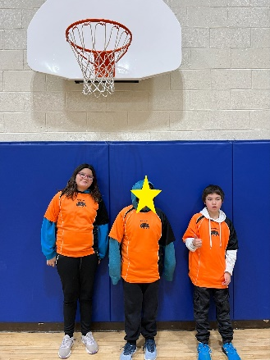 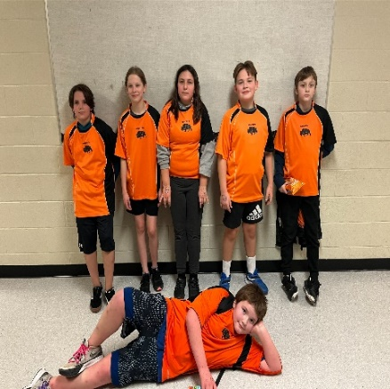

***ATTENTION GRADE 8 PARENTS***



Mrs.Badowski and Ms.Barabash from the SVRSS will be meeting with the Grade 8 class Friday, March 1 to discuss the high school registration process and course options available to them in grade 9. The SVRSS will then hold an Open House for current Grade 8 parents March 6th at 7pm. **Grade 8 students will tour the high school Friday, March 8from 1 -2 pm.** Teachers will provide a brief explanation of their introductory courses to students and their parents at this time.

**THUNDERHILL ALTERNATE Grade 5-8 SKI TRIP – March 6**



**HOT DOG SALES – MARCH 8 & 22 Grade 8 Fundraiser**

Order forms to come

 **SPRING AHEAD!**

On Sunday, March 10th, we all need to turn our clocks forward 1 hour to begin Daylight Savings Time.

 **ICE FISHING**

Grades 5 – 8 will be going ice fishing this month to Whitefish Lake. Wednesday, March 13 will be the Grade 5/6 class and Thursday, March 14 will be the Grade 7/8 class. **Parents/Guardians are welcome to join their child(ren) on these days, meeting the students at the lake.** A hot dog lunch will be provided, therefore, please let us know if family member(s) will attend so enough food will be prepared.

Details and permission forms will follow shortly.

 **PARENT TEACHER INTERVIEWS**

Parent/Teacher interviews will be held on Thursday, March 14th from 4-6 pm, and Friday, March 15th from 9:30-11:30am.

Please make an appointment by calling the school at 204-734-4506, alternate arrangements can be made with your child’s teacher if these dates and times do not work for parents.

**NO SCHOOL FRIDAY MARCH 15TH – PARENT TEACHER DAY**

**FREE PIZZA LUNCH**



On March 19th, Bowsman School will provide a pizza lunch to all the students and staff. K-Grade 2 will receive 1 large pie piece, while Grades 3-8 will receive 2 large pie pieces.

Pepperoni or Cheese will be the student choices per slice, along with a juice box.

Please bring own lunch if this is not of interest.

**SPRING BREAK – MARCH 25th – 29th** School will resume on April 1st. School Day 6.

