

**BOWSMAN SCHOOL**

**FEBRUARY NEWSLETTER 2024**

**FEBRUARY IS “I LOVE TO READ MONTH”**

[](https://www.google.ca/url?sa=i&rct=j&q=&esrc=s&source=images&cd=&cad=rja&uact=8&ved=2ahUKEwjAsbO4q5vgAhVH5oMKHReiAN4QjRx6BAgBEAU&url=http://worldartsme.com/i-love-books-clipart.html&psig=AOvVaw1bcJiBt99fZn7T2iB4J5qQ&ust=1549138138396005)

We will again be doing various activities within the school, during class time, but there are a few activities that parents can help with at home.

Each week will have an I Love to Read Month Dress Up Day.

If the clothing the students wear have words on them, all the better!

**February 1**: Team Up for Reading … **Wear a sports T-shirt or jersey**

**February 9**: PAWsitively Wild about Reading … **Wear animal print**

**February 16:** Hats off to Reading … **Wear a hat**

**February 23:** Surfs Up for Reading … **Wear a colorful or Hawaiian shirt**

**February 29:** We ‘Read” All Month … **Wear the colour red**  
  
 Happy Reading, everyone!

**NO SCHOOL – FRIDAY, FEBRUARY 2nd**

This is a Professional Development and Administration Day for all teachers.

**SKATING SCHEDULE TO BE ANNOUNCED**

Grades 2-8 are hoping to begin going skating this month. Students are to supply their own skates and helmets if able. Please let your teacher know if you will need, as there is access to a limited supply of skates and helmets to borrow. Reminder to dress for the rink temperature!

**Remember:** CSA approved helmets are required for skating. Students (Grade 5-8) can bring along hockey sticks, but only if their helmets have a cage on them and have hockey gloves.

***\*Permission forms with skating dates will be sent out and are required for students to participate\****

**CROSS COUNTRY SKIING and SNOWSHOEING**

Bowsman School grades 5-8 will be cross-country skiing and snowshoeing in gym class starting in February, weather and snow dependant. Please dress appropriately for outside gym classes.

**VALENTINE’S ACTIVITIES**

All Valentine’s activities will be done in individual classrooms. Please do not send candy or food for exchanging at school. Teachers will send out a notice for cards

**STUDENT COUNCIL VALENTINE SALE**

Mini Chocolate bars (100g) will be available for sale at lunchtime Monday, February 12th and Tuesday, February 13th. Write a special note on the package, a gift to give to special people on February 14th, $0.50 each

**NO SCHOOL – MONDAY, FEBRUARY 19th**

There will be no school on February 19th, as this is a statutory holiday. (Louis Riel Day)

**DOWNHILL SKIING AT THUNDERHILL**

****Our grades 5 – 8 students will be going downhill skiing at Thunderhill **Thursday, February 29th**, weather permitting, with the alternate ski date being March 7th. Forms will be going home soon and must be returned by February 16th. **ALL SECTIONS OF THE FORM MUST BE FILLED OUT**. There cannot be any sections left out on the form as it is very important for the staff at the ski hill to have all the information to ensure that your child is properly equipped and safe while at their facility.



Thank you to the Bowsman School parent fundraising committee for sponsoring this activity!



**TACO IN A BAG LUNCH – THURSDAY, FEB 22ND**

Bowsman School will be providing a free Taco in a Bag lunch to all staff and students on Thursday February 22nd.

**KINDERGARTEN 2024-2025**

Do you have a child that will be 5 years old on or before December 31, 2024

who would be attending Bowsman School in the fall? Then it is time to register!

Stop in to fill out a registration form or download it from the division website.

Proof of age (Government issued ID), and/or a Manitoba Health

Number MUST BE PRESENTED.

Please contact the school at 204-734-4506 with any questions!

**PINK SHIRT DAY FEBRUARY 28 – ANTI-BULLYING DAY – WEAR PINK!**

**HAPPY NEW YEAR RESOLUTIONS, FIREWORKS AND DRAGONS!**

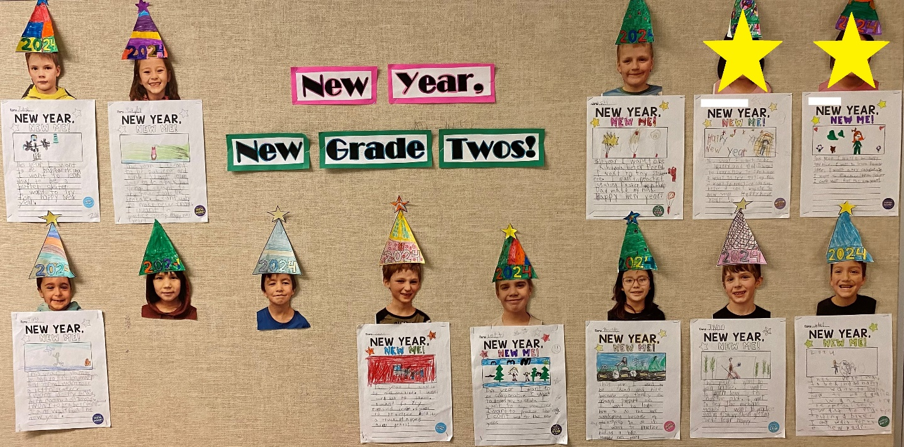

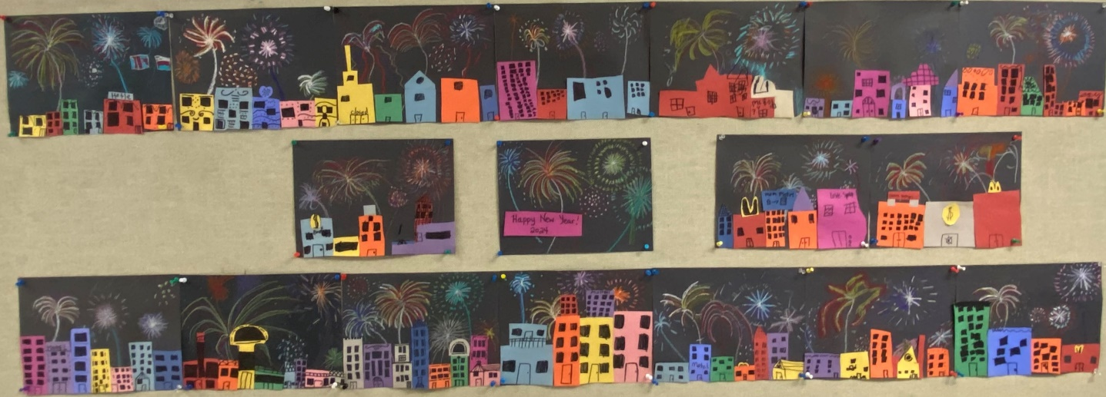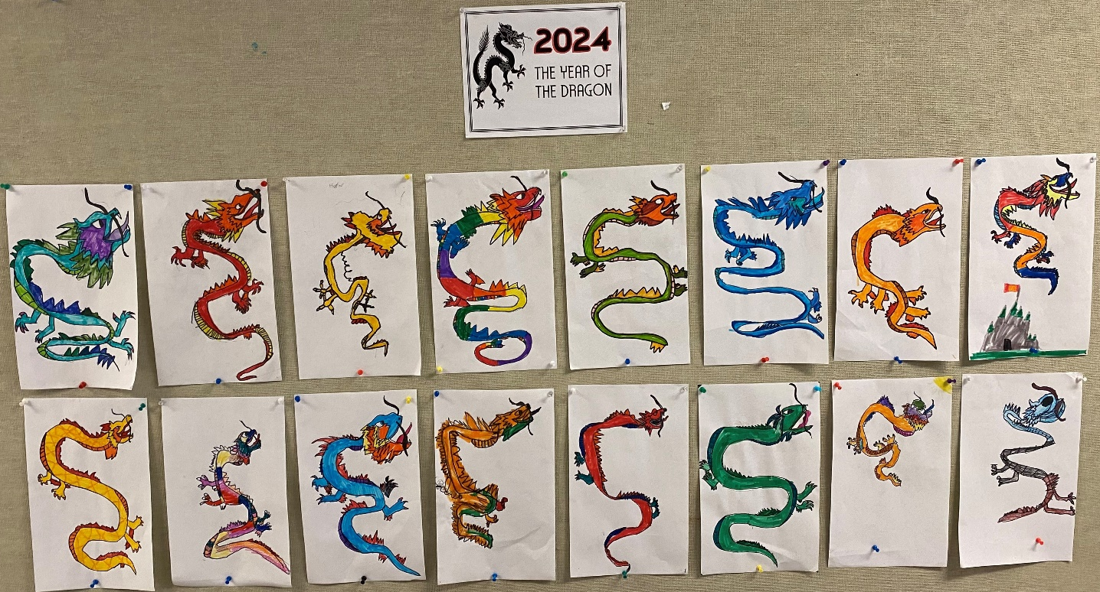

[This Photo](https://freepngimg.com/png/135813-bright-vector-fireworks-colorful-free-png-hq) by Unknown Author is licensed under [CC BY-NC](https://creativecommons.org/licenses/by-nc/3.0/)