**BOWSMAN SCHOOL NEWSLETTER**

**Dates to Remember:**

**May 9th** – Pancake Breakfast Fundraiser

**May 15th** – Hot Lunch

**May 19th** – Victoria Day - No School

**May 23rd** – Sunburn Classic (grades 5-8)

**May 27th** –Hot Lunch

**KINDERGARTEN REGISTRATION**

It’s that time of year again – it is time for you to register your child for kindergarten.

If you have a child, or know of someone in our area who has a child who will be 5 on or before December 31st of this year, please encourage them to contact the school to arrange to register their child for kindergarten as soon as possible.

**BADMINTON**

Congratulations to all badminton players who competed in the grade tournaments April 15th, 22nd & 23rd, as well as in the Valley Champs on the 29th. Bowsman School placed 3rd overall!

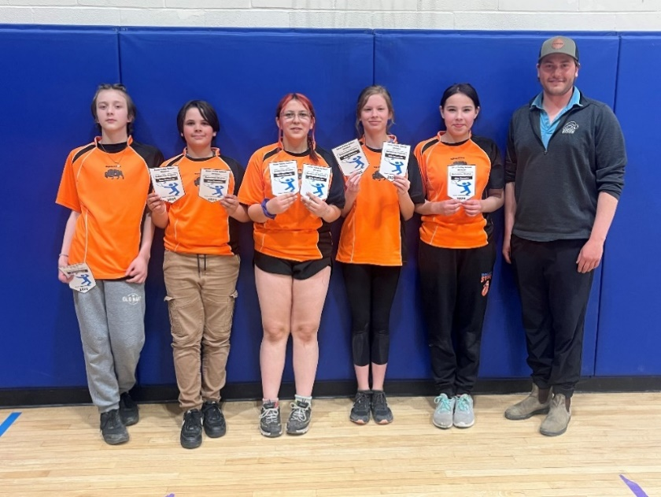**Grade 7**

**Boys’ singles**

B pool - 1st Ryder

**Girls’ singles**

A pool -2nd Kaelynn

B pool - 1st Aubree

C pool - 1st Courtney

**Boys’ doubles**

A pool - 2nd Hayden and Ryder

**Girls’ doubles**

A pool - 2nd Kaelynn and Aubree

**Grade 6** **Valley Champs** -**Grade 8**

**Girls’ singles** – All pools - 2nd Tori **Boys’ singles -** Ethan

**Girls’ doubles** – B pool - 2nd Tori and Kaylee

**SCHOOL ACTIVITES**

**Buddy Reading** between our K/1 and 4/5 classes have been happening this year. They have enjoyed reading inside and outside! The partners have read to each other, listened to stories on the playground, and, our big buddies helped our little buddies build some paper airplanes that we were able to fly down the hill.

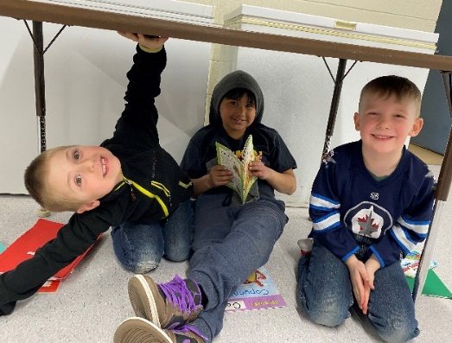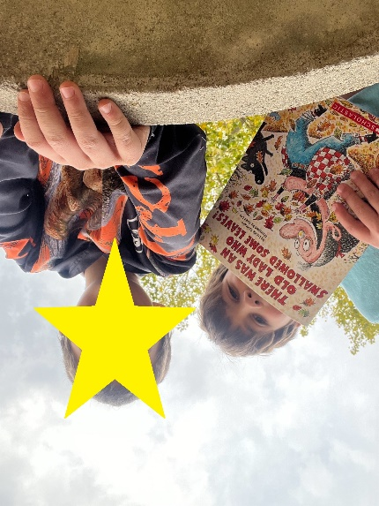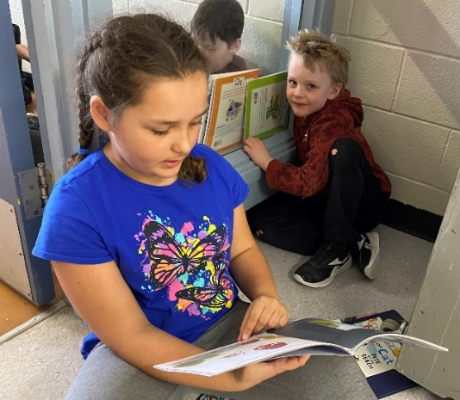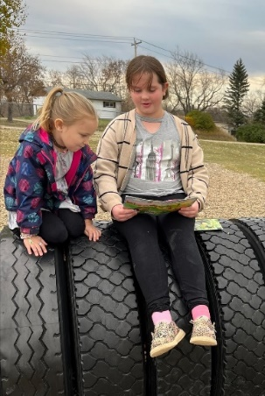

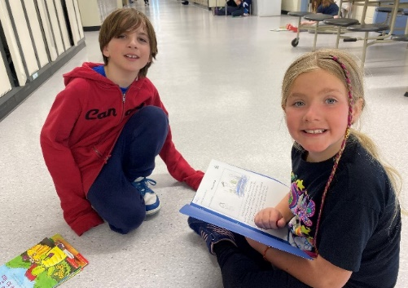

**Crochet Club** met every Tuesday at lunch recesses throughout the months of January-April. We started learning by making chains. We used chains to create belts, bracelets, and necklaces. Next, we learned how to single crochet. Once we mastered single stitches with our practice yarn, we moved onto our rainbow yarn! We created mini 20x20 stitch squares using our single stitches in hopes of making a blanket. Sadly, we did not make enough squares to make a blanket together, but we used our skills to move onto double crochet stitches and to make little gifts for our friends, such as necklaces, rings, mini blankets and scarves for stuffies, and more. We had such a blast together visiting and creating new pieces of work!

**Plant Club** has just started this week! Miss Cook and Miss Lies are eager to share their knowledge about plants and gardening with our club. We will meet every Wednesday at lunch recess and participate in a variety of activities that will build on our knowledge and skills related to farming, gardening, and plant life. Some activities included will be: planting personal plants, decorating rocks for a rock garden, learning about greenhouses, creating a garden bed for our school, and taking a field trip for some hands-on budgeting and plant shopping experience! We can’t wait to start planting!

**Ribbon Skirt Project with Mrs. Munro**

The Grade 6–8 girls have been hard at work creating their very own ribbon skirts with the guidance of Mrs. Munro. Each student thoughtfully selected their own fabric and ribbon colors, bringing their personal style and creativity to life. With care and dedication, the girls learned how to sew and assembled their skirts from start to finish. This meaningful project has not only built practical skills but also celebrated cultural expression and individuality. We’re so proud of their efforts and the beautiful results!

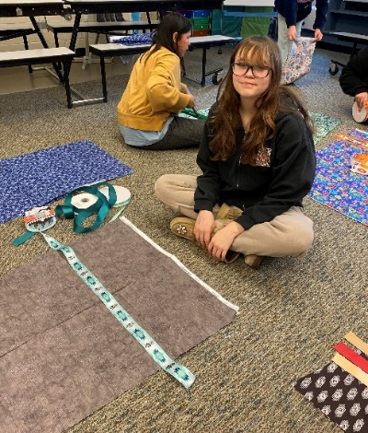

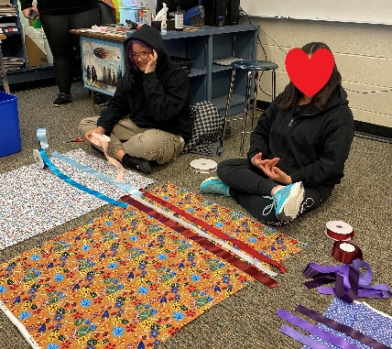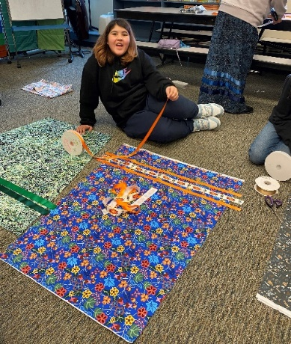

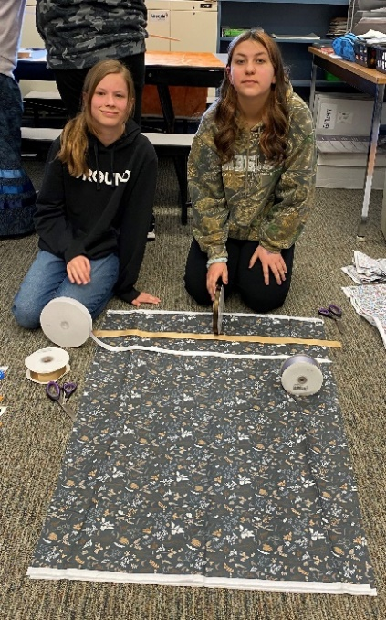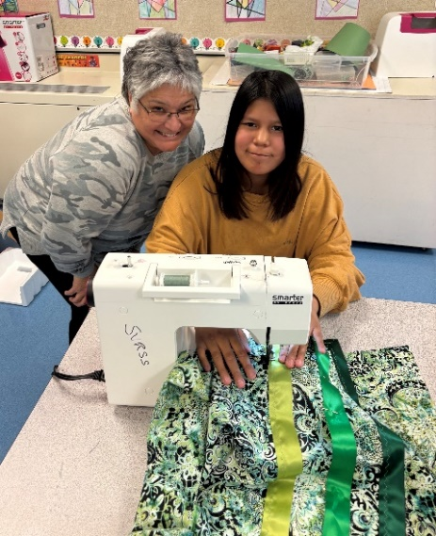

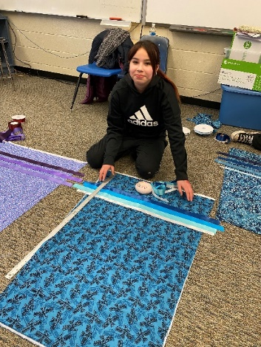

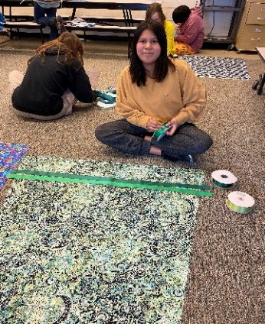

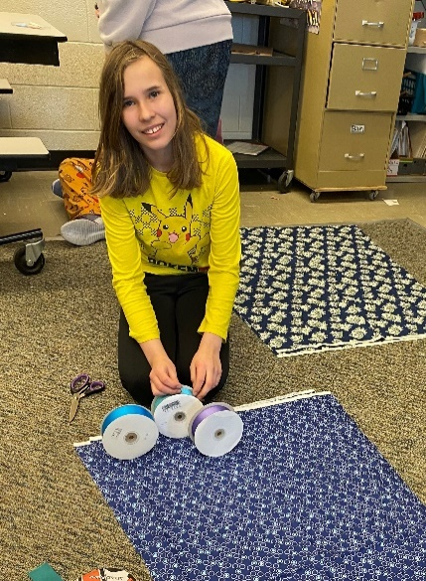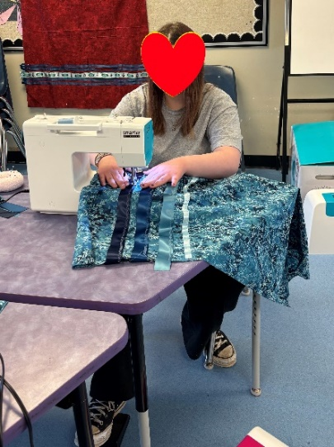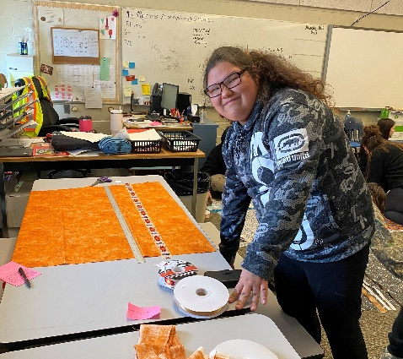

**MOTHER’S DAY PANCAKE BREAKFAST**

All students and community members are welcome to take part in our **Pancake Breakfast Fundraiser** on

**Friday, May 9th**, from **8:00 am – 10:00 am**.

This will include pancakes, sausages, and a drink.

The cost of the breakfast is **$7** per person.

Students will be preselling tickets, as well as tickets will be available at the door. Bowsman School students’ tickets have been sponsored by Swan Valley Funeral Services. Thank you to them for their generosity! Students will attend the breakfast with their class at 9 am, unless they have eaten with their families earlier. This fundraiser is to help support the Grade 8 year end trip, along with our school year-end endeavours.

**Community Plant Swap**

**A community plant swap will be held Friday, May 9 during our Mother’s Day Breakfast. We invite everyone that can, to bring flowers or plants that could benefit others – like shoots ready for replanting or homegrown plants. Please bring these to the school, where they will be sold for $5 each as part of our fundraiser. This is a great way to share the joy of gardening while supporting our event!**

**If you have any questions, please email:** [**hvessey@svsd.ca**](mailto:hvessey@svsd.ca)

**HOT LUNCH**

Sweet & sour meatballs, hash brown casserole & corn

hot lunch will be held Thursday, May 15th for all students and staff. Please bring your own lunch if you don’t want to participate.



**NO SCHOOL REMINDER**

No school on **May 19th** – Victoria Day

**BOWSMAN PARENT FUNRAISING GROUP**

Calling all parents!! Bowsman School has a parent fundraising group!

Just some of the things parents have done for our students through fundraising over the years:

* purchased each K student a Kinder Grad T-shirt
* purchased each grade 8 student a Grad hoodie
* purchased each student/staff a Bowsman School t-shirt
* sponsored ski days to Thunderhill for grades 5-8, as well as many other initiatives
* helped serve at Mother’s Day breakfast and yearend BBQ

Please consider helping all of our Bowsman School students and staff with your time. If you have any questions, please contact the school.

**FIELD TRIP**

The Swan Valley School Division is excited to welcome Lamarr Oksasikewiyin May 22nd to work with K to 8 staff and students on Indigenous Feats of Strength & Numeracy. Bowsman School students and staff will travel to Minitonas School to join them in this afternoon of learning.

**SUNBURN CLASSIC**

On Friday, May 23rd, our Grade 5 – 8 students will be participating in the annual Sunburn Classic Track & Field Meet. SVRSS 10AM-3PM

Student transportation is provided by the division.

Come out to cheer on your child!

 **FREE HOT LUNCH**

Bowsman Hotel hot lunch will be held Tuesday, May 27th for all students and staff. A plate of chicken fingers, fries and a drink will be served. Please bring your own lunch if you don’t want to participate.

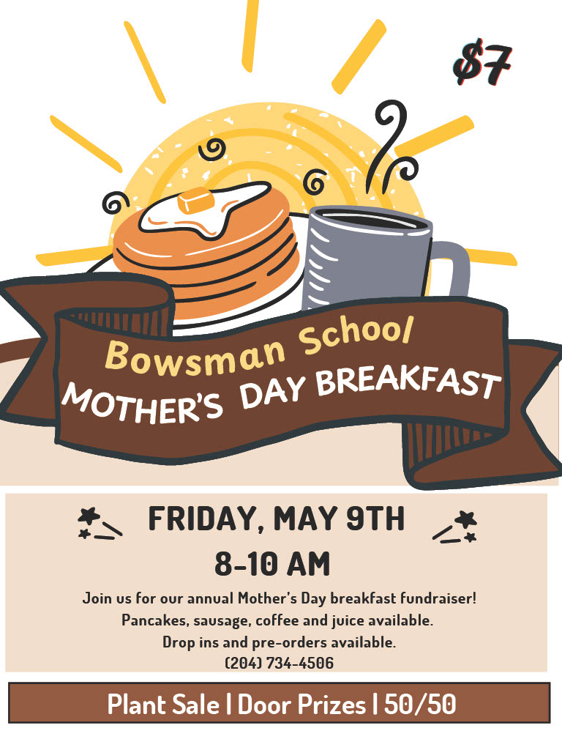

This newsletter is available in alternate formats upon request.