BOWSMAN SCHOOL
NOVEMBER NEWS 2023
Important
Dates to Remember:
Nov 16th – Harvest Lunch, P/T interviews 4-6pm
Nov 17th – No School – Parent Teacher Day Interviews 9:30-11:45am
Nov 29th – Sloppy Joe Lunch

THINGS TO REMEMBER:
** All students are expected to go outdoors for recesses and lunch hours. Please dress for the weather
**Please phone the school to let us know when your child/ren will be absent from school, even when their bus is cancelled
**All doors will be locked during the day. Parents/Visitors are asked to ring the door to enter the school
**Parents are encouraged to park away from the school bus route when dropping off and picking up their children. If you are meeting your child, please have a designated pickup spot outside
**Parents are asked to ensure their children are in good health. If your child is ill, please do not send him/her to school
**Town students who do not bring a lunch must go home for lunch
**Please check weekly for head lice**

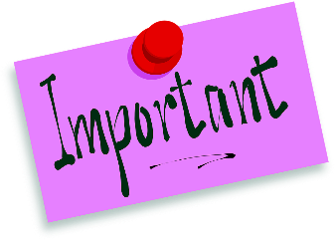
DON’T FORGET TO CHANGE YOUR CLOCKS NOVEMBER 5th

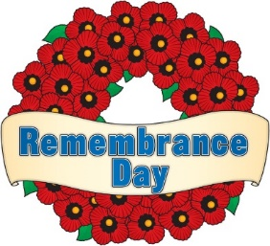
REMEMBRANCE DAY SERVICE

Bowsman School will hold our school service on Friday, November 10th at 10:45am. Parents are welcome to join us in the gym at this time.

HARVEST LUNCH

Bowsman School will be enjoying a delicious Harvest Lunch
Thursday, November 16
Students, staff and daycare friends will be served a full turkey dinner prepared by the SVRSS
The meal will include turkey, potatoes, stuffing, gravy, kernel corn, and a dessert
$9 per plate
** School students and staff lunches are FREE **
For those students who go home for lunch, please plan to stay this day.
For those students who do not want turkey dinner, bring your own lunch as usual

PARENT/TEACHER DAY
This year we will be having Parent/Teacher interviews on
Thursday, November 16th 4:00-6:00pm & Friday, November 17th 9:30-11:45am
Parents can choose between in-person or phone interviews on these two days.

Please book an appointment by calling 734-4506, pick your day/time and leave the working phone number where you wish to be called if phone interview is preferred.

There is NO SCHOOL for students on FRIDAY, NOVEMBER 17th

HOT LUNCH – WEDNESDAY, NOVEMBER 29TH

The school will provide a free hot lunch for all students and staff.
Menu will be Sloppy Joes with Carrot sticks

Sensory Gym
Bowsman School has been enjoying the partnership with the Swan Valley Cheetah’s Gymnastics Center where children have been enjoying the sensory gym experience. The programming helps with fine motor skills, body awareness, and social skills, as well as improving muscle strength, coordination and balance. K-2 classes, along with some older students, have, or will be, benefitting from this field trip program.
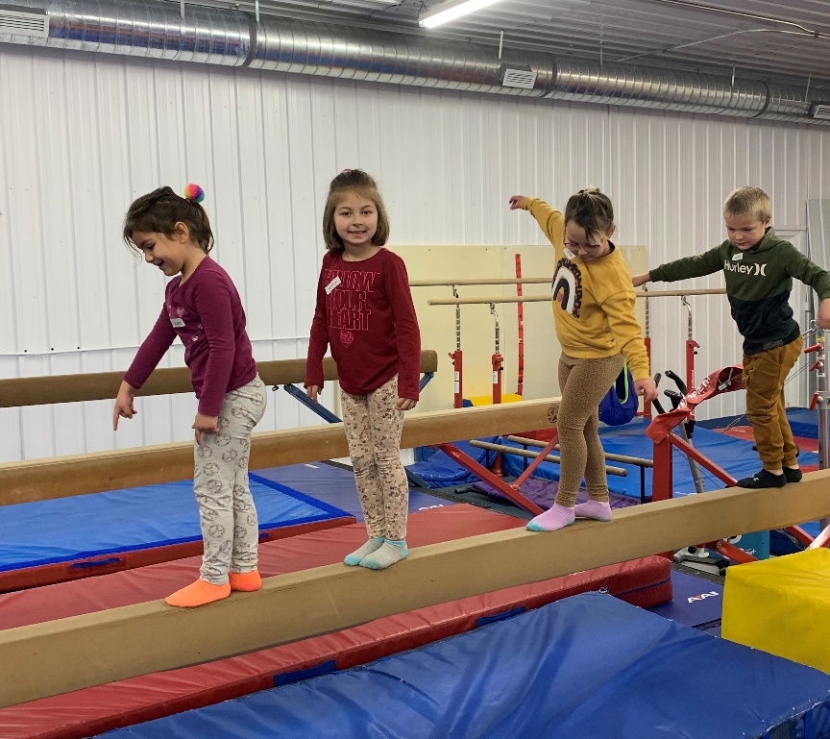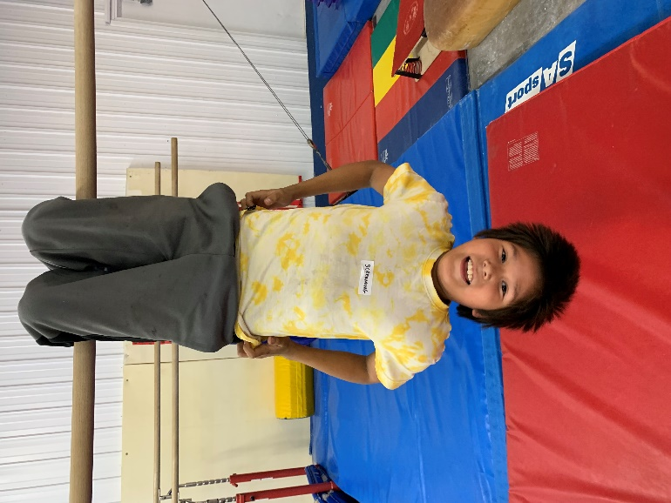

BISON NEWS
Soccer Valley Championships were held on Oct 6, our Bowsman Bisons were well represented with 10 players. A cold, but fun day was had by all! 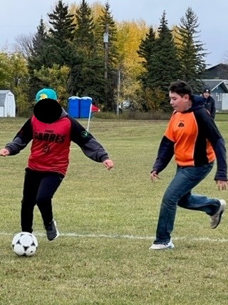 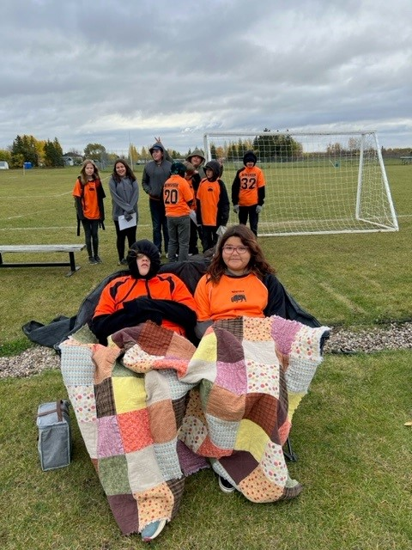
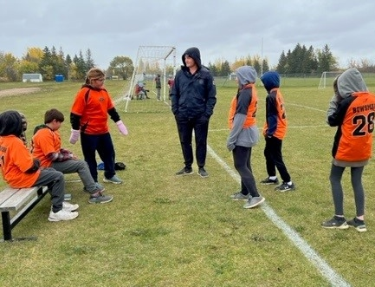
Volleyball development days were held in October. A number of Bowsman students joined other schools in the valley to learn and scrimmage with one another.
Volleyball tournaments and Championships will be held at the end of November.

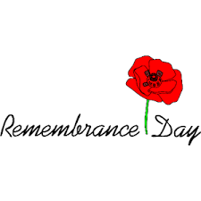
Principal Message
WHY SHOULD WE REMEMBER?
As the saying goes, “On the eleventh hour, of the eleventh day, in the eleventh month, we shall remember.” But, what does this really mean to those who are too young to know the history of Canada’s part in war? As educators, parents and community members, it’s our responsibility to teach you this very important information.
According to Veterans Affairs Canada, 2.3 million Canadians, of all ethnic backgrounds, from all walks of life, have served our country. More than 118,000 Canadian lives have been lost to war. It is estimated that over 12,000 Indigenous, Metis and Inuit men and women participated in WWI, WWII & the Korean War. Many of our own Valley residents played significant roles in our military. Valley historian, Glen McKenzie, estimates 300 locals participated in WWI & WWII, as well as, many other residents that have served in various missions, such as the Gulf War, Bosnia, Afghanistan, Peace keeping and everyday military services.
Following WW1, the women and children of France’s most devastated areas began producing poppies to sell in support of wounded veterans. Canada began supporting this tradition in November of 1921. From the last Friday in October, until Remembrance Day, the Canadian Legion asks every Canadian to wear a poppy proudly as a symbol of Remembrance. Please show your support for those who have dedicated and sacrificed their lives for our freedoms.
November 8th, is National Indigenous Veterans Day and Remembrance Day is on November 11. Together, we observe a moment of silence to mark the sacrifice of the many who have fallen in the service of their country, and to acknowledge the courage of those who still serve. It is a day we encourage every individual, young and old, to pause, to give thanks and to remember.
As a proud Canadian, I will take the time to remember my grandparents who both served in WWII. I encourage all students and families, no matter where you are, to take that moment.
Mrs. Shevernoha

