

BOWSMAN SCHOOL HANDBOOK

2023-2024

BOWSMAN SCHOOL HANDBOOK

**2023 - 2024**

Welcome to Bowsman School! The following information is intended to help parents/guardians and students understand the operation of our school.

We have four guiding principles:

* Everyone has the right to be respected and the responsibility to respect others.
* Everyone is unique and has a contribution to make.
* Everyone has strengths which must be nurtured and supported.
* Service to others in our community performed with caring and love makes a difference.

We will achieve these principles through:

* **Being Respectful**
* **Being Responsible**
* **Being Safe**

Students are reminded to:

1. Be respectful of ourselves, others and our community.
2. Be responsible for ourselves, others and our community.
3. Be safe, keep hands and feet to yourself. Play safe.

# STAFF LISTING

Mrs. P. Shevernoha Principal

Mrs. C. Pierrepont Kindergarten & Grade 1

Ms. C. Cook Grade 2

Mrs. M. Brundage Grade 3 & 4

Mr. K. Bender Grade 5 & 6

Ms. H. Vessey Grade 7 & 8

Mrs. G. Turton Music & Band

Mrs. C. Sutherland Resource Teacher

Mrs. E. Abrahamson Educational Assistant

Ms. C. Branconnier Educational Assistant

Mr. E. Campbell Educational Assistant

Ms. C. Crawford Educational Assistant

Ms. D. Deeks Educational Assistant

Ms. C. Graham Educational Assistant

Ms. J. Graham Educational Assistant

Ms. B. Guss Educational Assistant

Mrs. V. Honke Educational Assistant

Mrs. A. Jacobs Educational Assistant, Librarian

Mrs. L. Mullin Educational Assistant

Ms. I. Munro Educational Assistant

Mrs. H. Sigurdson Educational Assistant

Mrs. D. Unrau Educational Assistant

Mr. A. Andrews Custodian

Mrs. C. Werbicki Administrative Secretary

Bowsman School

Box 248

401 4th Ave

Bowsman, MB

R0L 0H0

Phone #: 204-734-4506

Fax #: 204-238-4917

Email: bowsmanoffice@svsd.ca

## SCHOOL DAILY SCHEDULE

First Bell 8:50 a.m.

Period 1 9:00 – 9:45 a.m.

Nutrition Break/Recess 9:45 – 10:00 a.m.

Nutrition Break/Recess 10:00 – 10:15 a.m.

Period 2 10:15 – 11:00 p.m.

Period 3 11:00 – 11:45 p.m.

Lunch time 11:45 - 12:00 p.m.

Noon Recess 12:00 – 12:45 p.m.

Period 4 12:45 – 1:30 p.m.

Period 5 1:30 – 2:15 p.m.

Nutrition Break/Recess 2:15 – 2:30 p.m.

Nutrition Break/Recess 2:30 – 2:40 p.m.

Period 6 2:40 – 3:25 p.m.

Period 7 3:25 – 3:55 p.m.

Dismissal 3:55 p.m.

## BOWSMAN SCHOOL GUIDELINES

**General Information**

**Awards:** The following may be awarded to students at the end of the school year:

**Honor Roll:** A minimum of 80% in core subjects and no less than 75% in other subject areas.

**Award of Excellence:** Awarded to the student with the top overall mark.

**Award of Distinction:** Awarded to the student with the 2nd highest overall mark.

**Citizenship Award:** Given to the student who is an engaged, inquiring and caring individual who understands and respects the differing perspectives of others. They make strong contributions to the life of the school, developed a sense of community at the school by bringing people together.

**Leadership Award:** Is given to a student who has demonstrated through his or her actions. Has what it takes to be a leader both in and outside the classroom.

**Science Award:** Combination of the highest marks in Science and Math.

**Arts Award:** Combination of the highest mark in ELA and Social Studies.

**Fairplay Award:** Awarded to the student who demonstrated the fair play qualities on a consistent base during physed activities.

**Fine Arts Award:** Combination of the highest marks in Music, Art and Drama.

**School Photographs:** A commercial photographer will take school photographs, on September 20th. An envelope including proofs and picture package pricing will be sent home with students soon after so that parents may choose to purchase photos.

**Arrival Times**: Students in Kindergarten to grade 4 will be outside until 8:50 am. Students in grades 5 – 8 will be allowed into the gym once buses have arrived.

### Visitors: Visitors to the school may ring the bell located on the south side of the main doors in front of the flag pole. If you need to see your child, we will page them to the office and escort them outside.

**Telephone Usage:** The school telephone is available for students to use upon request. Students should be aware that they may only use a school phone, when they are under the supervision of a teacher. Social arrangements MUST be made beforehand during the night before, and a note or phone call made to the school to inform us of any changes to their normal routine. This includes noon house arrangements and after school activities. We reserve the right to deny students the use of the phone if their telephone use and behavior is unacceptable

Parents are welcome to leave a message for a student with the office. Students will be called out of class for emergency situations only.

**Lunch Rules:** All students who stay for lunch will remain in their designated seats for the duration of their lunch break. Due to the staggered lunch schedule, students that leave the school at lunch are dismissed at 11:45 and are to return at 12:45 for afternoon classes.

11:45 – 12:15 – Kindergarten to Grade 4 Lunch

Grade 5 – 8 Recess

12:15 – 12:45 – Kindergarten to Grade 4 Recess

Grade 5 – 8 Lunch

Washroom breaks are allowed during noon hour. Students must let a Noon Hour Supervisor know that they are leaving the playground to come inside the school.

**Lost and Found:** Students who find lost articles are asked to turn them in to the main office.

Students should check the office and the lost and found box for lost items. The

lost and found box will be emptied regularly, so students need to check it

frequently when they have lost something.

**Agendas:** Students in Kindergarten to grade 6 are to use their agendas each day. We ask parents to check the agendas for any messages, etc. Teachers will check for notes from home. Please sign the agendas each day.

**Texts and Supplies:** Textbooks are issued in some subjects. If any school books are damaged or lost,

students are required to pay for the damage, or for replacing the item(s). Students

are responsible for bringing all other materials such as paper, pencils, pens,

mathematical sets, calculators, binders, dividers and a change of clothes for

physical education and other activity oriented classes.

**Homework:**  Students are required to complete some assignments at home. Homework should

include assigned work as well as unassigned study and review. The following

areas should serve as guidelines for a weekly homework plan:

1. work not finished in class
2. work missed due to absenteeism
3. long term assignments
4. organization of notes, assignments
5. review of each day’s work
6. study for tests and examinations
7. assigned homework

It would be beneficial if parents and students could agree upon a suitable place

and a regular time for students to complete homework. Parents are encouraged to

check notes and assignments on a regular basis and to ensure that homework is

completed.

**Attendance:** At Bowsman School, we believe that there is a strong positive correlation between attendance and success at school. Consistent attendance, punctuality and good work habits are essential for success. In order to gain the full benefits of educational instruction and involvement with the school community, it is necessary for pupils to be present and on time.

The responsibility for attendance rests with the student and his or her parents or guardians. **If students are absent, it is the responsibility of their parent or guardian to call the secretary at 734-4506 or email:** [**bowsmanoffice@svsd.ca**](mailto:bowsmanoffice@svsd.ca) **.**

**Absences:** Student absences are categorized as **EXCUSED, EXPLAINED or TRUANT.**

Absences are considered ***excused*** if the student is involved in a school activity which may include but not limited to field trips, sporting events, special outings, suspensions, etc.

Absences are considered ***explained*** if they are for unavoidable causes and are supported by a signed written note or telephone call from the student’s parent or guardian. Explained absences may include illness or medical appointments. In the case of prolonged illness, the student’s absences must be supported by a medical certificate. An illness is considered prolonged if it keeps a student from attending classes longer than three (3) consecutive days. If a prolonged illness is an isolated case supported by a medical certificate, it will be considered as one day of absence for the purpose of protocol of response.

Student absence that is neither excused nor explained is an act of ***truancy***.

It is the student’s responsibility to obtain and complete all work missed while

absent and to make arrangements to write tests that may have been missed. These

matters should be looked after when the student returns to school.

**Attendance Protocol**:

Teachers and/or Educational Assistants are expected to be in continuous supervision of pupils during the day. Formal electronic attendance will be taken at the beginning of the day and then immediately following noon recess. At that time, **all non-excused or unexplained absences will be electronically reported and parents or guardians will be contacted.**

**Response to Student Absences:**

In the event of multiple unexplained absences, lates or truancy, the school will contact the parent/guardian to discuss the importance of regular attendance and to offer support sustaining healthy attendance patterns. If need be, SVSD student services staff maybe come involved to assist with developing and implementing plans to avoid future absences including establishments of follow-up meetings as are required.

**Lates:** Students are expected to be punctual for all classes. A pupil who arrives late for class not only loses valuable instructional time, but also disrupts the learning of others. Parents or guardians will be notified if their son or daughter arrives late for class. As required, appropriate school personnel will host meetings with students and their families designed to improve punctuality.

A continuing pattern of late arrivals will result in the SVSD Student Services Teams being invited to work in collaboration with the student, his/her family, the Principal, the Teachers, and the community as necessary until healthy attendance patterns have been established and sustained.

**Truancy:** Students are expected to attend all classes during the day. Parents or guardians will be notified if their son or daughter is truant from individual classes. As required, appropriate school personnel will host meetings with students and their families designed to improve attendance in all classes.

A continuing pattern of truancy from classes will result in the SVSD Student Services Team being invited to work in collaboration with the student, his/her family, the Principal, the Teachers, and the community as necessary until healthy attendance patterns have been established and sustained.

**Suspensions:** A suspension from school is an excused absence. The school will provide academic programming for missed classes.

A continuing pattern of suspensions will result in the SVSD Student Services Team being invited to work in collaboration with the student, his/her family, the Principal, the Teachers, and the community as necessary until healthy attendance and behaviour patterns have been established and sustained.

**SCHOOL CODE OF CONDUCT**

**ROLES AND RESPONSIBILITIES**

Bowsman School strives to provide for a positive and safe learning environment for all students.

The Principal, under the direction of the Swan Valley School Division, takes a leadership role in the daily operations of the school. The Principal is also responsible for the following:

* The detailed organization of the school and the assignment, scheduling and care of personnel and students in accordance to the Public Schools Act and its Divisional Policy and priorities so as to strive for a safe, positive and relevant educational experience of all students.
* Holding everyone accountable for their behaviour and actions.
* Demonstrating a commitment to academic excellence.
* Communicating regularly with all members of the school community.

Teachers and staff members, under the direction of the Principal maintain order in the school and expect to hold everyone to the highest standard of behavior. Teachers are responsible for the following:

* Motivating students and help them reach their full potential.
* Establishing effective ways of communication with parents.
* Showing respect for all students, staff, and parents.
* Preparing students to be responsible contributors to society.

Students must demonstrate respect for themselves and also for others. Students are responsible for the following:

* Showing respect for others and for those in authority.
* Coming to school prepared, on time, and ready to learn.
* Taking responsibility in their own academic learning and planning.
* Avoiding bringing weapons and things to school that may compromise the safety of others.
* Obeying the rules of the school and take responsibility for their own actions.

Parents are encouraged to play a role in the education of their child. Parents are responsible for the following:

* Demonstrating respect for others and for those in authority.
* Establishing effective ways of communication with the teachers and school administration.
* Taking a responsibility and interest in their child’s academic progress and planning goals.
* Volunteering in school activities when called upon, including the Parent Teacher Association.

**STUDENT CODE OF CONDUCT**

**Step 1: -** A Discipline Referral is opened and filled out on the student outlining the  behaviour violation, date and time of the violation.

- Teacher must address the issue with student in private.

- Bowsman School Behaviour Matrix and Bottoms Lines and Consequences Plan will be followed. (see pages 14 and 15)

- Inappropriate behaviour is emphasized.

- Teacher’s expectations are emphasized.

- Teacher informs the student that if his/her behaviour is not corrected the teacher will contact parents or guardians.

- Consequences are stated by the Teacher (if the inappropriate behaviour

continues, the Principal will be informed and a detention or suspension may

occur.)

**Step 2:** Same as above.

- Teacher informs the student that his/her parents will be contacted and that the

Principal will also be informed of the inappropriate behaviour.

- Teacher will also inform the student that if the inappropriate behaviour

continues he/she may be faced with a detention or a school suspension.

**Step 3:** Teacher informs the Principal of the continued inappropriate behaviour. The Principal then contacts the parent or guardian of the student and informs them of the situation and the consequences that are carried out for the continued inappropriate behaviour. Consequences will be determined by the Principal and may include in school and/or out of school suspensions. As well, the Superintendent and Student Services Coordinator may be involved in the process.

**Re-Entry Process**

Students who return from an out of school suspension can expect the following to occur:

* Before returning to classes, the principal, teacher, parent/guardian, student and possibly Superintendent and/or Student Services Coordinator will meet.
* A Behaviour Intervention Plan may be either developed or reviewed.
* Expectations for student behaviour will be reviewed.
* Possible referral to outside agencies may occur.

**General Behaviour**

**Digital Citizenship: Elementary (Kindergarten – Grade 6) as per SVSD Digital Citizenship Policy**

SVSD devices are to be used in the classroom for learning. Students should not bring personal devices to school except in exceptional situations as supported by the classroom teacher.

**Middle Years (Grade 7 & Grade 8) as per SVSD Digital Citizenship Policy**

SVSD devices are to be used in the classroom for learning. Students are allowed to use personal devices as supported by the classroom teacher for positive education benefits and guided classroom instruction. The use of personal devices should promote learning in new and innovative ways.

At Bowsman School, grade 7 and 8 students may use their devices during designated times in designated locations. Inappropriate use will result in the following consequences:

**First Offence**-the item(s) will be confiscated for the day; the student may pick up their item at the end of the day.

**Second Offence** – the item will be confiscated for a week; the student may pick up their item at the office.

**Third Offence** – parents must pick up the item.

**Valuables:** **Students are asked not to bring valuables to school.** (unless authorized by the teacher) **These include:** Toys**,** IPods, Cell Phones, Cameras, Hand-Held Video Games, and Electronic Devices.

**First Offence**-the item(s) will be confiscated for the day; the student may pick up their item at the end of the day.

**Second Offence** – the item will be confiscated for a week; the student may pick up their item at the office.

**Third Offence** – parents must pick up the item.

**Collectables:** Collectable items, such as hockey and baseball cards etc., are not permitted at school or on the bus.

**Gum/Seeds/Pop/**

**Energy Drink:** Pop, Energy Drinks, Gum and seeds of any kind are not allowed at school.

**Dress Code:** Bowsman School staff expect parents and students to make wise choices and act as responsible citizens of their school. Certain clothing may be considered inappropriate for school and school events. The following is a guideline of clothing expectations:

* Hats and other headgear, clothing with inappropriate language and/or symbols, torn clothing, “belly” shirts, halter or tube tops and muscle shirts are not acceptable school attire.
* Skirts and shorts must be of a modest length.

Teachers will consult with the Principal and determine the appropriateness of a clothing item. If deemed inappropriate students may be required to return home and change, turn the shirt inside out or change into a shirt that will be provided.

**Hats and outside coats or jackets** – students are not allowed to wear these items to classes. They must be left in lockers. Hoods on hoodies are not to be worn up on the head.

**Backpacks/purses** cannot be taken into classrooms. They must be left in lockers and used to take belongings to and from school only.

At all times during the school year students should always dress appropriately for the weather. eg. wet weather means boots. These necessities include rubber boots for wet weather and proper winter coats, pants, boots, toque and mitts.

In winter students should dress in a way which will allow them to remain warm while outdoors for 45 minutes. Bus drivers may refuse to pick up students who are not dressed appropriately for the day. Kindergarten to Grade 8 students will be outside for the noon hour and recesses on most days. If the wind chill is high, or the temperature is too low, we will keep students indoors or shorten the time out accordingly.

Students who are too ill to be participate in recess activities should not be at school. In exceptional circumstances, we can make an arrangement for recesses, but we prefer they were at home, in bed, getting well.

**Students must remove their outdoor footwear as they enter the school and leave the shoes in the vestibules (K-4) and lockers (5-8). A second pair of shoes, with non-marking soles is necessary for indoor wear.**

**Bus Behavior:** Parents are encouraged to read their Bus Ridership Handbook. Students may lose

the right to ride on the bus if they are bullying, loud, unruly and/or disruptive.

Appropriate behavior is expected from all students while riding Division buses to

and from school, as well as on field trips. Masks are mandatory for all students riding the bus.

**School Safety**

**Leaving School Property:**

Students are reminded that they are not to leave the school grounds without both parental and teacher permission during the school day. This is to ensure that they are well supervised and that we always know where they are.

All outside doors are locked. Late students and visitors must ring the bell at the main entrance to enter the building and sign in at the office.

In case of emergency, it is essential for the office to be able to contact a parent at any time during the day. **Please ensure that a working phone number and available contact is listed in your registration.** **Please inform us of telephone and/or address changes**.

**Fire Drills:** Fire drills will be held on a regular basis, approximately 10 per school year.

**Tornado Drills/Lockdown Procedure:** Will follow current provincial guidelines.

**Storms:** Throughout the year, there may be times when the buses or classes will be cancelled due to inclement weather or an emergency. School closing announcements will be made over radio stations SVSD website [www.svsd.ca](http://www.svsd.ca) , SVSD Facebook page, CKDM – Dauphin (730), CJGX – Yorkton (940), FOX FM, Yorkton, and our local radio station.

All students who ride a bus must have a storm contact that can pick them up and/or house them if the buses should be cancelled during the school day.

**Illness or Injury:** First Aid will be given to a pupil who is injured on the premises or the school grounds. If the accident is serious, you will be notified immediately. If the parents cannot be reached, then we will notify the emergency person indicated on the registration form. We reserve the right to call an ambulance without parent notification in extreme emergencies. It is recommended that parents take out Student Accident Insurance if they are not already covered by another agency.

**We advise that students who wake up ill (cold/flu symptoms/general feeling of being unwell) in the morning should remain at home until they have recovered.**

If a student becomes ill and/or is injured at school, she/he should notify a teacher and in turn, this student should report to the office. If the illness or injury appears to be serious, a parent will be notified by school personnel and will be requested to come to school to take the student home or for a medical examination. It is essential that the office be contacted when a student is ill – students are not to remain in a washroom or anywhere else without notifying the office.

**Head Lice Policy:** Periodically during the school year, as needed, students will be checked for

head lice.

The following procedures are put into place if eggs or lice are found:

1. If eggs or lice are found in a child’s hair, that child will be sent home with a letter indicating this. The child must be treated with purchased shampoo or the home remedy before they can return to the classroom. All families in the school will receive an email informing them that someone in the school has eggs/lice.
2. The student that has had lice or eggs, will be re-checked in 7 – 10 days, to ensure they are free of eggs and/or lice. If either is found, the process of number 1, 2, and 3 begins again.
3. If the 3rd head check reveals eggs or lice, steps 1 and 2 will be repeated, however, a note from a medical doctor or a public health nurse will be required stating that the child is free from lice and/or eggs, before the child can return to school.

If these requests are ignored or neglected, administration has no alternative but to

refer the child and his or her family to the Public Health Unit and/or Child and

Family Services.

If untreated, lice can become a very painful condition for anyone, especially a child.

* If a family is unable to purchase the shampoo, arrangements can be made with

the Public Health Office to receive the shampoo at no cost.

This policy is in place for the protection of all our students.

**Medication:** The school will administer medication to students as per Division policy. Parents /Guardians must complete a permission form that includes a Doctor’s signature. Medication in the original prescription container and written instructions for administration by the physician. These forms can be obtained from the school secretary.

**Extra-Curricular Activities:**

The school has special events scheduled on a periodic basis, which students are expected to attend and participate. The events are sports days, class group activities, etc. The scheduling of these events is intended to develop social skills and large group skills among all students.

**Extra Activities:** There are activities that go on outside regular school hours. Students participate on a voluntary basis, but everyone is encouraged to take part in an activity. The intramural program is a major part of our extracurricular program. Students are divided into teams and participate by grades, in various sports such as soccer, volleyball, basketball, etc. There is also an interscholastic program where we compete against other schools.

Bowsman School offers a variety of extra-curricular clubs, Student Council, sports, and activities. Students are encouraged to enrich their school experience by participating in extra-curricular activities.

Visits to places and activities outside of the school often add considerable enhancement to the school program and are considered part of the program. Students are expected to attend.

A student’s inappropriate behavior may result in a loss of the privilege to participate in a special event or extra activity.

Classroom teachers and/or the Principal reserve the right to suspend certain privileges.

## Enrichment Day Seminars:

## During the school year a variety of day seminars will be planned for specific grade levels.

Students who wish to attend these seminars must meet set criteria for selection. The enrichment activities are planned for students that are keen to learn about specific subjects. Please note that some students may be chosen to attend several sessions a year if they meet the criteria.

Day seminars are planned by the Division Enrichment Committee.

**Athletics**

**Phys. Ed.** All students are expected to participate in Phys. Ed. (PE) Classes. If a student has a sprain or some other minor ailment, a note from a parent or guardian will allow your child to “sit out” a physical education class. Another note is required to allow the student to miss the following class. These notes are to be presented by the student to the physical education teacher before the class. Daily participation, skill development and ability all contribute to the overall PE grade.

Grades 5-8 Students must have a complete change of clothing for physical education classes. We suggest the following: shorts and sweatpants (no zippers), athletic socks, clean, non marking running shoes used for indoor wear only, and deodorant for grades 4 and up.

**Intramurals:** Various Activities may be run throughout the school year. Announcements will be made for activity sign up.

**Expectations of Players and Spectators at Athletic Functions:**

* Offer constructive support to our teams and avoid criticizing the opposition.
* Show appreciation of good plays by both teams.
* As a host, welcome the visitors as guests, offering all possible assistance.
* As a visitor, respect the property of the host school, and accept the hosts’ regulations.
* Recognize and accept an official’s (referee) decision as final.
* Respect the feelings of all participants, and show sincere concern for an injured player.
* Learn the rules of the game and play by them.
* Accept either victory or defeat graciously, respecting the efforts of everyone.
* Express thanks to those responsible for the opportunity to enjoy a school sports activity.

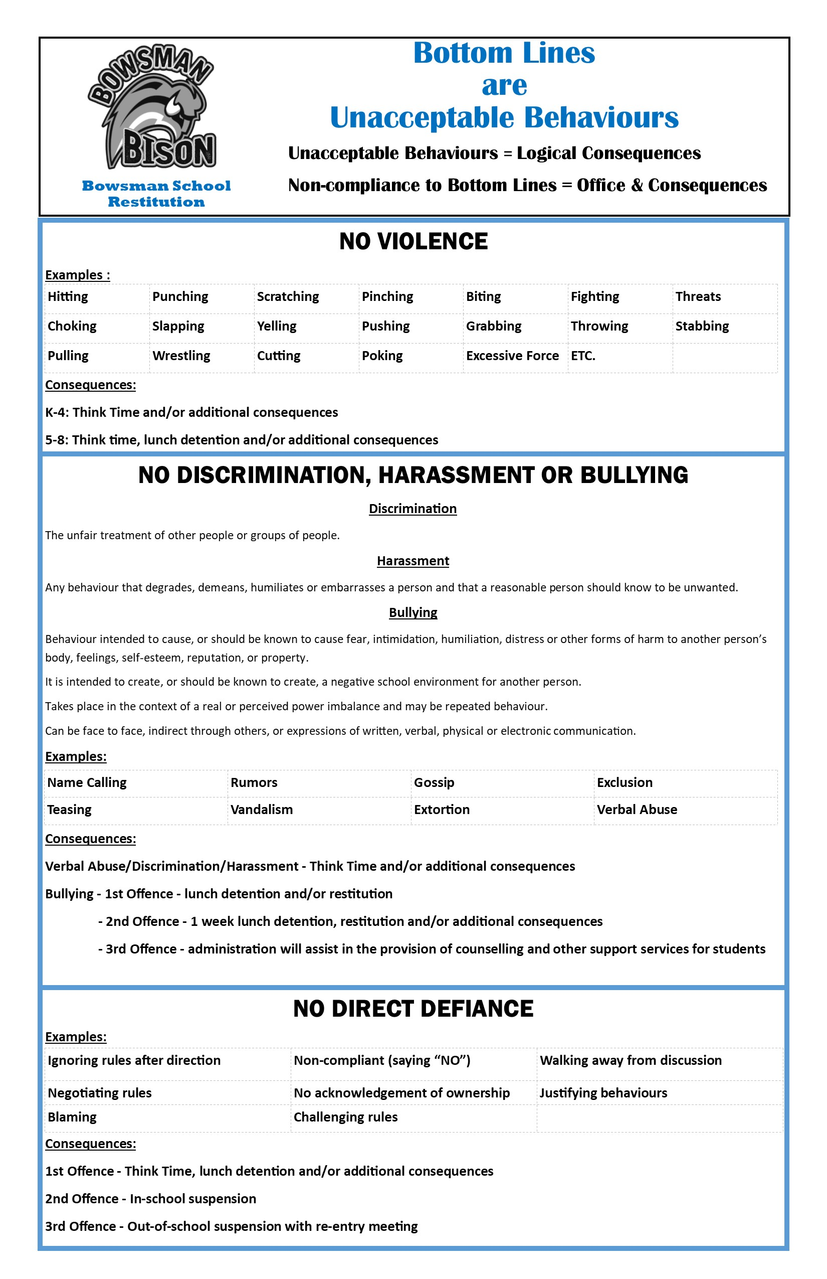

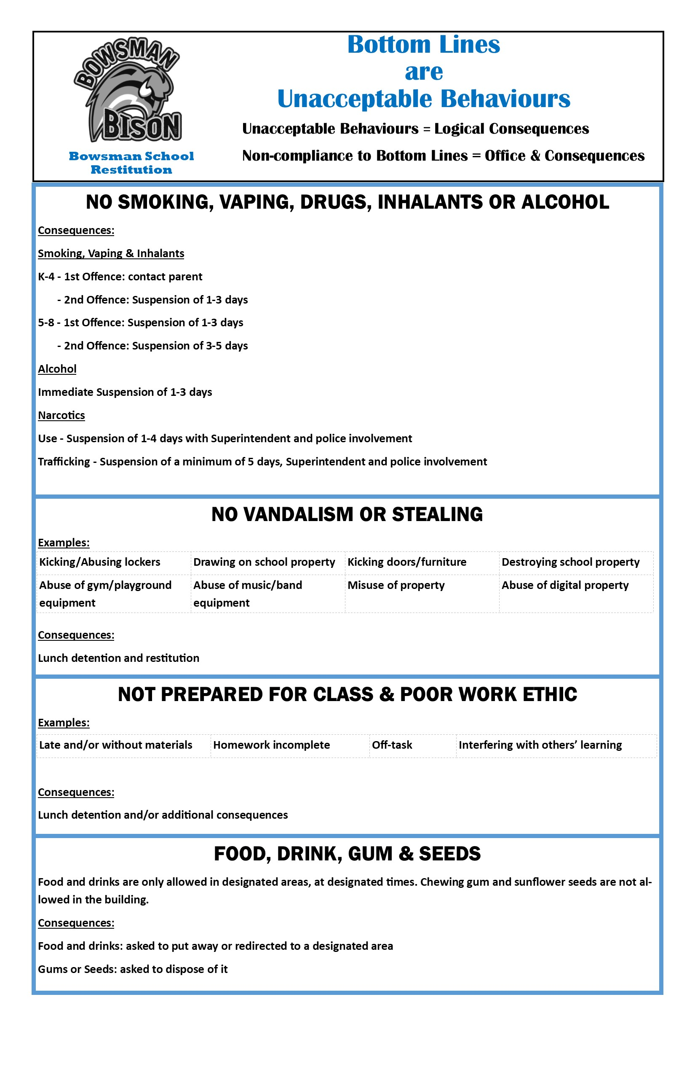

**Please Note**: Minor violations will be dealt with at the discretion of the teacher and the principal. However, depending upon the frequency and severity of the offence, the Swan Valley School Division discipline policy may come into effect.

**SWAN VALLEY SCHOOL DIVISION DISCIPLINE POLICY**

The following is the Swan Valley School Division policy for disciplinary matters.

**Suspension:**

**Out of School Suspension**

Offenses for which a student may be suspended include but are not restricted to: a) weapons b) physical assault (staff and students) c) smoking d) verbal assault (staff and students) e) chemical abuse

Following the decision to suspend a student, the Principal will notify the parent/guardian as to reasons subsequent to the suspension period to clarify expectations for re-entry. The school will institute a for suspension and duration; inform the parent/guardian that a meeting with the school is required process to ensure all personnel are informed of the terms of re-entry on a “need-to-know” basis. In determining the duration of the suspension of a student, the following factors should be taken into consideration: a) severity of the offense; b) whether the student was responsible for or was a participant in the offense; c) whether the student had been suspended previously for a similar offense. Dependent upon the factors identified, the following are guidelines for the duration of suspensions:

* Initial suspension - 1 to 3 days
* Subsequent suspension - 3 to 5 days
* Physical assault (causing bodily harm) - minimum of 5 days
* Threatening with a weapon - minimum of 5 days

Recommendation for suspension from school of students for a period longer than five days will be forwarded to the Superintendent for consideration, outlining the reasons for the request and actions taken by the school to address the situation.

No action on the request should be taken until approval from the Superintendent has been received.

Five common categories where suspension of students may be appropriate are: - chemical abuse

- physical assault

- verbal assault

- weapons in school.

- misconduct

- bullying

- unacceptable conduct or discrimination

Specific guidelines for suspension have been identified under each category, normally for first offense.

**Smoking:** Smoking is not permitted during regular school hours nor during school activities. **No student in Bowsman School has the legal right to purchase tobacco products. We will seize and destroy all cigarettes, etc. found in the possession of any student.**

- Early Years

* 1st offence - contact parent
* 2nd offence - suspension 1-3 days

-Grades 5-8

* 1st offence - suspension 1-3 days
* 2nd offence - suspension 3-5 days

**Alcohol Influence:** a) **Under the Influence** - students appearing at school under the influence of alcohol will be suspended immediately, with notification to the parent/guardian. Depending upon the degree of impairment and the age of the student, the school either will have the parent/guardian pick up the student or have the student accompanied by an appropriate adult from the school to the home. The appropriate period of suspension may be one school day up to an additional two days.

b) **Use of Alcohol on School Premises** - students found in possession of, or consuming, alcohol in the school will receive immediate suspension, with a notification to the parent/guardian. The student will be held at the school until the parent/guardian arrives.

**Narcotics Influence** a) **Under the Influence** -students found to be, or suspected of being, under the influence of a non-prescription narcotic will be suspended from the school and the parent/guardian should be contacted and requested to take the student home or to the hospital. In more serious cases, students should be taken directly to the hospital while attempts are being made to contact the parent/guardian. Suspension normally will be a minimum of one school day and up to an additional two days.

b) **Use of Narcotics on School Premises** - students found to be in possession of or using a non prescription narcotic substance will be suspended immediately and both the parent/guardian and the police will be notified. Suspension normally will be a minimum of one school day and up to an additional three days depending upon the circumstances of the case. The student will be held at the school until the police and parent/guardian have arrived.

c) **Trafficking of Narcotics/Drugs** - students found to be trafficking a narcotic substance should be suspended immediately and both the parent/guardian and the police are to be notified. The student shall be suspended for a minimum of five days and the Superintendent shall be consulted with a view to possible extension/expulsion.

**Physical Assault on Other Students**

**Fighting** - when two students are guilty of assaulting each other, depending upon the circumstances, the students may be sent home for the balance of the day or up to two days, with a warning and notification to the parent/guardian or they may be assigned to in-school suspension. If inappropriate behaviors continue, the students may be suspended for an additional one to three days.

**Physical Assault** - this category of offense covers a one-sided assault by one student on another, without causing physical injury. A suspension of one day, up to an additional three days, would be appropriate. The police may be contacted by the person assaulted or the Principal.

**Sexual Assault** – this category of offense includes any physical assault that has sexual overtones. The period of suspension should be a minimum of five days. The police and social services will be contacted.

**Causing Injury** – where physical assault of one student on another causes injury, the student causing the injury shall be suspended immediately and the period of suspension should be a minimum of five days.

The police may be contacted by the person assaulted or the principal. In cases where this offense is repeated, consultation between the principal and superintendent is recommended to either request extension beyond the five day limit.

**Physical Assault on Teachers/Other Adults**

**Physical Assault** – immediate suspension of the student for one day up to an additional three days would be appropriate. In more serious cases, upon consultation with the superintendent, recommendation for alternate programming or expulsion.

**Causing Injury** – where assault by a student on a teacher or other adult causes injury, the student shall be suspended for a minimum of five days and the superintendent shall be consulted with a view to possible extension/expulsion. The person assaulted or the principal may wish to contact the police.

**Verbal Assault on Other Students**

**Swearing:** Profane and vulgar language and gestures are not acceptable at any school-related activity.

Threats, harassment, verbal abuse and extortion shall constitute verbal assault. In cases of verbal abuse, an initial warning may be sufficient or a warning with suspension for the remainder of the school day also is possible. Subsequent offenses should result in suspension of one day or more if repeated. Depending upon the severity of the case, a warning with suspension for the remainder of the school day may suffice or suspension of one – three days may be appropriate. Repeated occurrence may result in more serious suspension consequences.

**Extortion** – In the case of extortion, a suspension of a minimum of three days would be appropriate. The police may be contacted.

**Possession of Weapons on School Property**

a) **Guns** – A student guilty of bringing a gun to school shall be sent home on immediate suspension. The principal shall notify the police and consult with the superintendent to arrange for a six week suspension and possible expulsion.

b) **Knives** – When a student is found to be carrying a knife that could be regarded as a weapon, the principal shall confiscate the knife and notify the parent/guardian that it is being held at the school to be retrieved by the parent/guardian.

c) **Other Weapons** - When a student is found to be carrying other weapons, the Principal shall confiscate the weapon and notify the parent/guardian.

Suspension for the balance of the day and possibly for additional days as deemed appropriate.

**Threats (involving weapons) -** If a gun, knife or other weapon is used by a student in a threatening way toward another student or adult, the offending student shall be suspended immediately for a minimum of five days. The Principal should consult with the Superintendent as to the possibility of an extension up to six weeks or expulsion and the police ordinarily will be notified.

**Attacks (involving weapons) -** If a gun, knife or other weapon is used by a student in an attack on another student or adult, the offending student shall be suspended immediately for a minimum of five days. The Principal should consult with the Superintendent as to the possibility of an extension up to six weeks and expulsion. The police SHALL be notified.

**Student Misconduct Situations**

**Insubordination** - students who refuse to accept the authority of adults in the school will be suspended for the balance of the school day, or up to two days. Should the offense recur, an additional two day suspension is appropriate.

**Uncontrollable Behavior** - in cases where students exhibit repeated uncontrollable behavior, a suspension for the rest of the day is appropriate. If the behavior continues, a suspension for a further one to three days may be appropriate.

**Vandalism** - in accordance with the policy on Restitution, the school shall attempt to recover the costs of the damage from students who vandalize school property or the private property of others in the school. While individual cases will vary in severity, an additional penalty of a one or two day suspension may be appropriate. . A vandalism report will be completed and forwarded to the Division Office which will take action to collect the money owing.

In the case of vandalism to technology equipment:

1) If this damage is to hardware, the student will be charges for damages.

2)If there is damage to software and applications through destroying or tampering/changing programs, the student is subject to suspension and criminal action will be considered.

Any graffiti or other defacement of school property is strictly prohibited. Students can face suspension, expulsion and/or criminal charges for any graffiti or other defacement of school property.

**Setting off the Fire Alarm** - the deliberate setting off of a fire alarm by a student will be treated as a serious offense. A three day suspension for this offense is appropriate and contact with the Fire Department and Police is warranted.

**Arson or Attempted Arson** - a minimum suspension of five days for arson or attempted arson is appropriate and contact with the police is warranted. The Principal should consult with the Superintendent as to the possibility of an extension up to six weeks and expulsion.

**Inordinate Display of Affection** - in cases where students exhibit repeated inordinate displays of affection, a suspension for the rest of the day is appropriate. If the behaviour continues, a suspension for a further one to three days may be appropriate.

**Inappropriate Dress** - in cases where students continue to wear inappropriate dress, as outlined in the student handbook, a suspension for the rest of the day is appropriate. If the behaviour continues, a suspension for a further one to three days may be appropriate. Students will not be permitted to wear clothing or symbols which denote gang membership. Failure to comply will result in automatic suspension and possible removal from school.

**Procedures for suspension of students**

All student suspensions are subject to appeal to Board of Trustees providing an appeal request is registered with the principal or Division Office within five calendar days of the notice to suspend. The Board after hearing the appeal, may remove, confirm or modify the suspension and where the Board considers it appropriate may order that any period of suspension be expunged

1 In-School Suspension- to Superintendent, if a dispute arises.

2 Out-of-School Suspension: to Superintendent, if a dispute arises.

3 Expulsion: Public Schools Act outlines procedures and right of appeal to the Board of Trustees. Final appeal can always be made to the Board of Trustees.

**In-School Suspension**

The primary purpose of an in-school suspension is to offer a structured, supervised program for suspension of students in lieu of an out-of-school suspension. The student who is assigned to the in-school suspension will be in an educational environment with restricted contact with his/her peers.

Student assignment to an in-school suspension will be at the discretion of the school administration. The administrator will evaluate each case individually as to whether the alternative to “out- of-school suspension” will be used. The nature, number and seriousness of the offenses will be the determining factors coupled with a concern and judgment whether the student can learn from an in- school suspension.

The structure of an in-school suspension should include the following:

a) a specific location is provided for in-school suspension participants.

b) Appropriate staff is assigned to supervise the student(s);

c) The student’s activities within the school are completely restricted:

- movement to and from suspension location is at designated times only; - the student will not be allowed to talk or walk around the in-school suspension centre; - the

student is restricted from all assemblies and after-school activities until re-entry is earned.

d) Specific instructions are given for all assignments. The completion of all class work in a manner satisfactory to the supervisory personnel is necessary for the student to gain re-entry into the regular classroom. The assignments are provided by the classroom teacher(s).

e) Goal setting (both academic and social) will be incorporated in the re-entry process along with the student’s general attitude and cooperation while assigned to the in-school suspension.