 **BOWSMAN SCHOOL**

**APRIL NEWSLETTER**

**2025**

**MARCH FISHING TRIPS**

On Thursday, March 20, 2025, a group of students from grades 4-6 headed out for a day of ice fishing at Whitefish Lake. The weather was awesome for an ice fishing trip, making it a perfect day to be outdoors. The group had a successful day, catching four northern pike! The students were excited to see their catches and learn more about ice fishing.

The very next day, Friday, March 21, 2025, the grades 7/8 students went ice fishing at Whitefish Lake as well. This time, the weather was much colder, but the group was determined to enjoy the day. Although it was chillier, they managed to catch one northern pike. Even though the fish weren't biting as much, the students still had a great time learning and spending time together on the ice.

On Monday, March 24, 2025, a smaller group of students from Bowsman school as well as Minitonas, traveled to Two Mile Lake for another ice fishing adventure. The day was warm again, which made for a comfortable fishing experience. The group had an amazing time, catching about 20 splake and one rainbow trout! The students were thrilled with their catches and enjoyed the peaceful, sunny day out on the lake.

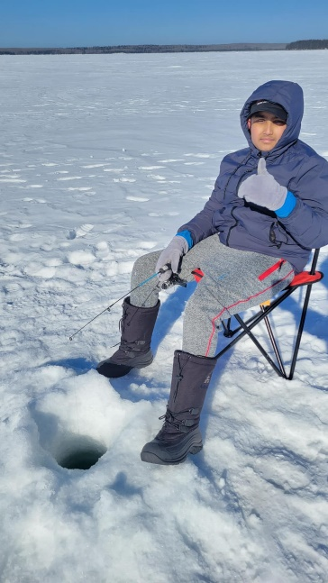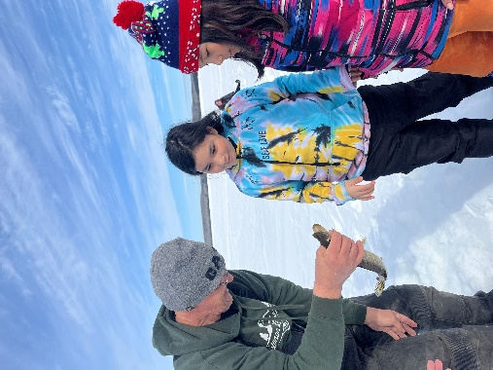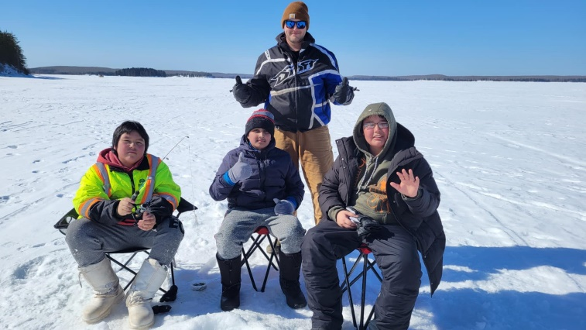

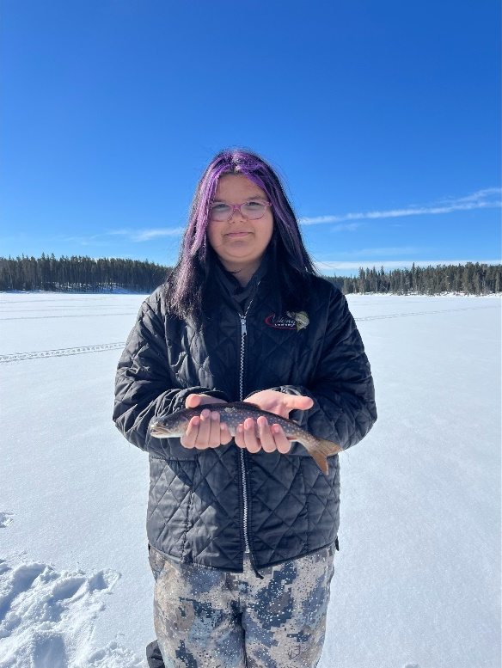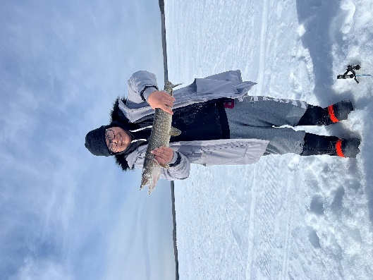

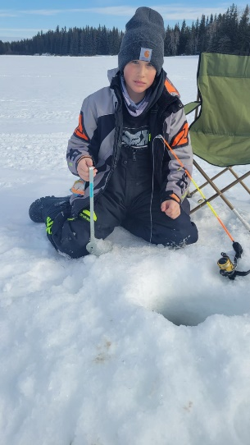

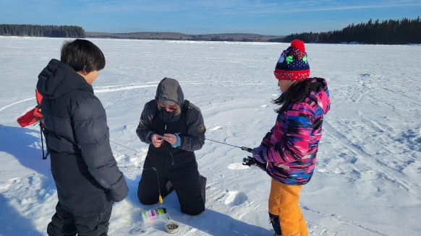

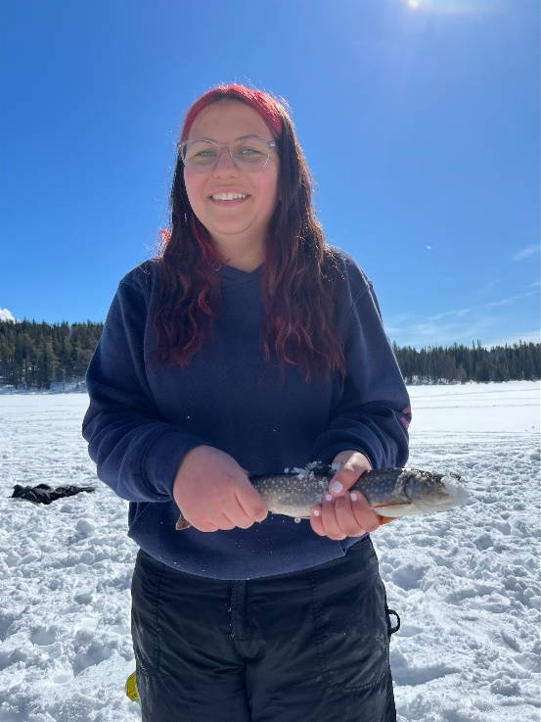 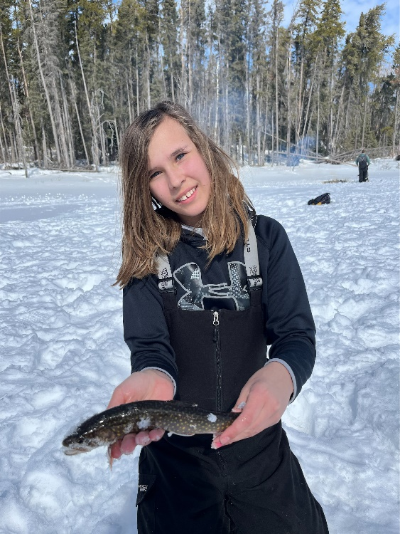 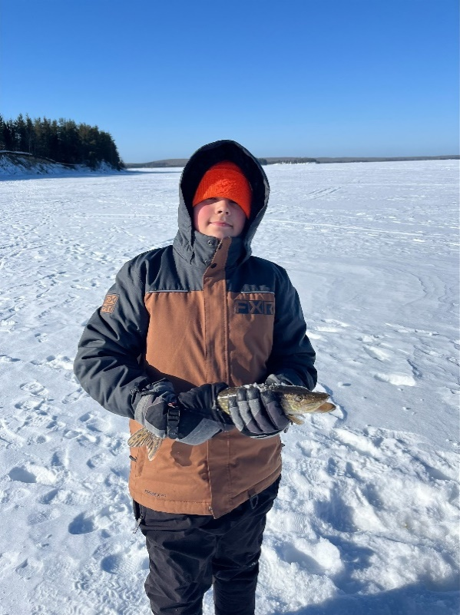

**IT’S REGISTRATION TIME!!**

****It’s Kindergarten registration time! If you have a child who is turning 5 on or before December 31st, it’s time to sign up for school!

Registration forms can be filled out at school, can be found online, or we can also email the form to you.

Please bring a birth certificate for age verification.

**Loonies for Letti**

Students, staff and

community members

collected almost $400 for Letti’s Angel

Hair for Kids fundraising endeavour! Letti cut her hair and collected even more

donations, for a total of $1500 to send in with her braid. Awesome!!

**Kindness Slippers**

Thank you, again, to Karen and Troy for their

donation of homemade slippers.

Random draws were made, and numerous students took home a cozy pair to

wear, or a pair of minis for play. $50 was deposited to the playground

fundraising account on behalf of their kindness.

**HAVE A GREAT SPRING BREAK! SEE YOU MONDAY, APRIL 7TH, SCHOOL DAY 4**



**IMPORTANT APRIL DATES**

April 9 – Public Health Immunizations

April 10 – Free Hamburger Soup Lunch

April 11 – Wicihitowin Kindergarten Prog

Gr8 Passport to Health

April 15 – Gr 7 Badminton

April 16 – Gr 8 Badminton

April 17 – PD Day – No School

April 18 – Good Friday – No School

April 21 – K Grad Photos

April 22 – Gr 5 Badminton

April 23 – Gr 6 Badminton

April 24 – Free Ham & Perogy Lunch April 29 - Badminton Valley Champs

** FREE HOT LUNCH**

**Thursday, April 10th** there will be a free hot hamburger soup/bun lunch and drink provided to all students and staff of Bowsman School. Children can bring their own lunch if they do not want to participate.

[This Photo](https://foto.wuestenigel.com/wecker-und-ein-klemmbrett-mit-dem-text-quot-daylight-saving-time-sommerzeit-quot-vor-gelbem-hintergrund/) by Unknown Author is licensed under [CC BY](https://creativecommons.org/licenses/by/3.0/)

**Wicihitowin Kindergarten Program**

Shannon Fullerton, SVSD Presence & Engagement Coordinator, will be hosting a Wicihitowin Kindergarten Program, April 11th. She will contact parents with information.

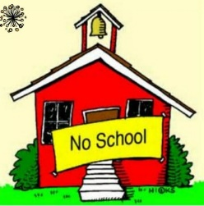 **NO SCHOOL**

**Thursday, April 17th - Professional Development Day**

**Friday, April 18th – Good Friday**

**KINDERGARTEN GRAD PHOTOS**

On **April 21st**, Lifetouch will be here to take our Kindergarten Grad Photos. Please ensure that your child has their own comb or brush for any “touch ups” that day.

**HAM & PEROGY LUNCH APRIL 24th**

Enjoy a FREE lunch of Ham, Perogies, SVRSS salad, and a bun catered by Julie Nahnybida

Bring your own lunch if this is not desired.

**LICE HEAD CHECKS**

**Please continue to carefully check your child’s head for lice or eggs. If they are found, you must treat your child with either a store-bought/Public Health remedy or home remedy.**

**Helpful Hint:** use an LED light when checking for eggs/nits in your child’s hair. The LED light makes the eggs shine; therefore, they are easier to see and remove thoroughly.

**If you find lice, your child should be treated today, again in one week and again the week following.**

**All eggs must be removed:** please note: the nit comb that comes with the store-bought remedy does not remove all the nits. You must go through the hair strand by strand.

Please ensure that their bedding, etc. has been laundered in HOT water and any areas that your child has been near (mattress, couch, carpet, bed, toys, etc.) is vacuumed thoroughly. Please be diligent in checking your child’s hair weekly, as we need to maintain a healthy environment for ALL of our students.